 |  |  | Journal of Advanced Vehicle System |  |  |  | 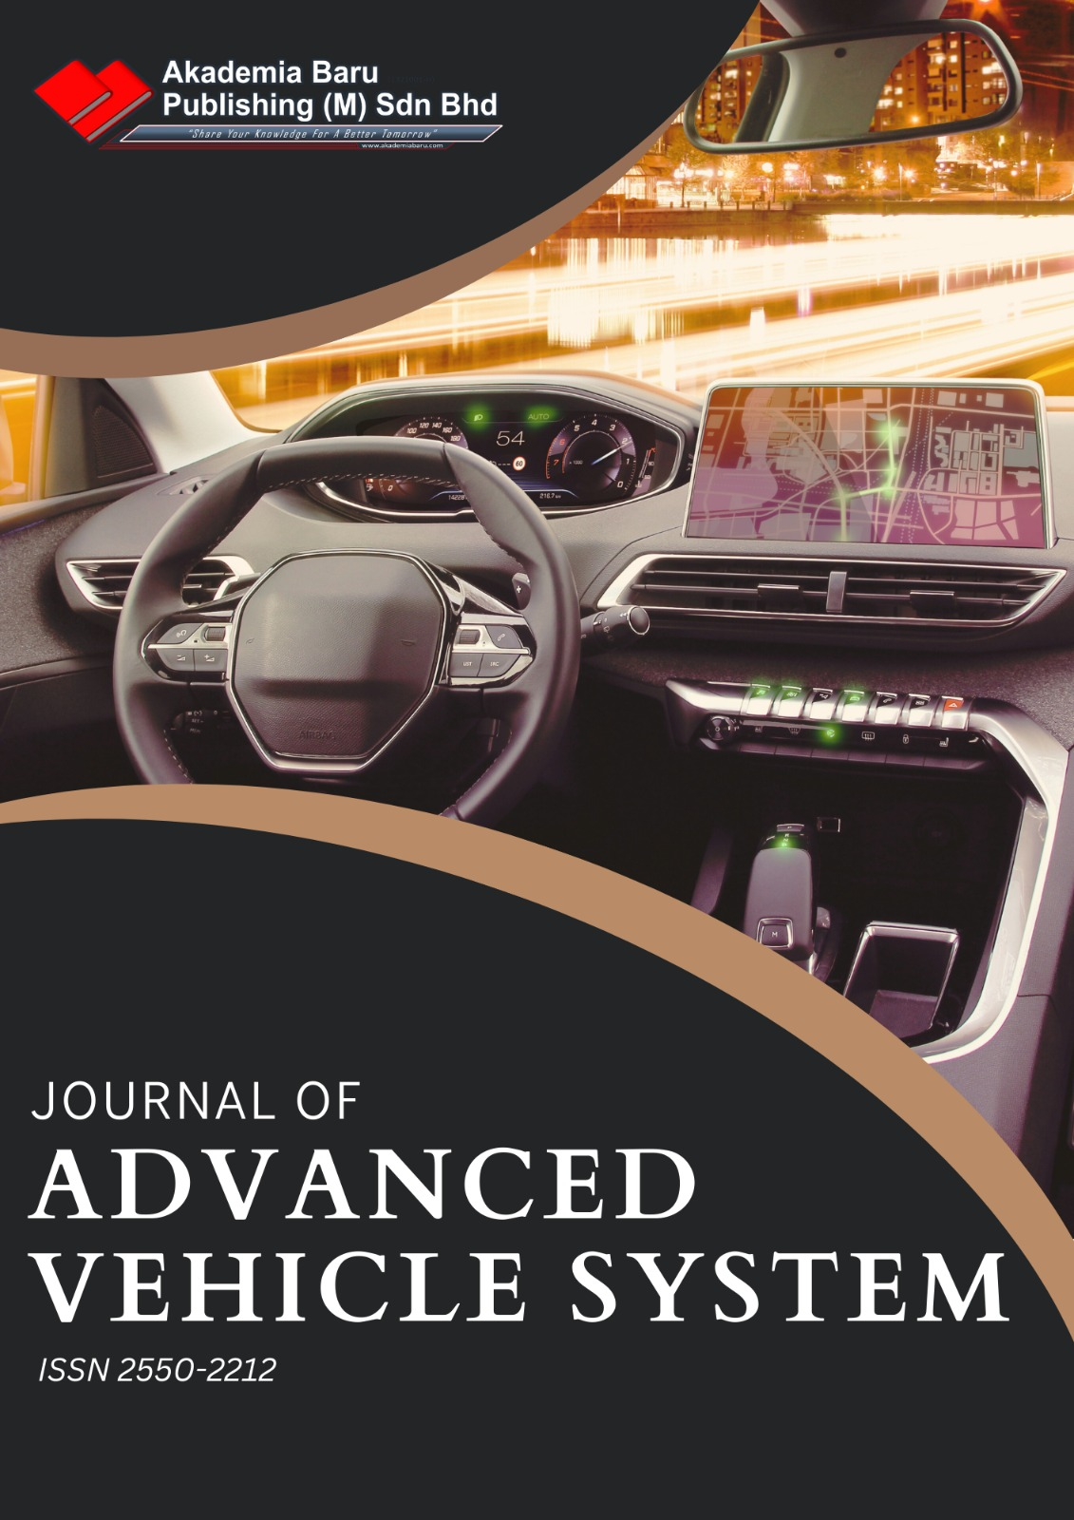
Journal homepage: http://www.akademiabaru.com/submit/index.php/javs/index
ISSN: 2550-2212
The Comparison of Intention to Purchase Safer Car
Khairil Anwar Abu Kassim¹, Mohd Hafiz Johari¹, Najihah Wahi¹,*, Yahaya Ahmad², Zulhaidi Mohd Jawi², Wira Jazair Yahya³

¹ | Malaysian Institute of Road Safety Research (MIROS), 43000 Kajang, Selangor, Malaysia
² | Vehicle Safety and Biomechanics Research Centre (VSB), Malaysian Institute of Road Safety Research (MIROS), 43000 Kajang, Selangor, Malaysia
³ | Malaysia – Japan International Institute of Technology (MJIIT), Universiti Teknologi Malaysia, Malaysia
ABSTRACT
Road accident injuries are expected to become the fifth leading cause of death by 2030.
Keywords:
ASEAN NCAP; Vehicle Safety;
Received: |  | Revised: |  |  | Accepted: | Published:

1. Introduction

Road accident have taken away many lives of people. According to World Health Organization (WHO), road accident injuries are expected to become the fifth leading cause of death by 2030 [1]. WHO [14] stated that an individual, family, and the nation experience economic losses due to crashes, which results from the cost of treatment as well as lost productivity for those killed or disabled by their injuries. In most countries, road accidents cost 3% of their gross domestic product.

2. Study Objective

This research aims to analyze customer’s intention to purchase safer car between Indonesia and Thailand by using the Theory of Planned Behavior and Descriptive Statistics.

3. Methodology
3.1 Data Acquisition

A primary data has been used in this research. A self-administered questionnaire has been distributed to selected sample. Sample consisted of engineers, scientists, government officers, lecturers, and self-employed person. A self-administered questionnaire is convenient because no bias can be introduced from the way questions are asked since there is no presence of interviewer to inject bias toward respondents.
The questionnaires contained a few demographic questions such as gender, age, marital status, and several other questions to create a profile for each respondent in this research. There were a five-point Likert-type scales of questions to measure the constructs. Respondents were asked to range themselves from strongly disagree (1) to strongly agree (5), very unimportant to most important, very impossible to very possible and other ranges.

3.2 Theory of Planned Behavior

In 1985, the Theory of Planned Behavior (TPB) is proposed by Icek Ajzen that is developed from the theory of reasoned action [3]. TPB is implemented when a researcher aims to understand consumer’s intention or decision making. Human behavior is difficult and complex to be understand but it can be interpretable with an extreme concern on biological and environmental factors on behavior. Therefore, social attitude and personality trait played a big part in explaining human behavior. Figure 2 depicts the conceptual framework of theory of planned behavior for this research.

Attitude
Intention to purchase safer car in Singapore
Subjective Norm
Perceived Behavioural Control

Fig. 2. Conceptual Framework of Theory of Planned Behaviour
Table 1
Adapted Construct Domain and Measurement Items
Construct | Literature Source
Attitude (ATT)  [4 items] | ATT1 [7]  ATT2 [10]  ATT3 [7,10]  ATT4 [7,10]

4. Results and Discussion

Descriptive statistics will be used to compare the safer car purchase intention between the consumers in Indonesia and Thailand. 18 questions in total will be analyzed from four TPB constructs which are attitude, subjective norms, perceived behavioral control and consumers’ purchase intention. Mean and standard deviation for each construct will be generated to see which country engage better in safer car purchasing behavior based on five-point Likert scale (1 to 5).

4.1 Attitude

In the first determinant of TPB, four questions were asked in the questionnaire regarding consumer’s favorable or non-favorable attitude towards safer car purchasing behavior. Table 2 presents the mean and standard deviation of the constructs for Indonesia and Thailand.
5. Conclusions

It can be concluded from the result of this study that TPB is an effective method to predict the safer car purchase intention. The objective of this study in comparing the safer car purchase intention among consumers between Indonesia and Thailand have been successfully achieved. Thailand have higher mean scores in attitude, subjective norms, and perceived behavioural control. Hence, it resulted in Thailand people have a stronger intention to purchase a safer car compared to respondents in Indonesia.

Acknowledgements
The research team would like to express their deepest gratitude to the relevant organizations for lending their knowledge and invaluable advice to this study, and the participants who have channeled their time and energy towards the completion of this project.

References
[1] ASIRT. (2009, December 3). Association for Safe International Road Travel. Retrieved from https://www.asirt.org/safe-travel/road-safety-facts/
[2] Van Lange, Paul AM, Arie W. Kruglanski, and E. Tory Higgins. Handbook of theories of social psychology: Volume two. Vol. 2. SAGE publications, 2011.
[3] Ajzen, Icek. "The theory of planned behavior." Organizational behavior and human decision processes 50, no. 2 (1991): 179-211.

Corresponding author. E-mail address: najihah@miros.gov.my

