 |  |  | International Journal of Advanced Research in Future Ready Learning and Education |  |  |  | 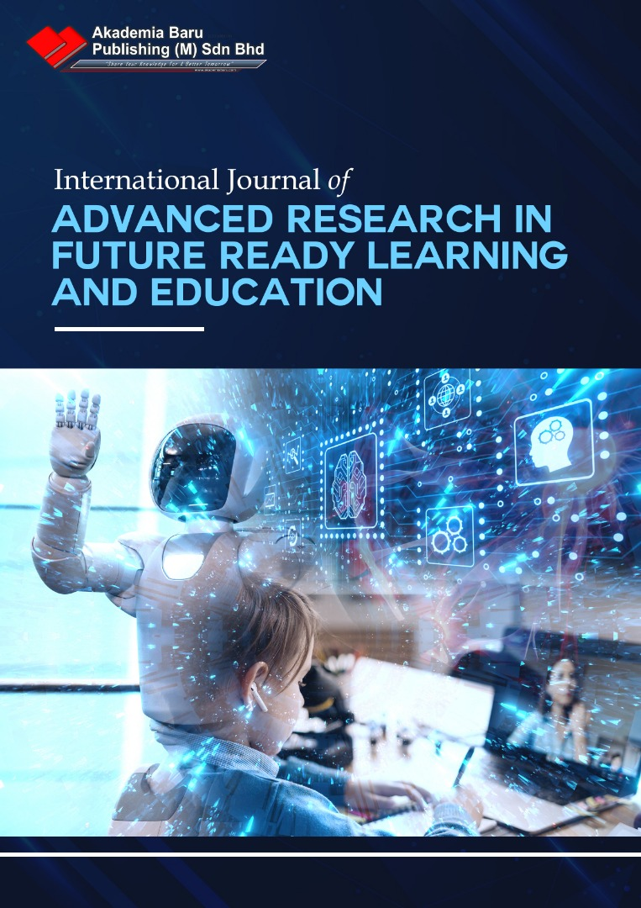
https://www.akademiabaru.com/submit/index.php/frle/index
ISSN: 2462 - 1951
COVID-19: What are the challenges of online learning? A literature review
Author¹, Author2^{2,}

¹ | School of Computing, Faculty of Engineering, Universiti Teknologi Malaysia, Skudai, Malaysia
² | Azman Hashim International Business School, Universiti Teknologi Malaysia, Skudai, Malaysia
ABSTRACT
The COVID-19 pandemic has made countries and organizations around the world to revise their business operations. Some countries took a step further by executing Movement Control Order (MCO) to reduce the spread. During MCO like Malaysia, all non-essential businesses were closed, interstate travel was prohibited, and purchasing of daily needs were limited. This pandemic had rendered Malaysian homebound. Xxxxxx.
Keywords:
Covid-19, online learning, learning management system, movement control order
Received: XX April 20XX |  | Revised: XX May 20 XX |  |  | Accepted: XX June 20 XX | Published: XX June 20 XX

1. Introduction

The coronavirus COVID-19 has created a global pandemic that led to the rapid closure of school worldwide, rendering 1.2 billion students out of classrooms [1-2]. An unprecedented event that has not happened in a decade except for the SARS period has created such uncertainty and challenges in education for teachers, parents, and students. Given the infective nature of the virus, face-to-face interaction was prohibited. The congregation was unadvisable, and confinement at home has taken into place.

1.2 Research Question

Our research aims to study the difficulties of online learning during the coronavirus pandemic. As well as using past articles to identify solutions. Hence, our main research question is:

“What are the challenges and recommendations for online learning during COVID-19?”

1.3 Research Objectives

The goal of this research is to identify the factors affecting online learning during COVID-19. Hence, our studies objectives are as follow:

2. Methodology

The literature review began with the selection of conference papers, proceedings, and journal articles sourced from eleven online databases available in our university library. The online databases are the Academic Search Premier, Emerald, IEEE, JSTOR, ProQuest, Reaxys, SAGE, ScienceDirect, Scopus, SpringerLink, and Wiley Online Library. The search is limited to the papers published in December 2019 to July 2020 as it is the period of the COVID-19 pandemic.
The organization that implements the ADKAR model led to a predictable path, as seen in Figure 1, with much better performance in a short period, compared to organizations that did not implement the model [19].

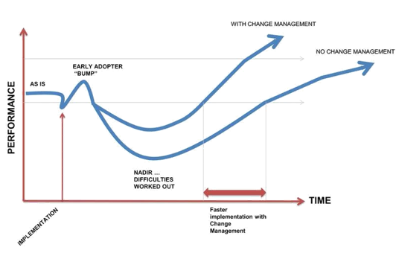
Fig. 1. Model depicting an early surge in performance, followed by majority acclimatizing quicker to the change factor [21]

3. Results and Discussion

Concerning the challenges in the learning and focus of the students, teaching through online are crucial. The recommendation of having a small online group by Sander aims to optimize the learning experience. This approach is to ensure that each student contributes during the live streaming lecture [19] using any of the synchronize video conference applications such as ZOOM, Webex, Skype, Top hat, and more. Tips for synchronizing classes are to segregating it into a series of components that have smaller learning tasks to better convey the lessons, with a break in between.

4. Conclussion

The current notion of students being a digital native is not a given stance. Despite their receptive age to technology, students need to be exposed, train, and become familiar with online educational platforms [3]. Hence, prior experience in education technology before the pandemic is crucial.
References (minimum 15)
[1] World Health Organization 2020 Coronavirus disease (COVID-2019) Situation reports 171 1-18
[2] Basilaia G and Kvavadze D 2020 Transition to online education in school during a SARS-CoV-2 Corona virus (covid-19) pandemic in Georgia Pedagogical Research. 5 1-9
[3] Bao W 2020 COVID-19 and online teaching in higher education: A case study of Peking University Hum Behav & Emerg Tech. 2 113–115
[4] Ali W 2020 Online and remote learning in higher education Institutes: A necessity in light of COVID-19 pandemic Higher Education Studies. 10 16-25

Corresponding author. E-mail address: xxxxxxx@gmail.my

