 |  | Journal of Advanced Research in Materials Science |  | 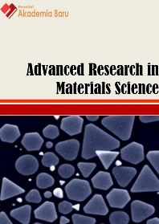
Journal homepage: www.akademiabaru.com/arms.html
ISSN: 2289-7992
Calcium phosphate cement for bone filler applications |  |  |  |  | Open  Access
Sufiamie Hablee¹, Iis Sopyan^{1,}∗, Maizirwan Mel¹, Hamzah Mohd. Salleh¹, Md. Mujibur Rahman²

¹ | Kulliyyah of Engineering, International Islamic University Malaysia, Kuala Lumpur, Malaysia
² | College of Engineering, Universiti Tenaga Nasional, Selangor, Malaysia
ARTICLE INFO |  |  | ABSTRACT
Article history:  Received 2 July 2016  Received in revised form 1 February 2017  Accepted 4 August 2017  Available online 27 November 2017 |  |  | Various formulations of calcium phosphate cement (CPC) have been developed to get cement paste with optimum setting times, injection capabilities, as well as mechanical and biological properties. This is important to ensure that CPC is applicable for clinical uses as bone filler materials. The existing studies on CPC have investigated factors affecting its properties which include liquid-to-powder ratio, types of solid and liquid phases used, concentration of liquid phase, and particle size of powder phase. One of the promising and interesting routes to improve properties of CPC is by incorporating polymeric additives as setting agents, such as gelatin, alginate, chitosan and hydroxypropyl methylcellulose. The aim of this paper is to review the recent developments of CPC for bone filler applications.
Keywords:
Bone cement, bone filler, calcium phosphate, review, setting agent |  |  | Copyright © 2017 PENERBIT AKADEMIA BARU - All rights reserved

1. Introduction

Development of artificial bone substitute materials is addressed to overcome the drawbacks of naturally derived bone grafts (autografts and allografts). Autograft is not immunogenic and offers the best osteoinductive and osteoconductive properties [1]. However, it has limited supply [1-5], cannot duplicate the bone replaced, and requires additional surgeries resulting in extra cost and pain for patient [3]. In contrast, allograft is available in considerable quantity and can duplicate mechanical strength of the bone being replaced [1,3,5]. However, it is immunogenic, and has low osteoinductivity, high risk of diseases transmission, as well as expensive cost of operation and storage [1,3-5]. These issues can be solved by using synthetic bone graft because it offers bioactivity, biocompatibility, bioresorbability, and low infection and rejection rates with low inflammatory reaction to the surrounding tissues. In addition, the use of artificial bone substitute materials can avoid additional operations [5].
Calcium phosphate cement (CPC) is one of the most promising materials to be used as injectable bone substitute materials. CPC is the mixture of powder phase that contains one or more calcium phosphate (CaP) compounds and liquid phase of water or calcium- or phosphate-containing aqueous solution [3,6,7]. Advantages of using CPC are associated with its excellent biological behaviour, injectability, ability to harden in vivo and microporosity. However, CPC normally has poor injectability without additives, weak cohesion and low mechanical strength [3]. CPC has more advantages as bone substitute material when compared to poly(methyl methacrylate)-based cement and calcium sulfate cement because CPC is bioactive and osteoconductive, with various degrees of bioresorbability and isothermal setting reactions [8].
One of the important applications of CPC is in the drug delivery [9,10]. The porous structure of CPC enables it to be used as carriers for controlled drug delivery. The use of CPC as drug carriers has been demonstrated by Haghbin-Nazarpak et al. [11], Hong et al. [12] and Vorndran et al. [13]. CPC also has been widely used in orthopedic applications, mainly for non- or moderate load-bearing sites [1, 9]. Scordino et al. [14] incorporated CPC into polyetheretherketone (PEEK) implant to fix opening wedge osteotomy. Moreover, Harms et al. [15] has investigated the use of nanocrystalline hydroxyapatite for load-bearing defect site in sheep model. Other applications of CPC including vertebroplasty and kyphoplasty [7,16], dental [17], craniofacial and maxillofacial [18,19], and ossiculoplasty [20-22].
For a successful implantation, CPC needs to fulfill the clinical requirements. It is favorable for the cement to set slowly enough to provide sufficient time for surgeon to perform implantation but fast enough to prevent delaying of the operation [3]. Thus, various formulations of CPC have been investigated with the aim to alter setting time, injectability, mechanical properties as well as biological properties by investigating the factors affecting these properties. The purpose of this paper is to present an overview on the recent development of CPC for bone filling material.

2. Setting Reactions of CPC

Setting reaction of CPC is one of the important features which significantly control setting time and other setting properties, nature of the cement products, and physical and biological properties of the hardened cements [3]. The setting reaction of CPC involves three stages which are: (1) dissolution of reactants to saturate the mixing liquid in calcium and phosphate ions, (2) nucleation of crystals, (3) growth of crystals [23].
The chemical process during setting reaction involves two mechanisms, which are dissolution and reprecipitation [3]. Dissolution is the phase where supersaturation is generated as calcium and phosphate ions are released by the starting powders. Supersaturation will lead to the nucleation of new phase surrounding the powder particles when the ionic concentration has reached the critical value. This is a continuous process as long as the dissolution of the reagents continues. The final composition of precipitates produced by this dissolution/reprecipitation process is determined by the relative stability of CaP salts in the system. A less stable (more soluble) CaP phase will dissolve to form a more stable (less soluble) one [23-25]. The main final products for CPC reaction are apatite and brushite; at body temperature apatite is the most stable at pH > 4.2, while brushite is at pH < 4.2, at body temperature [24,25].
Chemical reactions possible to occur during setting of CPC can be either acid-base interaction or hydrolysis of CaP depending on their chemical composition. The acid-base interaction involves the reaction between a relatively acidic CaP with relatively basic CaP to produce a relatively neutral compound. An example of this type of reaction is the reaction between tetracalcium phosphate (TTCP) (basic) and dicalcium phosphate anhydrous (DCPA) (slightly acidic) in an aqueous suspension to produce a poorly crystalline precipitated hydroxyapatite (HA) (slightly basic). In contrast, the hydrolysis of CaP in aqueous media involves only one CaP compound producing a compound of same initial and final calcium-to-phosphate (Ca/P) ratio. This type of reaction is called single-phase or single component [9].

3. Properties of CPC
3.1 Setting Time

Setting time of CPC is defined as the time needed for the CPC to become strong enough to resist an applied force [3]. The standardized methods to measure the setting time of CPC are Gillmore needle method [3 9,26,] and Vicat needle method [9,26]. By means of Gillmore needle method, setting time of CPC is the time from the initial setting time (the time when CPC able to resist the small fixed pressure applied by a thick Gillmore needle) and final setting time (the time when CPC able to resist the high fixed pressure applied by a thin Gillmore needle) [3].
Generally, fast setting limits the period of workability of the cement such that the cement may become unworkable before the surgeon finishes performing implantation, and slow setting delays the operation such that it prevents the surgeon to close the defect site [3,9,26]. CPC with favorable setting time for clinical application can be obtained by modifying its setting kinetics. Setting kinetics can be controlled by the contact area between reagents and mixing liquid, the reagent solubility in the mixing liquid, and the saturation of the mixing liquid towards the reagent. Additives could also be incorporated to control setting such as dissolution inhibitors or surface modifier (passivation or activation of the surface), nuclei and nucleation inhibitors, and crystal growth inhibitors [23].
Fast kinetics and short setting time can be normally achieved by using smaller particle size (high specific surface), and low crystallinity particles. Shorter setting happens at higher setting temperature and low liquid-to-powder ratio, as well as by the addition of setting accelerators and nucleating phase [3,26].

3.2 Injectability

Injectability of a CPC can be defined as the ability of cement paste to stay homogeneous (without filter-pressing) during injection, independent of the injection force [3]. Injectability can be evaluated by measuring the weight percentage of the cement paste that could be extruded from a syringe by either a hand or a force of 100 N maximum of a compressive mode [9].
During injection, filter-pressing, phase separation or phase migration may happen. This happen due to the liquid which may flow faster than solid, resulting in local changes of paste composition [9,26]. Filter-pressing can be reduced in order to improve injectability properties of cement paste by reducing its viscosity, powder-to-liquid ratio as well as the mixing time. Excellent injectability can be achieved by using smaller particle size, shorter and larger diameter cannula, lower flow rate, spherical shape particles and addition of additives such as polysaccharides, methylcellulose, and citrate ions [3,9].

3.3 Cohesion and Anti-Washout Ability

Cohesion is the ability of a CPC to harden without disintegrating into small particles in a static aqueous environment, meanwhile anti-washout ability in a dynamic aqueous environment [3]. Improvement of cohesion and anti-washout ability of a cement can be done by using smaller particle size, decreasing liquid-to-solid ratio, increasing the viscosity of the mixing liquid, and adding biopolymers such as sodium alginate, hydroxypropyl methylcellulose (HPMC), hyaluronic acid, chitosan and modified starch [3,26]. A continuous and quantitative assessment of paste cohesion by Bohner et al. [27] revealed that there are two mechanisms of cohesion, which are a continuous but slow process and a rapid weight loss. Weight losses of both mechanisms were due to the action of gravity forces on the paste.

3.4 Mechanical Properties

CPCs are produced via a dissolution-reprecipitation process at room or body temperature formed an entangled network of apatite crystal, which contributes to its mechanical properties. With time, apatite crystals continue to grow and the entangled network becomes denser until the cement achieves its maximal mechanical properties [3]. CPC materials shows a brittle properties, with tensile strength 1-10 MPa and compressive strength 10-100 MPa [9,26]. There are many ways to enhance mechanical strength of CPC including the addition of water-soluble polymers, such as poly(acrylic acid), poly(vinyl alcohol), sodium alginate, sodium polyacrylate, polyelectrolytes, poly(ethylene oxide), bovine serum albumin, and superplasticizers [9]. Furthermore, strength improvement can be done by reducing porosity and pore size with the use of smaller particles size, high aging temperature and addition of accelerators or retarders [3].

3.5 Biological Properties

Biological properties of CPC has significant role in the strategy to repair bone defects by using a resorbable bone substitute and then replaced by new mature bone. Due to this, it is essential to use a macroporous bone substitute to assist the replacement by new mature bone. CPC with macropores can be prepared by the addition of highly soluble solids, hydrophobic liquids, gas bubbles and granules with hydrogel [26]. In addition, factors affecting the growth rate of newly forming bone are porosity, bulk site, anatomic site, crystallinity, chemical composition (brushite or apatite), particle size and powder-to-liquid ratio of the cements [9].
Bioactivity of a CPC can be evaluated by its ability to form apatite when immersed in Simulated Body Fluid (SBF). A successful of implantation depends on the degradation of cement and its subsequent replacement by the autologous tissue is dependent upon the cellular responses during the initial and chronic inflammatory phases of healing [4].

4. Injectable CPC

Recent years, various studies have been done on CPC materials development where various formulations of CPC have been discovered. The formulations were developed to produce bone filler material with better injectability, setting time, mechanical strength and biological properties which is therefore applicable for clinical uses.
Weitao et al. [28] have developed injectable CPC which composed of β-tricalcium phosphate (β-TCP), calcium phosphate dibasic anhydrous (DCPA) and nanocrystalline hydroxyapatite (HA) as the powder phases, and sodium alginate and Na2HPO4 / NaH2PO4 buffer as the liquid phase. This work disclosed that addition of sodium alginate in the liquid phase and calcium carbonate and nanocrystalline HA in the powder phase would provide easier injectability and keep cement cohesion. The formation of bond between sodium alginate and Ca²⁺ ions of the cement produced a gel of sodium alginate, which promotes excellent cohesiveness and reduces viscosity of the cement. The cement also has longer setting time, higher porosity and easier to degrade in vivo compared to the commercial one.
Study on the effect of powder-to-liquid (P/L) ratio and needle sizes on the injectability of CPC have been done by Burguera et al. [29]. The cement was formulated from tetracalcium phosphate (TTCP)- dicalcium phosphate dehydrate (DCPD), with the addition of sodium phosphate as the hardening accelerator and hydroxypropyl methylcellulose (HPMC) as the gelling agent in the cement liquid phase. The results of this study revealed that the increased needle gauge size would increase the injection force. The effect of P/L ratio on injectability also showed the same trend, such that the increase in P/L ratio would decrease the percentage of extruded pastes and the injection force increased. Furthermore, the increase in P/L ratio has positively affected the mechanical properties of the cement as it increases the strength, elastic modulus and density, and reduces the pore volume as well as crystal dimensions.
Alqap et al. [30] investigated the effect of calcium excess, water content and mixing time on the injectability of CPC produced by low temperature hydrothermal technique. Calcium oxide granules (CaO) and ammonium dihydrogen phosphate as the precursors, and water as the solvent. This work showed that higher Ca excess would increase the extrusionload with increasing mixing time, thus lowering cement injectability as shown in Figure 1. The increase of Ca excess makes the cement less injectable. Cement paste with good injectability is more moldable, finer in structure and longer (CP2) as shown in Figure 2 (b) and (c). Meanwhile, CP20 with rough surface and nonflexible structure shows cement paste with poor injectability as shown in Figure 2 (a).

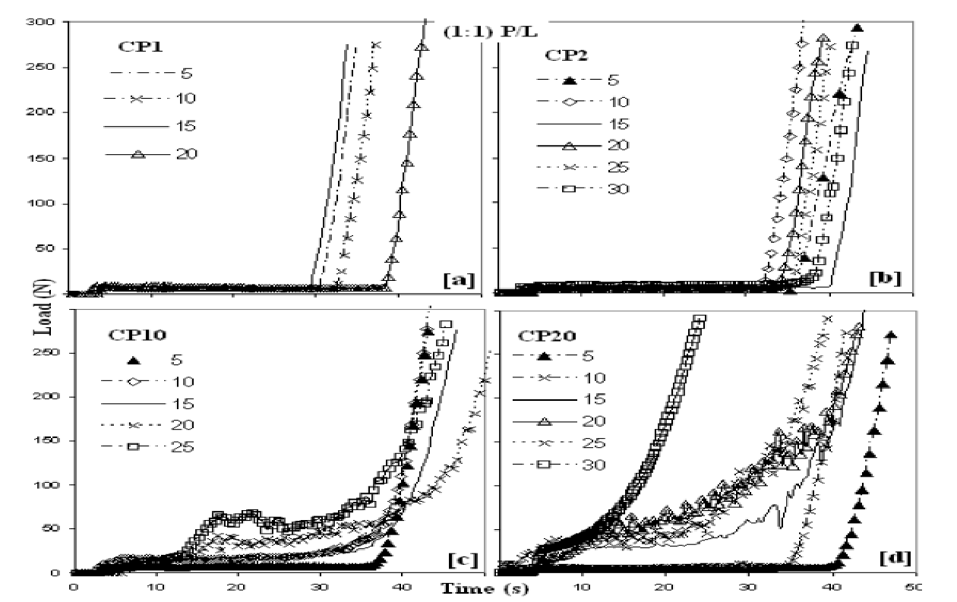
Fig. 1. Injectability of CPC with different Ca excess after different mixing time, and P/L ratio of 1:1 [30].

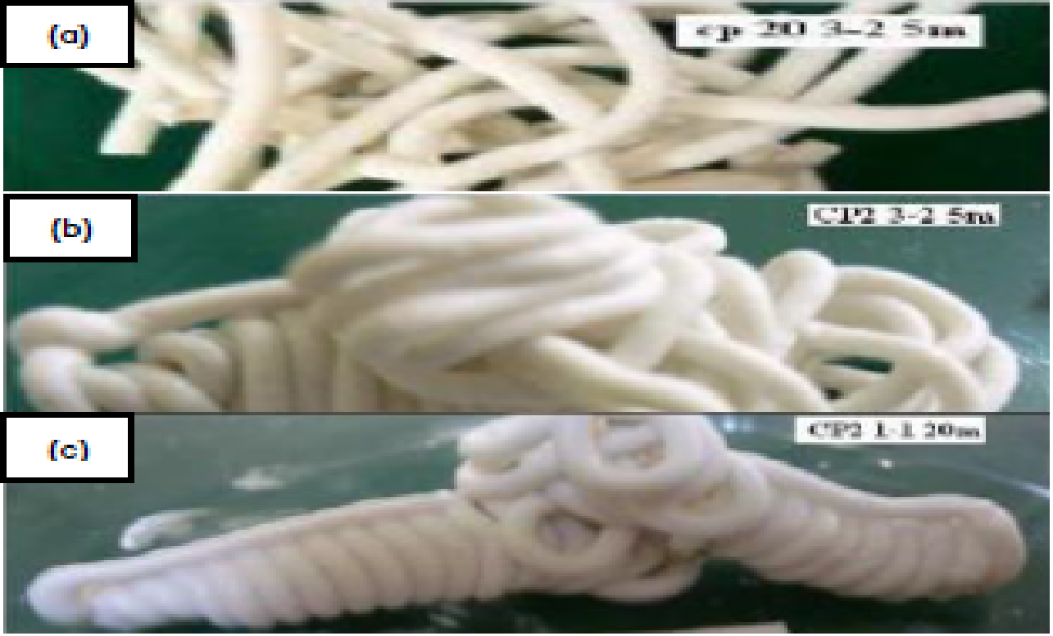
Fig. 2. Moldable form of CPC after injection: CP20 (3:2) after 5min (a); CP2 (3:2) after 5 min (b); CP2 (1:1) after 20min (c) [30].
Vlad et al. [31] examined the effect of calcium-tophosphate (Ca/P) ratio on the setting properties of CPC by adding precipitated hydroxyapatite and disodium hydrogen phosphate as setting accelerator. This study has revealed that cement with Ca/P ratio of 1.50 has the optimum setting time approximately 10 minutes, with highest compressive strength of 50MPa after 24h setting. This is because the maximum supersaturation happened at room temperature around pH 9. Grover et al. [32] disclosed the effect of amorphous pyrophosphate on calcium phosphate bone cement resorption and bone generation. The pyrophosphate cement is more resorbable than orthophosphate cement such that 33 area% new bone has been formed throughout the 12 months implantation. In vitro study on degradation rate demonstrated that calcium pyrophosphate preferentially dissolved from the implanted material which has been proved by the presence of brushite after 12 months. Chen et al. [33] studied the effects of concentration of diammonium hydrogen phosphate on the properties of CPC derived from tetracalcium phosphate (TTCP)-dicalcium phosphate anhydrous (DCPA). Both working and setting times of the cement paste decrease with the increasing concentration of the setting solution, because diammonium hydrogen phosphate accelerated the formation of hydroxyapatite (HA). The compressive strength increased with diammonium hydrogen phosphate concentration until optimum value of 0.6M is achieved and further increase reduced the compressive strength. Engstrand et al. [34] investigated the effect of L/P ratio, monocalcium phosphate monohydrate (MCPM)- to-β-tricalcium phosphate (β-TCP) ratio, relative concentrations of sodium pyrophosphate (SPP) and citric acid, and MCPM particle size on mechanical properties of cement. The results revealed that lower L/P ratio produced stronger cements. In addition, increasing MCPM content improves the compressive strength up to 45 mol% MCPM. Moreover, low concentration of citric acid results in higher strength cement than that of low concentration. Furthermore, small MCPM particles produced more porous and stronger cement compared to large MCPM particles. Sarkar et al. [35] have synthesized a brushite-based CPC with multichannel HA granule loading to impart porosity and mechanical strength for bone regeneration. Granules loading into CPC prolongs the setting time because of the mechanical interlocking between large granules. Moreover, the reinforcing effect of granules has improves compressive strength of CPC. Sawamura et al. [36] studied the effect of temperature on the compressive strength and hydration reaction within the CPC setting bodies, by heating the CPC pastes at different temperatures during the initial setting process. The CPC was prepared by mixing DCPA, TTCP and dextran sulfate sodium aqueous solution. The increased initial setting temperature has increased the hydration reaction rate and compressive strength of CPC but shortened the setting time. Furthermore, soaking in simulated body fluid (SBF) improved the compressive strength of cement, but it decreased with the increase in setting temperature because highly crystalline HA formed in the initial setting bodies at high temperature delayed the setting reaction in SBF.

5. Premixed CPC

At present, most of the commercially available CPCs are in the form of powder and liquid that will be mixed immediately before use. This system required the ability to properly mix the cement and then place it into the defect within the prescribed time, and also achieve an optimum result. Therefore, it is favorable to have a premixed cement paste prepared in advance using a controlled process, stable in the packages, and hardens only when it is placed in the bone defect [37]. Premixed cements are the easiest to use as they do not need any mixing or transferring into an appropriate delivery system, and also do not have time constraint to use once it is open [26].
Recently, to improve the available premixed CPCs, Shimada et al. [37] have synthesized and studied the properties of dual-paste HA-forming CPC. The cement they produced consisted of two premixed cement, which are dicalcium phosphate anhydrous (DCPA) mixed with NaH₂PO₄ and TTCP mixed with water, with the addition of HPMC as gelling and lubricating agents in the liquid phase. Their study revealed that setting time of the cement was dependent on the TTCP particle size and phosphate concentration, such that small TTCP particle and high phosphate concentration would shorten the setting time. High porosity and low diametral tensile strength of the cement can be attributed to the low P/L and Ca/P ratio used in this study. Furthermore, the apatitic products of smaller powder particles were less crystalline than that of coarse particles.
Chen et al. [38] have designed a premixed CPC with long term suspension stability. The premixed CPC was formulated by mixing TTCP and DCPA as the powder phases with the liquid phases consisted of 1,3-propylene glycol, disodium hydrogen phosphate and fumed silica. Propylene glycol is the viscoplastic media used as the continuous phase, and fumed silica as the thixotropic agent. This study disclosed that fumed silica is the stabilizing agent that improved suspension stability of premixed CPC. The increased fumed silica content would increase the compressive strength of the cement due to the reinforcement of fumed silica short fiber on the paste matrix. However, addition of fumed silica would reduce injectability of the cement such that the viscosity of the cement paste increased. In addition, the cement was suggested to be cytocompatible such that it supports cell attachment and proliferation.

6. Reinforcement of CPC

One of the most critical drawbacks of CPCs is its poor mechanical strength. Many aspects need to be considered, such that injectability and strength of the cements are among the important properties and were correlated with each other. Improving the injectability by reducing P/L ratio would increase the porosity and hence, decrease the compressive strength. This in turn limits the application of CPCs to medium or non-load bearing site if no further steps are taken. Thus, reinforcement is one of the ways that have been implemented nowadays so that CPC could have both good injectability as well as good mechanical properties.
Incorporation of CPC/bioactive glass (BG) and CPC/poly(lactic-co-glycolic acid) (PLGA)/BG have been investigated by Renno et al. [39]. The cement powder consisted of α-TCP, DCPA and HA, with NaH2PO4 as the liquid phase. This study revealed that addition of PLGA increased porosity of the cement, meanwhile addition of BG prolonged the setting time. Degradation of CPC/BG showed a pH increase, whereas CPC/PLGA/BG showed a pH decrease. This can be attributed to BG influence in accelerating degradation rate of materials and creating of macroporosity. In addition, CPC/PLGA and CPC/PLGA/BG showed faster and more mass loss compare to CPC and CPC/BG formulations. This could be related to the degradation of the polymeric phase associated with the rate of dissolution of BG over time. Figure 3 shows the SEM micrograph of this study which confirmed the homogeneous distribution of PLGA-microparticles and/or BG granulates within CPC.
Mostafa and Zaki [40] have developed injectable bioactive bone cement based on tricalcium silicate (TCS)/α-TCP composites. From their study, setting time of the cement paste is longer as the amount of TCS increased due to the production of amorphous calcium silicate hydrate (CSH) gel during hydration of
TCS that cover the unhydrated TCP grains. In addition, increasing TCS content also increases the paste injectability. However, the compressive strength test showed that TCS/α-TCP composite has lower strength compared to TCP cement and much lower than TCS. The degradation rate decreases as the TCS content increases. The hydration of TCS/α-TCP yielded a bioactive silicon-substituted HAP and Ca(OH)₂ released reacted with calcium-deficient hydroxyapatite (CDHAP) to drive it more stoichiometry.
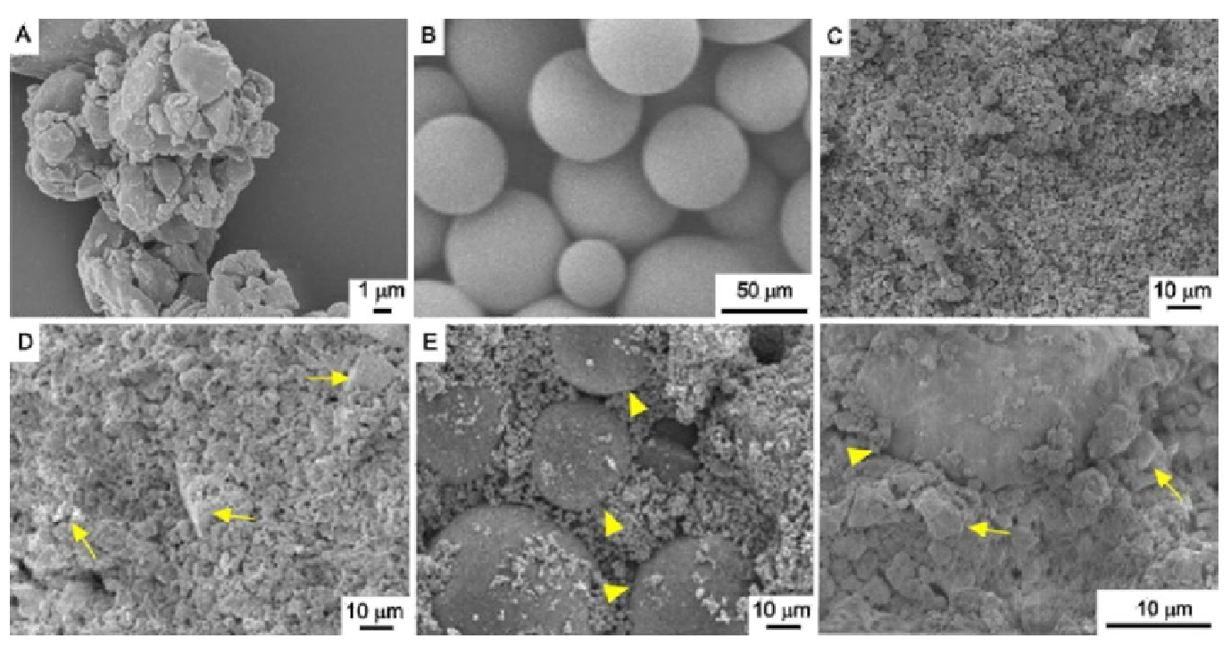
Fig. 3. Microscopic SEM micrograph of (A) BG granulate, (B) dense PLGA-microparticles, (C) CPC, (D) CPC/BG30, (E) CPC/PLGA and (F) CPC/PLGA/BG30. BG (arrow) and PLGA-microparticles (arrowheads) are indicated in the SEM micrograph [39]

Zhou et al. [41] have synthesized CPC material with the addition of strontium element (Sr), collagen I and modified starch. The powder phase was made up of CaP, anhydrous calcium phosphate, and modified starch added, whereas the liquid phases comprised of type I collagen dissolved in deionized water. XRD analysis of this work verified the hydration product of cement was poorly crystalline HA as shown in Figure 4. The setting time of the cement increased with liquid-to-powder (L/P) ratio and curing temperature. The increased L/P ratio also improved the injectability of the cement, however the compressive strength of the cement become poor. Anti-washout ability of the cement was improved by the addition of modified starch. Sr doping in Ca improved the strength of the material and promoted bone formation. When Sr concentration was increased, the degradation of bone cement become faster and hence accelerated new bone formation.

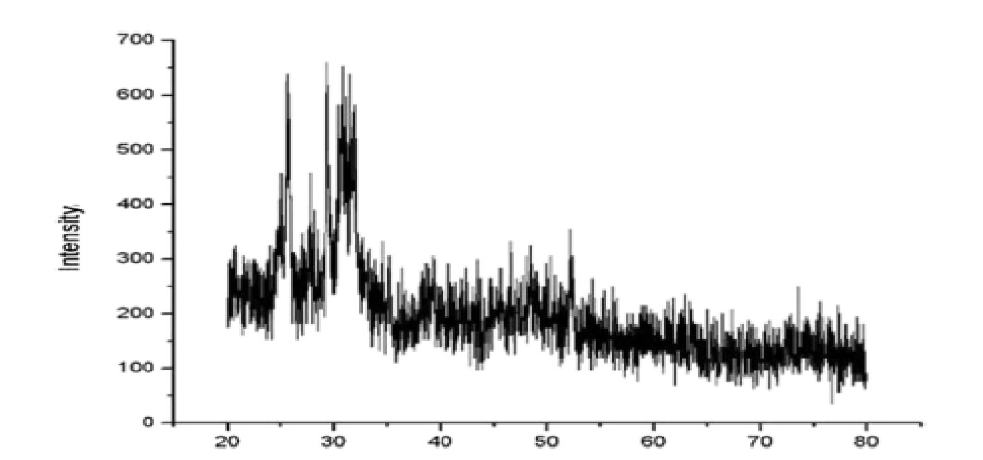
Fig. 4. X-ray diffraction pattern of injectable strontium-containing calcium phosphate cement with collagen [41]

7. Polymeric Additives as Setting Agents

The incorporation of setting agents into CPC has become trend in various recent studies of CPC materials. The addition of polymeric additives as setting agents is able to enhance performance of CPC materials in terms of injectability, setting time, cohesion and biological response [42].
Dessi et al. [43] and Kovtun et al. [44] used gelatin as porogen. These studies have proved that gelatin acted as cohesion promoter and improved injectability as well as biocompatibility. However, the presence of gelatin lowered compressive strength of cement because bubble’s volume in foaming technique increases cement ductility.
Park et al. [45] combined CPC with alginate to develop macropores for effective culture of cell tissues and bone regeneration. Increasing CPC-to-alginate ratio causes the surface morphology less dense and particle size bigger. The spheres are able to support cells to adhere, spread, and increase quickly to undergo osteogenic differentiation. In addition, dense microcarriers with porous structure have been developed via freezing and lyophilizing the solidified microcarriers after soaked in water. Interconnected pores are formed after the frozen ice crystals were purified and the pore size increased with freezing temperature.
Preparation of injectable macroporous calcium phosphate cement using syringe-foaming method via a viscous hydrophilic polymer solution has been developed by Zhang et al. [46]. Their works used α-TCP powder and silanized-hydroxypropyl methylcelluose (Si-HPMC) solution as the foaming agent. Both injectability and setting time of the prepared CPC were improved. However, mechanical properties is reduced because the increasing volume of macropores due to foaming.
Hesaraki and Nezafati [47] revealed the effect of adding chitosan (CS) and hyaluronic acid (HA) to the liquid phase of CPC with mixture of TTCP and DCPD powders. Different P/L ratios were applied, 3/5 gml-1 for CPC only, 3/1 gml-1 for CPC/HA and 2/8 gml-1 for CPC/CS. In vitro results presented similar viability and cell growth rate for all CPC formulations. However, better alkaline phosphates activity was showed by CPC containing CS and greater results for HA.
Ogasawara et al. [48] have reinforced CPC with P(3HB-co-4HB), poly(L-lactic acid) (PLLA) and poly(lactic-co-glycolic acid) (PLGA) and investigated mechanical properties of the cement. This study revealed the improvement of mechanical properties when the biodegradable polymers were incorporated into CPC. This happened because of their hydrophilicity which enhanced the surface bonding between the polymer and CPC. Addition of P(3HB-co-4HB) shows superior fibers bridging which hinders the propagation of cracks compared to PLLA and PLGA.
Poly(vinyl alcohol) (PVA) has been used as setting accelerator by Sopyan et al. [49]. The setting times of CPC with different PVA concentrations were evaluated using Gillmore needle method. The result of shown in Figure 5 reveals that the increase in PVA concentration shortens the initial and final setting times. However, the effect of PVA addition is more significant on the final setting time than the initial setting time. This is because water absorption by hydrophilic PVA molecules needs time to be effective.

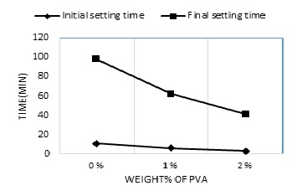
Fig. 5. Influence of PVA concentration on the setting times of CPC paste [49]

8. Concusion

Various formulations of CPC compositions have been discovered in order to produce injectable CPCs with better biological and physical properties. This is also to ensure that the cements can be used clinically and providing betterment for patients. The polymeric additives such as gelatin, alginate, hydroxypropyl methylcellulose, chitosan and others play vital role in enhancing the handling and mechanical properties of CPC. The injectability, cohesion and anti-washout resistance, setting time as well as mechanical performance can be improved by the addition of organic setting agents. However, further investigations are required to obtain better understanding on the cement properties and their controlling factors.

Acknowledgement
This work was financially supported by Fundamental Research Grant Scheme (FRGS) with the project ID of FRGS15-246-0487.

References
[1] Nandi, S. K., Samudra Roy, P. Mukherjee, Biswanath Kundu, D. K. De, and Debabrata Basu. "Orthopaedic applications of bone graft & graft substitutes: a review." (2010).
[2] Wang, Qifei, Jianhua Yan, Junlin Yang, and Bingyun Li. "Nanomaterials promise better bone repair." Materials Today 19, no. 8 (2016): 451-463.
[3] Zhang, Jingtao, Weizhen Liu, Verena Schnitzler, Franck Tancret, and Jean-Michel Bouler. "Calcium phosphate cements for bone substitution: chemistry, handling and mechanical properties." Acta Biomaterialia 10, no. 3 (2014): 1035-1049.
[4] Schnettler, Reinhard, Jens Peter Stahl, Volker Alt, Theodoros Pavlidis, Elvira Dingeldein, and Sabine Wenisch. "Calcium phosphate-based bone substitutes." European Journal of Trauma 30, no. 4 (2004): 219-229.
[5] Shepherd, J. H., and S. M. Best. "Calcium phosphate scaffolds for bone repair." Jom 63, no. 4 (2011): 83-92.
[6] Gao, Chunxia, Donglei Wei, Huilin Yang, Tao Chen, and Lei Yang. "Nanotechnology for treating osteoporotic vertebral fractures." International Journal of Nanomedicine 10 (2015): 5139.
[7] He, Zhiwei, Qingpan Zhai, Muli Hu, Chengbin Cao, Jihui Wang, Huilin Yang, and Bin Li. "Bone cements for percutaneous vertebroplasty and balloon kyphoplasty: current status and future developments." Journal of Orthopaedic Translation 3, no. 1 (2015): 1-11.
[8] No, Young Jung, Seyed-iman Roohani-Esfahani, and Hala Zreiqat. "Nanomaterials: the next step in injectable bone cements." Nanomedicine 9, no. 11 (2014): 1745-1764.
[9] Dorozhkin, Sergey V. "Self-setting calcium orthophosphate formulations: cements, concretes, pastes and putties." International Journal of Materials and Chemistry 1, no. 1 (2011): 1-48.
[10] Ginebra, Maria-Pau, Tania Traykova, and Josep A. Planell. "Calcium phosphate cements as bone drug delivery systems: a review." Journal of Controlled Release 113, no. 2 (2006): 102-110.
[11] Haghbin-Nazarpak, M. A. S. O. U. M. E. H., Fathollah Moztarzadeh, M. E. H. R. A. N. Solati-Hashjin, Ali Reza Mirhabibi, and M. O. H. A. M. M. A. D. R. E. Z. A. Tahriri. "Preparation, characterization and gentamicin sulfate release investigation of biphasic injectable calcium phosphate bone cement." Ceramics–Silikáty 54, no. 4 (2010): 334-340.
[12] Hong, Min-Ho, Kwang-Mahn Kim, Kang-Sik Lee, Chang-Kook You, and Yong-Keun Lee. "Biodegradable calcium phosphate bone cement incorporated with antibiotics." The Journal of the Korea Research Society for Dental Materials, 38, no. 4 (2011): 305-311.
[13] Vorndran, E., M. Geffers, A. Ewald, M. Lemm, B. Nies, and U. Gbureck. "Ready-to-use injectable calcium phosphate bone cement paste as drug carrier." Acta Biomaterialia 9, no. 12 (2013): 9558-9567.
[14] Scordino, Laura E., Elifho Obopilwe, Ryan Charette, Cory M. Edgar, Thomas M. DeBerardino, and Augustus D. Mazzocca. "Calcium phosphate cement enhances the torsional strength and stiffness of high tibial osteotomies." Knee Surgery, Sports Traumatology, Arthroscopy 25, no. 3 (2017): 817-822.
[15] Harms, Christoph, Kai Helms, Tibor Taschner, Ioannis Stratos, Anita Ignatius, Thomas Gerber, Solvig Lenz, Stefan Rammelt, Brigitte Vollmar, and Thomas Mittlmeier. "Osteogenic capacity of nanocrystalline bone cement in a weight-bearing defect at the ovine tibial metaphysis." International Journal of Nanomedicine 7 (2012): 2883.
[16] Tarsuslugil, Sami M., Rochelle M. O’Hara, Nicholas J. Dunne, Fraser J. Buchanan, John F. Orr, David C. Barton, and Ruth K. Wilcox. "Development of calcium phosphate cement for the augmentation of traumatically fractured porcine specimens using vertebroplasty." Journal of Biomechanics 46, no. 4 (2013): 711-715.
[17] Bresciani, E., W. C. Wagner, M. F. L. Navarro, S. H. Dickens, and M. C. Peters. "In vivo dentin microhardness beneath a calcium-phosphate cement." Journal of Dental Research 89, no. 8 (2010): 836-841.
[18] Mesimäki, Karri, Bettina Lindroos, Jyrki Törnwall, Jari Mauno, Christian Lindqvist, Risto Kontio, Susanna Miettinen, and Riitta Suuronen. "Novel maxillary reconstruction with ectopic bone formation by GMP adipose stem cells." International Journal of Oral and Maxillofacial Surgery 38, no. 3 (2009): 201-209.
[19] Sándor, George K., Veikko J. Tuovinen, Jan Wolff, Mimmi Patrikoski, Jari Jokinen, Elina Nieminen, Bettina Mannerström, Olli-Pekka Lappalainen, Riitta Seppänen, and Susanna Miettinen. "Adipose stem cell tissue–engineered construct used to treat large anterior mandibular defect: a case report and review of the clinical application of good manufacturing practice–level adipose stem cells for bone regeneration." Journal of Oral and Maxillofacial Surgery 71, no. 5 (2013): 938-950.
[20] Somers, Thomas, Vincent Van Rompaey, Gerd Claes, Liesbeth Salembier, Joost van Dinther, Zarowski Andrzej, and Erwin Offeciers. "Ossicular reconstruction: hydroxyapatite bone cement versus incus remodelling." European Archives of Oto-Rhino-Laryngology 269, no. 4 (2012): 1095-1101.
[21] Van Rompaey, Vincent, Gerd Claes, Thomas Somers, and Erwin Offeciers. "Erosion of the long process of the incus in revision stapes surgery: malleovestibular prosthesis or incus reconstruction with hydroxyapatite bone cement?." Otology & Neurotology 32, no. 6 (2011): 914-918.
[22] Galy-Bernadoy, C., M. Akkari, C. Mathiolon, M. Mondain, A. Uziel, and F. Venail. "Comparison of early hearing outcomes of type 2 ossiculoplasty using hydroxyapatite bone cement versus other materials." European Annals of Otorhinolaryngology, Head and Neck Diseases 131, no. 5 (2014): 289-292.
[23] Bohner, Marc. "Reactivity of calcium phosphate cements." Journal of Materials Chemistry 17, no. 38 (2007): 3980-3986.
[24] Chow, Laurence C. "Development of self-setting calcium phosphate cements." Journal of the Ceramic Society of Japan 99, no. 1154 (1991): 954-964.
[25] Ferna, E., F. J. Gil, M. P. Ginebra, F. C. M. Driessens, J. A. Planell, and S. M. Best. "Calcium phosphate bone cements for clinical applications. Part I: solution chemistry." Journal of Materials Science: Materials in Medicine 10, no. 3 (1999): 169-176.
[26] Bohner, Marc. "Design of ceramic-based cements and putties for bone graft substitution." Eur Cell Mater 20, no. 1 (2010): 3-10.
[27] Bohner, M., N. Doebelin, and G. Baroud. "Theoretical and experimental approach to test the cohesion of calcium phosphate pastes." Eur Cell Mater 12, no. 1473-2262 (2006): 26-35.
[28] Weitao, Y., K. Kangmei, and J. Anmin. "An injectable cement: Synthesis, physical properties and scaffold for bone repair." Journal of Postgraduate Medicine 53, no. 1 (2007): 34.
[29] Burguera, Elena F., Hockin HK Xu, and Limin Sun. "Injectable calcium phosphate cement: Effects of powder‐to‐liquid ratio and needle size." Journal of Biomedical Materials Research Part B: Applied Biomaterials 84, no. 2 (2008): 493-502.
[30] Alqap, A. S. F., Iis Sopyan, M. Husni, and N. Athirah. "The Effects of Calcium Excess, Water Amount and Mixing Time on The Injectability of Calcium Phosphate Filling Materials." In Applied Mechanics and Materials, vol. 110, pp. 8-12. Trans Tech Publications, 2012.
[31] Vlad, M. D., S. Gómez, M. Barracó, J. López, and E. Fernández. "Effect of the calcium to phosphorus ratio on the setting properties of calcium phosphate bone cements." Journal of Materials Science: Materials in Medicine 23, no. 9 (2012): 2081-2090.
[32] Grover, Liam M., Adrian J. Wright, Uwe Gbureck, Aminat Bolarinwa, Jiangfeng Song, Yong Liu, David F. Farrar, Graeme Howling, John Rose, and Jake E. Barralet. "The effect of amorphous pyrophosphate on calcium phosphate cement resorption and bone generation." Biomaterials 34, no. 28 (2013): 6631-6637.
[33] Chen, Chang-Keng, Chien-Ping Ju, and Jiin-Huey Chern Lin. "Setting solution concentration effect on properties of a TTCP/DCPA-derived calcium phosphate cement." Journal of Materials Science: Materials in Medicine 23, no. 9 (2012): 2109-2114.
[35] Sarkar, Swapan Kumar, Byung Yeol Lee, Andrew Reyas Padalhin, Avik Sarker, Nathaniel Carpena, Boram Kim, Kallyanshish Paul, Hwan Jun Choi, Sang-Ho Bae, and Byong Taek Lee. "Brushite-based calcium phosphate cement with multichannel hydroxyapatite granule loading for improved bone regeneration." Journal of Biomaterials Applications 30, no. 6 (2016): 823-837.
[36] Sawamura, Takenori, Yoichiro Mizutani, Masahiko Okuyama, Akiko Obata, and Toshihiro Kasuga. "Compressive strength of calcium phosphate cements prepared using different initial setting temperatures." Journal of the Ceramic Society of Japan 123, no. 1433 (2015): 59-61.
[37] Shimada, Yashushi, Laurence C. Chow, Shozo Takagi, and Junji Tagami. "Properties of injectable apatite-forming premixed cements." Journal of research of the National Institute of Standards and Technology 115, no. 4 (2010): 233.
[38] Chen, Fangping, Yuhao Mao, and Changsheng Liu. "Premixed injectable calcium phosphate cement with excellent suspension stability." Journal of Materials Science: Materials in Medicine 24, no. 7 (2013): 1627-1637.
[39] Renno, A. C. M., M. R. Nejadnik, F. C. J. Van De Watering, M. C. Crovace, E. D. Zanotto, J. P. M. Hoefnagels, J. G. C. Wolke, J. A. Jansen, and J. J. J. P. Van Den Beucken. "Incorporation of bioactive glass in calcium phosphate cement: Material characterization and in vitro degradation." Journal of Biomedical Materials Research Part A 101, no. 8 (2013): 2365-2373.
[40] Mostafa, Nasser Y., and Z. I. Zaki. "Injectable bone cement based on calcium silicate and calcium phosphate." International Journal of Chemical Sciences 13, no. 1 (2015).
[41] Zhou, Ziqiang, Dongping Ye, Weiguo Liang, Bin Wang, and Zhenzhong Zhu. "Preparation and characterization of a novel injectable strontium-containing calcium phosphate cement with collagen." Chinese Journal of Traumatology 18, no. 1 (2015): 33-38.
[42] Perez, Roman A., Hae-Won Kim, and Maria-Pau Ginebra. "Polymeric additives to enhance the functional properties of calcium phosphate cements." Journal of Tissue Engineering 3, no. 1 (2012): 2041731412439555.
[43] Dessi, M., Alvarez-Perez, M. A., De Santis, R., Ginebra, M. P., Planell, J. A., and Ambrosio, L. 2014. Bioactivation of Calcium Deficient Hydroxyapatite with Foamed Gelatin Gel: A New Injectable Self-Setting Analogue. J. Mater. Sci.: Mater. Med. 25:283-295.
[44] Kovtun, Anna, Melanie J. Goeckelmann, Antje A. Niclas, Edgar B. Montufar, Maria-Pau Ginebra, Josep A. Planell, Matteo Santin, and Anita Ignatius. "In vivo performance of novel soybean/gelatin-based bioactive and injectable hydroxyapatite foams." Acta Biomaterialia 12 (2015): 242-249.
[45] Park, Jung-Hui, Eun-Jung Lee, Jonathan C. Knowles, and Hae-Won Kim. "Preparation of in situ hardening composite microcarriers: Calcium phosphate cement combined with alginate for bone regeneration." Journal of Biomaterials Applications 28, no. 7 (2014): 1079-1084.
[46] Zhang, Jingtao, Weizhen Liu, Olivier Gauthier, Sophie Sourice, Paul Pilet, Gildas Rethore, Khalid Khairoun, Jean-Michel Bouler, Franck Tancret, and Pierre Weiss. "A simple and effective approach to prepare injectable macroporous calcium phosphate cement for bone repair: Syringe-foaming using a viscous hydrophilic polymeric solution." Acta Biomaterialia 31 (2016): 326-338.
[47] Hesaraki, Saeed, and Nader Nezafati. "In vitro biocompatibility of chitosan/hyaluronic acid-containing calcium phosphate bone cements." Bioprocess and Biosystems Engineering 37, no. 8 (2014): 1507-1516.
[48] Ogasawara, Toru, Takenori Sawamura, Hirotaka Maeda, Akiko Obata, Hitoshi Hirata, and Toshihiro Kasuga. "Enhancing the mechanical properties of calcium phosphate cements using short-length polyhydroxyalkanoate fibers." Journal of the Ceramic Society of Japan 124, no. 2 (2016): 180-183.
[49] Razali, N. N., M. Sopyan, H. M. Salleh, M. M. Rahman, and R. Singh. "Effect of Poly (Vinyl Alcohol) Addition on the Properties of Hydrothermal Derived Calcium Phosphate Cement for Bone Filling Materials."

∗ Corresponding author. E-mail address: sopyan@iium.edu.my (Iis Sopyan)

