 |  | Journal of Advanced Research in Materials Science |  | 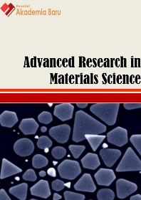
Journal homepage: www.akademiabaru.com/arms.html
ISSN: 2289-7992
Synthesis and characterization of silica ceramic membranes via sol-dip coating |  |  |  |  | Open  Access
Nor Amyra Zulianey Kahlib¹, Farah Diana Mohd Daud^{1,}∗, Maizirwan Mel², Ahmad Zahirani Ahmad Azhar¹, Noor Azlina Hassan¹

¹ | Department of Manufacturing and Materials Engineering, Kulliyyah of Engineering, International Islamic University Malaysia (IIUM), Jalan Gombak, 53100 Kuala Lumpur, Malaysia
² | Department of Biotechnology Engineering, Kulliyyah of Engineering, International Islamic University Malaysia (IIUM), Jalan Gombak, 53100 Kuala Lumpur, Malaysia
ARTICLE INFO |  |  | ABSTRACT
Article history:  Received 2 July 2016  Received in revised form 1 February 2017  Accepted 4 August 2017  Available online 13 November 2017 |  |  | The application of inorganic membrane as one of the methods for gas separation process has proven to show the greatest potential when compared to other methods. Ceramic membranes are considered as one of the many high potential inorganic membranes for this purpose. Current development of ceramic membrane focuses on the reduction of pore size for ceramic membrane up to nanometer scale without pinholes or cracking. Thus, in recent work, the silica ceramic membranes via sol dip-coating have been synthesized by using tetraethylorthosilicate (TEOS), distilled water and ethyl alcohol as sol. The influences of number of dipping have been examined. X-ray diffraction (XRD) results of the fabricated silica membrane show the presence of silica element and that each membrane possesses a periodic structure with each number of dipping. The IR adsorption from Fourier transform infrared spectrometry (FTIR) indicates the presence of functional group O-Si-O and Si-CH₃. The intensity of these functional groups increases as the dipping time increase. Field Emission Scanning Electron Microscope (FESEM) results show that the number of visible pores on the surface of the ceramic support diminished after modification of ceramic membrane, with the number of silica particles increasing linearly with number of dipping. Thus, the synthesized silica ceramic membrane with good structure and chemical properties has shown great potential for biogas separation application.
Keywords:
gas separation, ceramic membrane, sol-dip coating, number of dipping |  |  | Copyright © 2017 PENERBIT AKADEMIA BARU - All rights reserved

1. Introduction

Currently, the interest in application of membranes for various gas separation has increased significantly in term of economic importance as compared to other conventional methods. Due to the increase of environmental regulation, membranes are favorable as it reduces waste disposal expenditure and allow the recovery and recycling of the materials which results in economic advantage [1]. The CO₂ /CH₄ separation is significant in numerous developed methods such as biogas upgrading [2]. Economic and effective methods for CO₂ removal from CH₄ have concerned excessive awareness. There are three types of gas separation that have been utilized which are separation with sorbents/solvents separation by cryogenic distillation and separation with membranes. Membrane technology is an attractive alternative which deals greater economics associated to conventional separation methods. It is evaluated that the use of membranes can cut energy costs as much as 30% when related with conventional, energy exhaustive technology [3].
Membranes categories can be divided into organics, inorganics and mixed matrix membranes [4]. Inorganic membranes are membranes that are made of materials such as carbon, ceramic, zeolite, oxides silica and metals. Inorganic membranes are beneficial for CO₂ separation under simple environments. The porous inorganic membrane is favorable as they can tolerate higher temperatures and limit the connection between permeability and selectivity. Inorganic membranes can be divided into two categories, which are porous and nonporous forms which better for selectivity of gas.
Ceramic membranes are preferable because they possess the characteristics of high stability, resistance to chemical and solvents, long term durability and high mechanical strength [5-6]. Existing ceramic membranes are not suitable for most gas separation applications since their pore sizes are at least one order of-magnitude larger than the gas molecular size. Therefore, the ceramic membrane needs to fabricate with silica, which could generate uniform, mono-dispersed pore size and also responsible for its large surface area and high pore volume. Therefore, silica is a promising candidate for the ceramic membrane that will likely allow high separation efficiency and selectivity. For this reason, a strategy has been employed to fabricate ceramic membranes or porous ceramic support with silica.
Ceramic membrane can be prepared using a sol - gel process [7]. Sol-gel process is a process which involving polymerization and hydrolysis of TEOS inside solution of H₂O and alcohol [8-9]. Sol-gel process is the most practical process to prepare porous ceramic membrane as it provides many advantages such as high BET surface areas and precise pore size distribution [10]. Dip-coating is an example of sol-gel process that was widely used to fabricate ceramic membrane [11-13]. Sol-dip coating method attracts more attention to fabricate silica ceramic membrane owing to its outstanding processing stages, easiness and its potential for modification of pore structures.
In this paper, silica ceramic membrane was synthesized via sol-dip coating method at different number of dipping in silica sol and then was characterized by X-ray diffraction (XRD), Field Emission Electron Microscopy (FESEM) and Fourier transform infrared spectrometry (FTIR).

2. Experimental Research
A. Preparation of ceramic membrane

The ceramic support used was 10 inch Doulton OBE Ceramic with 32 mm, 48 mm internal and outer diameter while the support length of 200 mm. The water used throughout was distilled water. TEOS was supplied by Sigma Aldrich and nitric acid by R& M Chemical. The Ethanol also used was supplied by Systerm.
The silica will be applied to the symmetric porous ceramic supports of tubular configuration via sol dip-coating method to allow alteration of pore size in the membranes to utilize for gas separation in the permeation setup cell. In this process, TEOS, distilled water and ethyl alcohol (1:4.7:3.8 molar ratio) were mixed at 298 K. After that, acid catalyst added into the solution .Then, the ceramic candle (support) was dipped into this sol. The membrane was drying in atmosphere overnight and continued with the calcination process in a furnace, resulting in one layer membrane. The prepared membrane was calcined at 500°C with holding times of three hours. The process of dipping the support in sol and calcination was repeated one more time for second support and two more times for third support, in order to get two and three layer of membrane, respectively. There is no dipping and calcination repetition for first support.

B. Characterization

The crystal structures of supports were determined using a (XRD 6000, Shimadzu) diffractometer with Cu Kα radiation (λ=0.15406 nm) at a tube voltage of 40 kV and tube current of 30 mA. The field emission scanning electron microscope (FESEM) (JSM 6700F, JEOL) was accomplished to investigate membrane surface structure in term of appearance and changes of pore size. The SEM analysis was made on the membrane surface by cutting the membrane in smaller specimens. Fourier transform infrared spectrometry (FTIR)(Thermo Scienific) was utilized to find the fuctional group of silica ceramic membrane.

3. Results and Discussion

Figure 1 shows an XRD pattern of ceramic support using for synthesis silica ceramic membrane via sol dip-coating method. Two card number in the card data were provided at the end of the analysis for both samples, which are card number 11-0500 and 38-0448, respectively. Card number 11-0500 refers to the presence of aluminum phosphate while card number 38-0448 refers to the presence of silica. The detected reflections were solely the expected reactions from ceramic support (aluminum phosphate) and modified ceramic membrane (silica) indicating that no other phase was present in the membrane. From Figure 2, it was observed that an increase in intensity occurs as the number of dipping time increase. The increase in intensity of the silica peaks was correlated with the increase in the thickness of the silica membrane [14].
Figure 3(a) and (b) shows the surface of ceramic support at different magnification 1000x and 15000x whereas figure 4 shows the surface of silica ceramic membranes after fabrication by sol dip-coating at the different number of dipping. The FESEM analysis was applied to determine the surface morphology of the support and the modified membrane produced. From FESEM, the average pore size of the ceramic support is about 0.5 to 0.6 μm as in figure 3(b). After dipping, the pore sizes have reduced and cannot be seen clearly through FESEM. Based on FESEM analysis after the dipping, silica sol has penetrated into the pores which reduced the pore size as it covered the pore.
Figure 5 shows FTIR adsorption spectra of the fabricated membranes with different number of dipping. It was observed that the major peak is around 1060 to 1090 cm⁻¹, with a noticeable increase in peak transmittance as the number of dipping time increase. The broad absorption band in the region around 1060 to 1090 cm⁻¹ corresponds to the Si-O-Si bond of the mesoporous silica, altogether confirming the existence of silica. The modification of the Si-CH3 group on the silica membrane surface resulted in IR absorption at 791.64 cm⁻¹ [15,16]. In addition, the increase of the peak intensities in increasing dipping number indicates the increase of Si-O-Si bond as a proof of enhancement in the surface modification.
Comparison between support and membrane shows which the porosity of the membrane increase owing to increase in pore surface area. The three step dip-coating reveals an incremental deposition of a thin silica layer obtained after three numbers of dipping. The color variation between each dipping is also very discreet. The second and third dipping has a brighter presence than the first as a result of the silica. The support and the first dip are also rough in nature while the second and third dip seems flatter in nature.
The result revealed that the number of dipping in silica sol can functionally reduce pore size of ceramic support. Silica sol could generate uniform, mono-dispersed pore size. Therefore, the silica ceramic membranes are regarded as promising a candidate for biogas (CO₂/CH₄) separation applications is proposed.

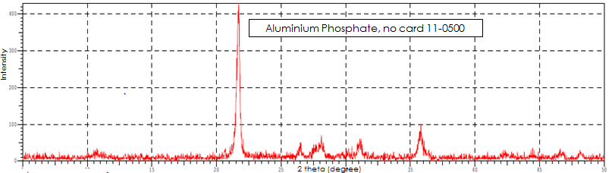
Fig. 1. XRD pattern of ceramic candle/support using for synthesis silica ceramic membrane via sol dip-coating method

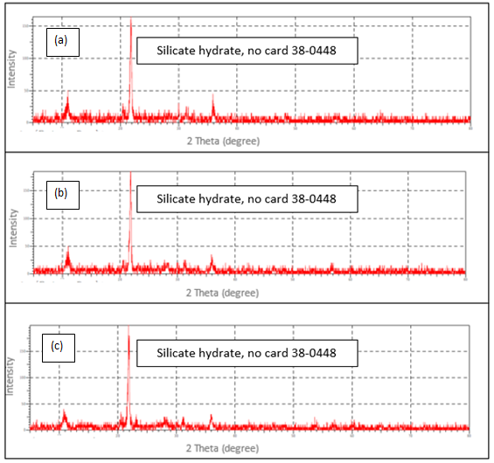
Fig. 2. XRD pattern of modified ceramic membrane via silica sol dip-coating method at different number of dipping ; a) first dipping; b) second dipping; c) third dipping

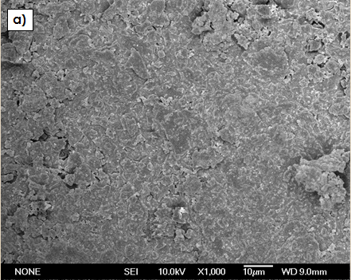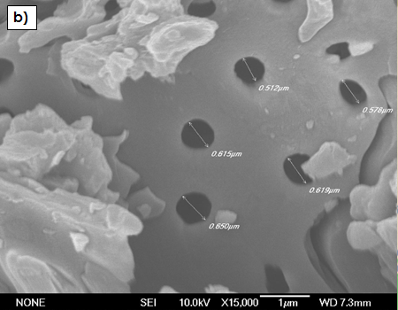
Fig. 3. FESEM images of ceramic support and modified silica ceramic membrane at the different number of dipping by sol-dip coating method

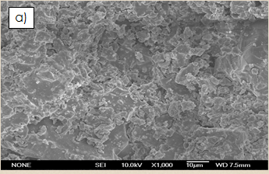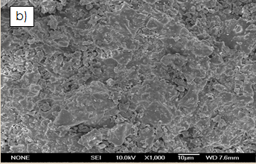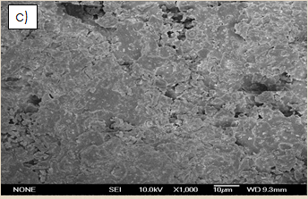
Fig. 4. FESEM images of modified silica ceramic membrane at the different number of dipping by sol-dip coating method; (a) first dipping, (b) second dipping, (c) third dipping.

4. Conclusion

As a conclusion, the preparation of modified ceramic membrane by sol dip-coating method was successfully achieved. The modified silica ceramic membrane is characterized physically and chemically. From the XRD analysis, the presence of silica after dipping was observed. It was also discovered that the highest IR adsorption is around 1060 to 1090 cm⁻¹, which indicated the presence of O-Si-O functional group. The number of dipping has affected the surface of the membrane for the rough to smooth surface. Furthermore, the pores on the surface of the ceramic candle does not appear after dipping, which proved that the silica sol have modified the ceramic support and coated the ceramic support surface.

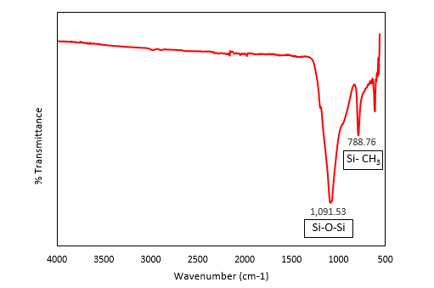
a)
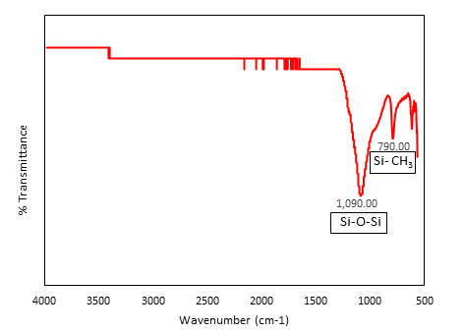
b)
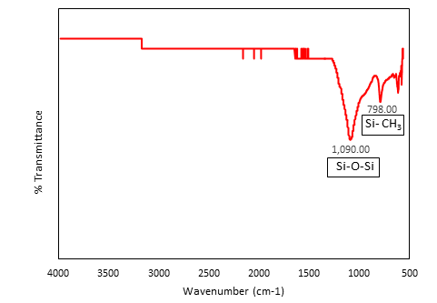
c)
Fig. 5. FTIR analysis of the modified ceramic membrane at the different number of dipping by sol-dip coating method; (a) first dipping, (b) second dipping, (c) third dipping.

Acknowledgement
The authors would like to acknowledge for the financial supports given from RIGS (RIGS15-1490149) grant from IIUM.

References
[1] Karkare, Manasi. Nanotechnology: fundamentals and applications. IK International Pvt Ltd, 2008.
[2] Othman, M. R., S. C. Tan, and S. Bhatia. "Separability of carbon dioxide from methane using MFI zeolite–silica film deposited on gamma-alumina support." Microporous and Mesoporous Materials 121, no. 1 (2009): 138-144.
[3] Shah, Miral, Michael C. McCarthy, Sonny Sachdeva, Alexander K. Lee, and Hae-Kwon Jeong. "Current status of metal–organic framework membranes for gas separations: promises and challenges." Industrial & Engineering Chemistry Research 51, no. 5 (2012): 2179-2199.
[4] Eiberger, Jan, Kai Wilkner, Corinna Reetz, Doris Sebold, Natividad Jordan, Marijke de Graaff, Wilhelm Albert Meulenberg, Detlev Stöver, and Martin Bram. "Influence of coal power plant exhaust gas on the structure and performance of ceramic nanostructured gas separation membranes." International Journal of Greenhouse Gas Control 43 (2015): 46-56.
[5] Lin, Yue‐Sheng, and Anthonie J. Burggraaf. "Preparation and Characterization of High‐Temperature Thermally Stable Alumina Composite Membrane." Journal of the American Ceramic Society 74, no. 1 (1991): 219-224.
[6] Chan, K. K., and A. M. Brownstein. "Ceramic membranes: growth prospects and opportunities." American Ceramic Society Bulletin 70, no. 4 (1991): 703-707.
[7] Tüzün, F. N., & Arçevik, E. (2010, January). Pore Modification in Porous Ceramic Membranes with Sol‐Gel Process and Determination of Gas Permeability and Selectivity. In Macromolecular symposia (Vol. 287, No. 1, pp. 135-142). WILEY‐VCH VerlagBirch J. 2012. Worldwide Prevalence of Red-green Color Deficiency. J Opt Soc Am A Opt Image Sci Vis. 29(3): 313–320.
[8] Aelion, R., A. Loebel, and F. Eirich. "Hydrolysis of ethyl silicate." Journal of the American Chemical Society 72, no. 12 (1950): 5705-5712.
[9] Dislich, Helmut, and Paul Hinz. "History and principles of the sol-gel process, and some new multicomponent oxide coatings." Journal of Non-Crystalline Solids 48, no. 1 (1982): 11-16.
[10] Akbarnezhad, Sh, Seyed Mahmoud Mousavi, and R. Sarhaddi. "Sol-gel synthesis of alumina-titania ceramic membrane: Preparation and characterization." Indian Journal of Science and Technology 3, no. 10 (2010): 1048-1051.
[11] Zhu, Jin, Yiqun Fan, and Nanping Xu. "Modified dip-coating method for preparation of pinhole-free ceramic membranes." Journal of Membrane Science 367, no. 1 (2011): 14-20.
[12] C.A Milea, C. Bogatu, A. Duta, “The influence of parameters in silica sol-gel process”, Bulletin of TheTransilvania
University of Brasov, 4(2011) :53.
[13] A. Sh, S. M. Mousavi und R. Sarhaddi, “Sol-gel synthesis of alumina-titania ceramic membrane: preparation and
Characterization.” Indian Journal of Science and Technology, 3, no. 10 (2010): 1048-1051.
[14] Tetsuro, Yalu Ma, Wakana Matsuda, Yoshitake Masuda, Mikie Nakajima, Kohei Ninomiya, Toshiharu Hiraoka, Jun-ya Fukunaga, Yusuke Daiko, and Tetsuo Yazawa. "Preparation of surface-modified mesoporous silica membranes and separation mechanism of their pervaporation properties." Desalination 280, no. 1 (2011): 139-145.
[15] Bowen, Travis C., Halil Kalipcilar, John L. Falconer, and Richard D. Noble. "Pervaporation of organic/water mixtures through B-ZSM-5 zeolite membranes on monolith supports." Journal of Membrane Science 215, no. 1 (2003): 235-247.
[16] Serrano, David P., Guillermo Calleja, Juan A. Botas, and Francisco J. Gutierrez. "Characterization of adsorptive and hydrophobic properties of silicalite-1, ZSM-5, TS-1 and Beta zeolites by TPD techniques." Separation and Purification Technology 54, no. 1 (2007): 1-9.

∗ Corresponding author. E-mail address: farah_diana@iium.edu.my (Farah Diana Mohd Daud)

