 |  | Journal of Advanced Research in Materials Science |  | 
Journal homepage: www.akademiabaru.com/arms.html
ISSN: 2289-7992
Kinetics of in SITU transesterification using waste-derived catalyst for biodiesel production |  |  |  |  | Open  Access
Sarina Sulaiman^{1,}∗, Nur Syakirah Talha¹, Siti Noor Balqis¹

¹ | Department of Biotechnology Engineering, International Islamic University Malaysia, P.O. Box 10, Kuala Lumpur 50728, Malaysia
ARTICLE INFO |  |  | ABSTRACT
Article history:  Received 2 July 2016  Received in revised form 1 February 2017  Accepted 4 August 2017  Available online 23 November 2017 |  |  | A kinetic study of in situ transesterification of solid coconut waste was conducted at 55-65°C. The mixing is kept constant at 350 rpm. The maximum conversion of 38.3% was obtained at 60°C, 1:10 solid to methanol ratio and 5 weight (wt.) % of catalyst. The feedstock was obtained after coconut milk extraction. The conversion of solid coconut waste to methyl esters was analyzed as function of temperature after 180 min of reaction. The experimental data appear to be a good fit into a pseudo first order kinetic model for the three stepwise reactions. The reaction rate constant, k and the activation energy, Ea were determined. In this study, the activation energy obtained from the experiment was 33.88 kJ/mol.
Keywords:
in situ transesterification, solid coconut waste, eggshells, biodiesel, kinetic |  |  | Copyright © 2017 PENERBIT AKADEMIA BARU - All rights reserved

1. Introduction

Reactive extraction or in situ transesterification is a process where the liquid phases are reacted and separated in the same unit [1]. The biomass is reacted directly with alcohol and a catalyst. The process generally produces biodiesel and glycerol as by product. Methanol is commonly used because it reacts the most rapidly and it is less expensive compared to other types of alcohol such as ethanol and butanol [2]. Throughout the process, alcohol acts as the extraction solvent and a reagent for the transesterification. Recently, the simplicity of the simultaneous process or hybrid has received much attention due to investment and energy cost savings [1]. Thus, reactive extraction can be used to achieve the aim of having a lower production cost and lower energy investment as the process is much simpler than the other processes available [3].
Generally, commercial biodiesel production used homogeneous base or acid catalyst. It demonstrated a very good progress in catalytic activity [4]. However, the process of separating the catalyst from biodiesel requires washing with water which results in loss of fatty acid alkyl esters (FAAE), energy consumption, and generates large amounts of waste water [5]. Moreover, arduous recovery of reactor may increase the cost of production. The heterogeneous catalyst can overcome all the problems stated as their catalytic activity will not having any major loss of FAAE, they are reusable and low in cost, making it an economical process [6, 7]. Therefore, heterogeneous catalyst is the best choice among the other catalysts to be implemented in this research.
Biodiesel is an alternative diesel fuel but it cannot be considered as primary fuel as the cost of production is high. Based on the cost analysis, 75% of biodiesel cost is derived from the feedstock, primarily crop-oil such as soybean oil, rapeseed oil and sunflower oil. Instead, in developing countries, the generation of the animal wastes, residential wastes, commercial wastes, and institutional wastes are high. Poor management of the wastes can cause environmental pollution; consequently, it becomes potential health hazards [8]. Hence, the organic wastes can be reused for the biodiesel production purpose.
In producing coconut milk, the coconut is extracted and the flesh is grated before being pressed. It will also produce byproduct which is the coconut waste. The waste still contain up to 24 wt. % of oil content. In Malaysia, 78,000 metric tons of solid coconut waste was generated by coconut oil and milk industry in 2010 and was utilized as fertilizer, feeding animals, biomass or left in the fields to decay by itself. Coconut waste can also be used for firewood or cooking fuel and coconut flour. Furthermore, in Malaysia, coconut is abundant as there are around 115,000 ha of coconut plantation in 2010 [9]. In this study, kinetics of the reactive extraction process is determined by using the pseudo first order kinetic model. Catalyst used in this study was derived from mixture of solid coconut waste and egg shell.

2. Materials and Methods
2.1 Materials

The solid coconut waste was collected from a coconut milk shop in Gombak, Malaysia. This waste was produced after the coconut milk extraction process. Meanwhile, n-Hexane and methanol (analytical grade) were purchased from Sigma Aldrich.

2.2 In-situ Transesterification

Before the reactive extraction process, solid coconut waste was dried overnight at 90˚C and then was kept in a dry cabinet for posterior use. The catalyst was prepared by mixing the solid coconut waste with the egg shells (5:1). The mixture was calcinated at 900˚C for 4 hrs in furnace. The catalyst was stored in a desiccator to avoid any moisture in the catalyst. The prepared heterogeneous base catalyst was then used for the transesterification process.
10 g of coconut waste were mixed with 100 ml of solvent, catalyst and n-hexane in the conical flask. The mixture was put on the hot plate with constant stirring for 3 hrs. Aliquots of the samples were collected every 5 minutes throughout the reaction. The reactive extraction was carried out with different catalyst concentration (1, 3 and 5 wt%) based on the experimental design for 3 hrs. Each reaction parameter was set at fixed value by which temperature at 60˚C, methanol to solid ratio (1:10) and agitation rate at 350 rpm. The mixture was poured into a separating funnel and was allowed to stand for phase separation. The top layer which was biodiesel was separated and measured. The biodiesel composition was determined using gas chromatography mass spectrometry (GC/MS) equipment.

3. Results and Discussion
3.1 In-situ Transesterification

The reactions were conducted using amount of catalyst 1, 3, and 5wt.%, while the solid to methanol ratio, temperature and stirring speed were maintained constant respectively to 1:10, 60℃ and 350 rpm. Theoretically, the yield of FAAE increases with increasing amount of catalyst. This is due to availability of more active sites by additions of larger amount of catalyst in the transesterification process (Gashaw, 2015). As shown in Figure 1, the biodiesel yield increased with the increasing of catalyst amount specifically at the first 30 min of reaction time. The reactive extraction using 1, 3, and 5wt. % catalyst amount shows 18.7, 28.2 and 37.4%, respectively.

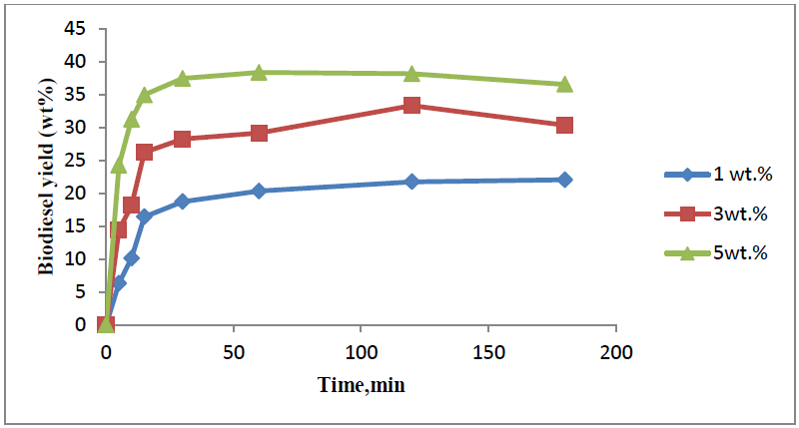
Fig. 1. Biodiesel yield as a function of time at various amount of catalyst (1, 3 and 5 wt.%)

An estimate of the order of magnitude of the reaction time scale of a system is a definition of characteristic time. The characteristic time is used to define whether the problem needs to be explained as an equilibrium problem or a kinetic problem in chemistry cases. It can be observed that in the graph, there is a characteristic period of time for which biodiesel yield in reaction mixture when it reaches 20−30% right after the fast transesterification begins. For reaction mixture containing 5 wt. % of catalyst, this characteristic time is 5 min, about 15 min for 3 wt. % and 60 min for 1wt. % of catalyst. Moreover, duration of fast process of transesterification is approximately the same either 1 wt. % of catalyst or more (3 or 5 wt. %) was used. Specifically, the biodiesel yield reached from 20−30% yield to 40% yield for about 30 min for every different amount of catalyst at 60 °C, 350 rpm and 10:1 ratio of methanol to solid.
Since the agitation speed applied is the same, thus, the results could be explained by taking into justification by two effects. First, the existence of larger amount of solid catalyst particles causes faster droplet diameter decrease. Second, the total surface of the catalyst at which the reaction takes place during the period of fast transesterification does not affect the rate of the process. Basically, the rate of transesterification is only defined by achieved interfacial area between the solid coconut waste and methanol.
In the previous studies, involving the waste frying oil (WFO), the yield increased steadily and became constant at the catalyst loading of 3.0–3.5% with the increasing amounts of catalyst. The conversion of triglycerides increased with increasing catalyst loads.
Based on a study on the reactive extraction of coconut oil, the higher concentration of catalyst, the longer time is needed to reach equilibrium biodiesel conversion. Although it took longer time to obtain the conversion, the biodiesel production is in high amount. In comparison with the results in Figure 1, the conversions are not expressively different for all sets of reactions as every catalyst concentration achieved the highest conversion after 50 min specifically at 1hr. The biodiesel conversion that is accomplished the standard biodiesel is generally 95%. Eventually, the percentage of highest biodiesel yield which is 38.3% did not reach the biodiesel standard. This could be because of the amount of samples taken for every minute were too small which is 1ml. Thus, the yield obtained was not high.

3.2 Effect of Reaction Temperature

Reactive extraction process which was conducted at various temperatures ranging from 55 to 65˚C is presented on Figure 2. The results show that the yield increases with temperature and decreases at 65˚C. Biodiesel yield at 55˚C and 60˚C were 36.7% and 37.4% at 30min, respectively. Temperature becomes the leading factor influencing the rate of transesterification reaction as the system becomes a kinetically-controlled process.

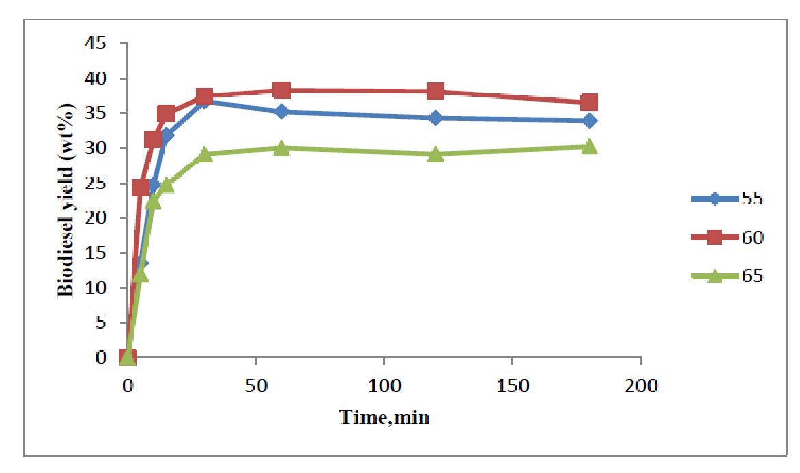
Fig. 2. Biodiesel yield as a function of time at various temperatures (55, 60 and 65°C)

As presented in the Figure 2, similar trends were observed for the graph of biodiesel yield over time at all investigated temperatures. As the temperature was increased from 55 to 60°C, the conversion rate was improved from 30 to 35.2%. The trend was also reported by Pukale et al. [10]. An increase in biodiesel yield can be achieved by increasing reaction temperature as this could be attributed to the enhanced solubility of methanol in solid phase. Thus, temperature noticeably influenced the reaction rate of biodiesel yield. In addition, further increases in the temperature above 65°C had no significant effect on biodiesel yield since methanol will be evaporate at 65°C.
In addition, after 120 min reaction time, conversions at 55, 60 and 65°C were limited to 34.3%, 38.1%, and 29.1%, respectively. These values do not signify the maximum amount of the reaction as there is a possibility, if the reaction was continued for another 2 hours, the methyl ester production would still occur. The results above illustrated that temperature conditions, order the extent and rate of 3.3 Kinetic Model
Theoretically, the thermal transesterification reaction is distributed into three steps [11]. It is found that in each reaction step one molecule of methyl ester is formed by consuming one mole of methanol within increasing of reaction time [12]. In this study, the reaction kinetics for all three reversible reactions has been considered and the rate constant for the overall reaction has been determined. In addition, all the three steps have been combined in a single step after ignoring the intermediate reaction of diglyceride (DG) and monoglyceride (MG) [11].
The fractional conversion of methyl ester XME was determined by weighing the biodiesel conversion. A linear relationship attained by fitting the data between ln (1-XME) supported the hypothesis that the reaction was of pseudo-first order. The value of reaction rate constant k, 0.0205, 0.0184 and 0.0142 was determined from the slope at different temperature which is 55, 60, and 65°C, respectively as listed in Table 1.

Table 1
Constant, k values
Temperature (ºC) | Constant k values
55 | 0.0184
60 | 0.0205
65 | 0.0142

Activation energy is the least energy an atom or molecule must possess to undergo a chemical reaction. If activation energy is huge compared to the temperature, then the reaction is slow. Meanwhile, if the temperature is greater than the activation energy, then the reaction is fast. By using the Arrhenius equation, the activation energy of transesterification reaction was obtained. The slope and intercept of the graph between ln k and 1/T give the values of activation energy. The activation energy (EA) determined from graph was 33.88 kJ/mol which is in the range with the previous study [11,13]. Table 2 shows the EA for different type of raw material done by other studies.

Table 2
Activation energy of Different Type of Raw Material
Raw Material | Activation energy (E_{A}), kJ/mol | References
Solid coconut waste | 33.88 | *This study
Soybean oil | 33.6 -84 | [13]
Palm oil | 14.7 | [14]
Waste frying oil | 79.32 | [15]
Rapeseed oil | 38.4 | [11]

4. Conclusion

The optimum temperature for this study was at 60°C with 38.3% yield of biodiesel. Further increases in the temperature above methanol evaporation point had no significant effect on biodiesel yield. The value of reaction rate constant k, 0.0205, 0.0184 and 0.0142 was determined from the slope at different temperature. From the constant k, the activation energy (EA) determined from graph was 33.88 kJ/mol. It can be concluded that in situ transesterification using waste catalysts follows the pseudo first order kinetic.

Acknowledgement
This research is funded by Ministry of Higher Education of Malaysia (MOHE) -Fundamental Research Grant 2013 (FRGS13-079-0320) and The World Academy of Sciences, TWAS-COMSTECH Research Grant_REF:15-333 RG/REN/AS_C – FR3240288948.

References
[1] Pai, Rajaram A., Michael F. Doherty, and Michael F. Malone. "Design of reactive extraction systems for bioproduct recovery." AIChE Journal 48, no. 3 (2002): 514-526.
[2] Zeng, Jianli, Xiaodong Wang, Bing Zhao, Jingcan Sun, and Yuchun Wang. "Rapid in situ transesterification of sunflower oil." Industrial & Engineering Chemistry Research 48, no. 2 (2008): 850-856.
[3] Shuit, Siew Hoong, Keat Teong Lee, Azlina Harun Kamaruddin, and Suzana Yusup. "Reactive extraction and in situ esterification of Jatropha curcas L. seeds for the production of biodiesel." Fuel 89, no. 2 (2010): 527-530.
[4] Sharma, Yogesh C., Bhaskar Singh, and John Korstad. "Latest developments on application of heterogenous basic catalysts for an efficient and eco friendly synthesis of biodiesel: a review." Fuel 90, no. 4 (2011): 1309-1324.
[5] Lam, Man Kee, Keat Teong Lee, and Abdul Rahman Mohamed. "Homogeneous, heterogeneous and enzymatic catalysis for transesterification of high free fatty acid oil (waste cooking oil) to biodiesel: a review." Biotechnology Advances 28, no. 4 (2010): 500-518.
[6] Suryaputra, Wijaya, Indra Winata, Nani Indraswati, and Suryadi Ismadji. "Waste capiz (Amusium cristatum) shell as a new heterogeneous catalyst for biodiesel production." Renewable Energy 50 (2013): 795-799.
[7] Tang, Shaokun, Hua Zhao, Zhiyan Song, and Olarongbe Olubajo. "Glymes as benign co-solvents for CaO-catalyzed transesterification of soybean oil to biodiesel." Bioresource Technology 139 (2013): 107-112.
[8] Li, Penglin, Xiaoling Miao, Rongxiu Li, and Jianjiang Zhong. "In situ biodiesel production from fast-growing and high oil content Chlorella pyrenoidosa in rice straw hydrolysate." BioMed Research International 2011 (2011).
[9] Sulaiman, Sarina, AR Abdul Aziz, and Mohamed Kheireddine Aroua. "Reactive extraction of solid coconut waste to produce biodiesel." Journal of the Taiwan Institute of Chemical Engineers 44, no. 2 (2013): 233-238.
[10] Pukale, Dipak D., Ganesh L. Maddikeri, Parag R. Gogate, Aniruddha B. Pandit, and Amit P. Pratap. "Ultrasound assisted transesterification of waste cooking oil using heterogeneous solid catalyst." Ultrasonics Sonochemistry 22 (2015): 278-286.
[11] Kusdiana, Dadan, and Shiro Saka. "Kinetics of transesterification in rapeseed oil to biodiesel fuel as treated in supercritical methanol." Fuel 80, no. 5 (2001): 693-698.
[12] Vujicic, Dj, D. Comic, A. Zarubica, R. Micic, and G. Boskovic. "Kinetics of biodiesel synthesis from sunflower oil over CaO heterogeneous catalyst." Fuel 89, no. 8 (2010): 2054-2061.
[13] Freedman, Bernard, Royden O. Butterfield, and Everett H. Pryde. "Transesterification kinetics of soybean oil 1." Journal of the American Oil Chemists' Society 63, no. 10 (1986): 1375-1380.
[14] Darnoko, D., and Munir Cheryan. "Kinetics of palm oil transesterification in a batch reactor." Journal of the American Oil Chemists' Society 77, no. 12 (2000): 1263-1267.
[15] Birla, Ashish, Bhaskar Singh, S. N. Upadhyay, and Y. C. Sharma. "Kinetics studies of synthesis of biodiesel from waste frying oil using a heterogeneous catalyst derived from snail shell." Bioresource Technology 106 (2012): 95-100.

∗ Corresponding author. E-mail address: sarina@iium.edu.my (Sarina Sulaiman)

