 |  | Journal of Advanced Research in Materials Science |  | 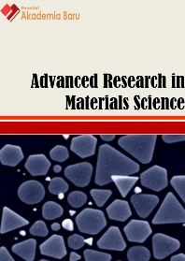
Journal homepage: www.akademiabaru.com/arms.html
ISSN: 2289-7992
Radiation protection, design safety and material aspects of nuclear power plants: A review |  |  |  |  | Open  Access
Muhd Adil Khattak^{1,}∗, Abdul Hakim Ali¹, Muhammad Firdaus Talhah¹, Fakruddin Mustakim Alisah¹, Chin Kim Wei¹, Rustam Khan², Sajjad Tahir²
¹ | Department of Nuclear Engineering, Faculty of Chemical Engineering Universiti Teknologi Malaysia, 81310 Skudai Johor, Malaysia
² | Department of Nuclear Engineering, Pakistan Institute of Engineering and Applied Sciences, Islamabad, 44000, Pakistan
ARTICLE INFO |  |  | ABSTRACT
Article history:  Received 12 August 2017  Received in revised form 9 November 2017  Accepted 13 November 2017  Available online 19 November 2017 |  |  | Human witnessed the disastrous effect of radiation on human with the first demo of nuclear weapon on Hiroshima and Nagasaki by the “Little Boy” and “Fat Man”. Radiation effect coming from the reactor was first exhibited by the RMBK in Chernobyl. During this phenomenon, the effect of radiation overdose on human was relatively more obvious as many victims did not die instantaneously, instead were affected gravely by the acute leaked radiation. These events prompted the setting of the standard of radiation limit allowed and the studying of radiation effect on human. There are generally two main scopes of radiation protection will be studied, namely the radiation safety aspects in the systems design and standard procedure of radiation worker. At every nuclear station in the country, radiation protection (RP) teams work daily to control and reduce the amount of occupational radiation exposure workers receive while performing various jobs in the plant. Radiation is a natural part of our environment and we all receive small amounts of radiation from the sun, the soil and the food we eat. There are two concerns mainly associated with radionuclides, namely contamination levels and radiation exposure rate. Permissible exposure limits (PEL) for radiation workers works to mitigate any possible accident risks that would ruin the mission progress and limiting chronic risks to as low as reasonable acceptable level (ALARA).
Keywords:
Radiation protection, dose limit, contamination levels, radiation exposure rate, ALARA 1.0 |  |  | Copyright © 2017 PENERBIT AKADEMIA BARU - All rights reserved

1. Introduction

The first display of how disastrous radiation effect can be on human was the “Little Boy” and “Fat Man” on Hiroshima and Nagasaki. The effect was monstrously overwhelming [1]. Radiation effect coming from the reactor was first exhibited by the RMBK in Chernobyl, Russia. During this phenomenon, the effect of radiation overdose on human was relatively more obvious as many victims did not die instantaneously, instead were affected gravely by the acute leaked radiation [2]. These events prompt the setting of the standard of radiation limit allowed and the studying of radiation effect on human. The earliest limits were based on avoiding budding of obvious effects as skin ulcerations that appeared after exposure to intense radiation [3]. Figure 1 shows the public exposure to natural radiation.

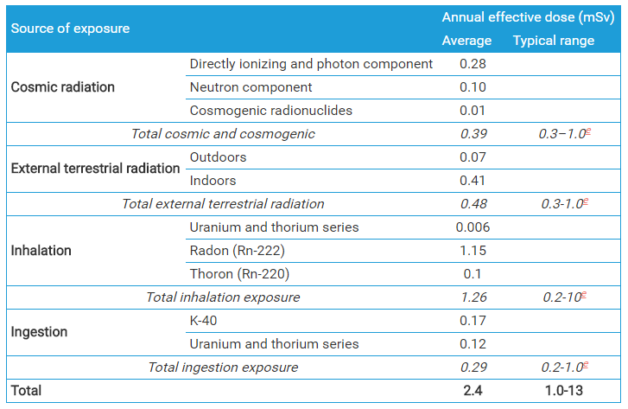
Fig. 1. Public exposure to natural radiation [2]

There are generally two main scopes of radiation protection, namely the radiation safety aspects in the systems design and standard procedure of radiation worker [4]. Radiation is a natural part of our environment and we all receive small amounts of radiation from the sun, the soil and the food we eat [5]. Nuclear station workers receive additional exposure, but you may be surprised at just how little. Radiation is measured in units called rems and millirems. The rem is a unit of measure that considers the effect of different types of radiation have on the body. A millirem is 1/1000th of a rem [6]. The Nuclear Regulatory Commission (NRC) allows up to 5,000 mrem of exposure annually for nuclear workers [7]. Duke Energy’s annual limit of 2,000 mrem is less than half of the federal limit. Scientists have observed no health effects from doses of radiation below 10,000 mrem [8]. In the nuclear industry, keeping radiation as low as reasonably achievable (ALARA) has become a basic tenet of plant operations [9]. In fact, radiation exposure for nuclear workers has trended down over the years largely due to training, technology and a constant emphasis on reducing sources of radiation in the plant. Sophisticated monitoring equipment located in certain areas of the plant provides real-time information on radiation levels. During pre-work planning, this information is used to help determine the most efficient approach to completing the work while minimizing worker exposure to radiation [10]. Special mockups of plant equipment such as valves and pumps are used to practice work activities so that workers spend less time and receive less exposure when performing the actual job. Each plant employee wears an electronic “dosimeter” that provides immediate information on their exposure. Time, distance and shielding represent the fundamentals of radiation protection. Through good planning and efficient work practices, the amount of time a worker spends in a radiation area can be reduced [11].
The issues related to the radiation protection of worker is mostly ethical problems of workers [10]. Some of the worker lack of professional knowledge and competency in working as well as working on task beyond abilities [13]. Some of the worker compromise public welfare and safety in favor of an employer's interest. Some of the statements of the worker lack of scientific basis [14]. Sensational and unwarranted statements of others concerning radiation and radiation protection shall be corrected by the worker truly. The worker shall protect the sources of confidential communications, provided that such protection is not in itself unethical or illegal [15]. So, a standard procedure of radiation protection for worker shall be strictly followed to ensure the optimization of radiation protection [16].
The standard procedure includes such as the guidance of the RPO and RPS ought to be looked for before new procedures are introduced or major changes are made to existing procedures [17]. New or changed procedures should be rehearsed, where possible, without using radioactive materials; radioactive materials should be received, handled, and stored at the specifically designated controlled location [18]. Vessels containing radioactive materials should be labelled with the radionuclide name, chemical form, activity, and date and time of calibration, and should be properly shielded while in use and in storage [19]. Working procedures should be designed to prevent spills, and in the event of a spillage, to minimize the spread of contamination.
In safety aspect of design, material choice is imperative for shielding. The generation and spreading of radioactive substances at a nuclear facility shall be restricted in accordance with the radiation protection optimization principle [20]. The corrosion, activation and migration of substances significantly affecting occupational dose shall be kept low by the choice of materials and structural designs, surface treatment as well as water chemistry and purification systems design [21]. Attention shall be paid to the components, systems, welded seam materials, and sealing of the primary circuit of a nuclear power plant that contacted with the coolant. Special attention shall be paid to the reactor core structures. The use of materials having a low nickel, cobalt, silver and antimony content helps prevent the formation of the activation products 58Co, 60Co, 110mAg and 124Sb in particular [22].
Parts and components of systems containing radioactive substances shall be located, as far as possible, in rooms such that workers are not unnecessarily exposed to radiation when operating, inspecting, maintaining and repairing them [23]. Parts of systems containing considerable amounts of radioactive substances usually shall be placed in rooms of their own. Pipelines containing radioactive liquids shall be located away from clean piping and at a sufficient distance from components requiring maintenance [24]. Systems and components shall be designed and located such that the number of work phases performed while exposed to a high dose rate is small and of short duration. Control, measuring, monitoring and auxiliary equipment shall be located away from components containing radioactive substances and in a separate room or a shielded area. In designing and dimensioning rooms for components and systems, the necessary testing, maintenance, measurements, inspections and repairs shall be taken into account [25].
There are several elements to be considered for radiation protection such as the experience at relevant plants (that has kept a decent operating record in terms of radiation safety), assessment of materials for primary circuit, burn-up and type of fuel, accident conditions, radiation protection for members of public or site personnel [24]. There are two concerns mainly associated with radionuclides, namely contamination levels and radiation exposure rate [27]. Permissible exposure limits (PEL) is indispensable in the standard of dose limit. For instance, PEL for astronauts works to mitigate any possible in-flight risks that would ruin the mission progress and limiting chronic risks to as low as reasonable acceptable level (ALARA) [28].
Design for shielding at the core of a reactor, say, a thermal reactor, is mostly associated with gamma radiation. The aspects that are required to be studied are fission, decay of fission products, capture processes in fuel, poison and other material, inelastic scattering in the fuel and decay of capture products [29]. According to the IAEA Standards in the design of the core of nuclear power plant (NPP), there are several safety considerations that need to be considered such as thermal and burnup effects, irradiation effects, variation in power levels effects, mechanical effects in fuel element, burnable poison effects in the fuel, corrosion and hydrating of fuel elements, and thermal-hydraulics effects in fuel assemblies [30]. In conclusion, reactor shielding is designed to minimize radiation exposure to personnel [31].
The reactor power can be used to relate to collective dose limit too. The number of MW-years of electricity generated can be used to determine the ratio of the average value of the annual collective dose (TEDE) to the number of MW-years of electricity generated. The ratio can be a measure of the dose incurred by radiation workers at NPP [32].

2. Discussion
2.1 Radiation Protection

Radiation sources throughout the plant shall be comprehensively identified, and exposures and radiation risks associated with them shall be kept as low as reasonably achievable [28], the integrity of the fuel cladding shall be maintained, and the generation and transport of corrosion products and activation products shall be controlled. Materials used in the manufacture of structures, systems and components shall be selected to minimize activation of the material as far as is reasonably practicable. For the purposes of radiation protection, provision shall be made for preventing the release or the dispersion of radioactive substances, radioactive waste and contamination at the plant.
The plant layout shall be such as to ensure that access of operating personnel to areas with radiation hazards and areas of possible contamination is adequately controlled, and that exposures and contamination are prevented or reduced by this means and by means of ventilation systems. The plant shall be divided into zones that are related to their expected occupancy, and to radiation levels and contamination levels in operational states (including refueling, maintenance and inspection) and to potential radiation levels and contamination levels in accident conditions. Shielding shall be provided so that radiation exposure is prevented or reduced.
The plant layout shall be such that the doses received by operating personnel during normal operation, refueling, maintenance and inspection can be kept as low as reasonably achievable, and due account shall be taken of the necessity for any special equipment to be provided to meet these requirements. Plant equipment subject to frequent maintenance or manual operation shall be located in areas of low dose rate to reduce the exposure of workers. Facilities shall be provided for the decontamination of operating personnel and plant equipment.

2.2 Definition of Safe Design
Safe design means the integration of control measures early in the design process to eliminate or, if this is not reasonable practicable, minimize risks to health and safety throughout the life of the plant being designed.
The safe design of any type of plant will always be part of a wider set of design objectives, including practicability, aesthetics, cost and functionality. These objectives need to be balanced in a manner that does not compromise the health and safety of those potentially affected by the plant over its life.
Safe design begins at the concept development phase when choices are made about design, materials used and methods of manufacture. Safer plant will be created when hazards and risks that could impact on downstream users over the lifecycle are eliminated or minimized during design and before manufacture. In these early phases there is greater scope to design-out hazards or incorporate risk control measures that are compatible with the original design concept and functional requirements of the product.
2.3 Defense in Depth
To achieve optimum safety, all the nuclear plants in the worldwide operate using a 'defense-in-depth' approach, with multiple safety systems supplementing the natural features of the reactor core. Key aspects of the approach are:

- high-quality design & construction,
- equipment which prevents operational disturbances or human failures and errors developing into problems,
- comprehensive monitoring and regular testing to detect equipment or operator failures,
- redundant and diverse systems to control damage to the fuel and prevent significant radioactive releases,
- provision to confine the effects of severe fuel damage (or any other problem) to the plant itself.

The safety provisions include a series of physical barriers between the radioactive reactor core and the environment, the provision of multiple safety systems, each with backup and designed to accommodate human error. Safety systems account for about one quarter of the capital cost of such reactors. As well as the physical aspects of safety, there are institutional aspects which are no less important.
The barriers in a typical plant are: the fuel is in the form of solid ceramic (UO2) pellets, and radioactive fission products remain largely bound inside these pellets as the fuel is burned. The pellets are packed inside sealed zirconium alloy tubes to form fuel rods. These are confined inside a large steel pressure vessel with walls up to 30 cm thick – the associated primary water cooling pipework is also substantial. All this, in turn, is enclosed inside a robust reinforced concrete containment structure with walls at least one meter thick. This amounts to three significant barriers around the fuel, which itself is stable up to very high temperatures.
These barriers are monitored continually. The fuel cladding is monitored by measuring the amount of radioactivity in the cooling water. The high-pressured cooling system is monitored by the leak rate of water, and the containment structure by periodically measuring the leak rate of air at about five times atmospheric pressure. Looked at functionally, the three basic safety functions in a nuclear reactor are:

- to control reactivity,
- to cool the fuel and
- to contain radioactive substances.

The main safety features of most reactors are inherent - negative temperature coefficient and negative void coefficient. The first means that beyond an optimal level, as the temperature increases the efficiency of the reaction decreases (this in fact is used to control power levels in some new designs). The second means that if any steam has formed in the cooling water there is a decrease in moderating effect so that fewer neutrons are able to cause fission and the reaction slows down automatically.
In the 1950s and 1960s some experimental reactors in Idaho were deliberately tested to destruction to verify that large reactivity excursions were self-limiting and would automatically shut down the fission reaction. These tests verified that this was the case.
Beyond the control rods which are inserted to absorb neutrons and regulate the fission process, the main engineered safety provisions are the back-up emergency core cooling system (ECCS) to remove excess heat (though it is more to prevent damage to the plant than for public safety) and the containment.
Traditional reactor safety systems are 'active' in the sense that they involve electrical or mechanical operation on command. Some engineered systems operate passively for example, pressure relief valves. Both require parallel redundant systems. Inherent or full passive safety design depends only on physical phenomena such as convection, gravity or resistance to high temperatures, not on functioning of engineered components. All reactors have some elements of inherent safety as mentioned above, but in some recent designs the passive or inherent features substitute for active systems in cooling. Such a design would have averted the Fukushima accident, where loss of electrical power resulted is loss of cooling function.
The basis of design assumes a threat where due to accident or malign intent (i.e. terrorism) there is core melting and a breach of containment. This double possibility has been well studied and provides the basis of exclusion zones and contingency plans. Apparently during the Cold War neither Russia nor the USA targeted the other's nuclear power plants because the likely damage would be modest. Nuclear power plants are designed with sensors to shut them down automatically in an earthquake, and this is a vital consideration in many parts of the world.

2.4 Materials Challenges for Nuclear Systems

The safe and economical operation of any nuclear power system relies to a great extent, on the success of the fuel and the materials of construction. During the lifetime of a nuclear power system which currently can be as long as 60 years, the materials are subject to high temperature, a corrosive environment, and damage from high-energy particles released during fission.

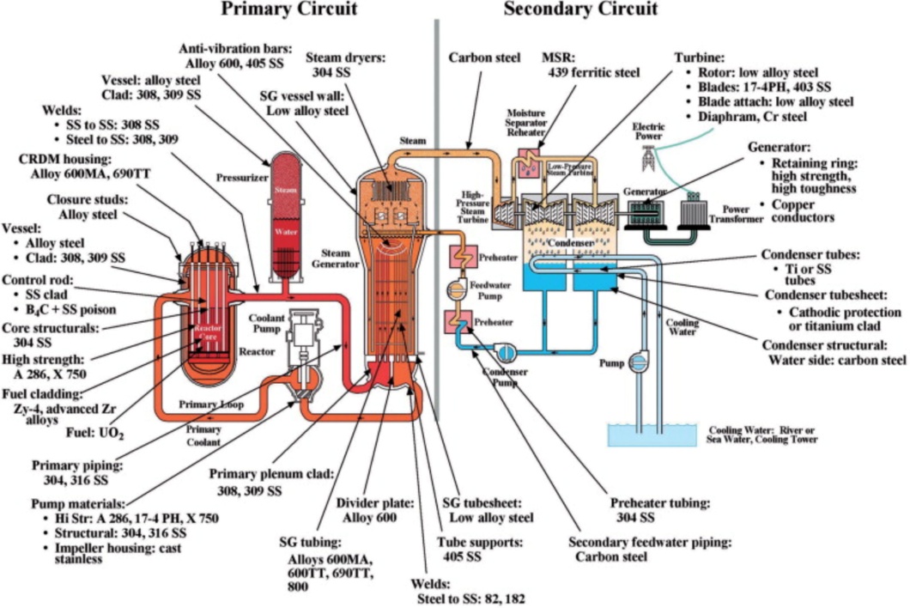
Fig. 2. Outline of PWR Components and Materials
Successful operation of current light water reactors and implementation of advanced nuclear energy systems is strongly dependent on the performance of fuels and materials. A typical Light Water Reactor (LWR) contains numerous types of materials (Fig. 2) that must all perform successfully.

2.5 Safety Mechanisms of a Nuclear Power Reactor

By regulation, the design of the nuclear reactor must include provisions for human (operator) error and equipment failure. Nowadays, almost all Nuclear Plants in the worldwide use a "Defense in Depth" concept which is a system with multiple safety components, each with back-up and design to accommodate human error. The components include;

2.5.1 Control of radioactivity
The control of reactivity should be designed in such a manner that it enables the power le el and the power distribution to be maintained within safe operating limits [30]. Many factors that affect the reactivity should be considered such as those associated with normal power transient, changes in xenon and boron concentrations, temperature coefficients effects, rate of flow of coolant or changes in temperature, the depletion of fuel and of burnable poison, as well as cumulative poisoning by fission products [30]. The means of control of reactivity includes the use of solid neutron absorber rods and blades, soluble absorber in the moderator or coolant, control of the coolant flow (moderator density), fuel with distributed or discrete burnable poison, control of the moderator temperature and height, liquid absorber in tubes, batch refueling and loading pattern and on-load refueling [30].
Control of reactivity requires being able to control the neutron flux. If we decrease the neutron flux, we decrease the radioactivity. The most common way to reduce the neutron flux is including neutron-absorbing control rods. These control rods can be partially inserted into the reactor core to reduce the reactions. The control rods are very important because the reaction could run out of control if fission events are extremely frequent. In modern nuclear power plants, the insertion of all the control rods into the reactor core occurs in a few seconds, thus halting the nuclear reaction as rapidly as possible. In addition, most reactors are designed so that beyond optimal level, as the temperature increases the efficiency of reactions decreases, hence fewer neutrons can cause fission and the reactor slows down automatically.

2.5.2 Maintenance of core cooling
In any nuclear reactor, some sort of cooling is necessary. Generally nuclear reactors use water as a coolant. However, some reactors which cannot use water use sodium or sodium salts.
The coolant should be physically and chemically stable with respect both to high temperatures and to nuclear irradiation to fulfil its primary function – the continuous removal of heat from the core. Safety considerations associated with the coolant should include the following: (a) Ensuring that the coolant system is free of foreign objects and debris prior to the initial startup of the reactor and for the operating lifetime of the plant; (b) Keeping the activity of the coolant at an acceptably low level by means of purification systems and the removal of defective fuel as appropriate; (c) Taking into account the effects on reactivity of the coolant and coolant additives4 and in particular the effects in determining the capabilities of the reactor control system and shutdown systems for operational states and design basis accidents; (d) Determining and controlling the physical and chemical properties of the coolant in the core to ensure compatibility with other components of the reactor core, and minimizing corrosion and contamination of the reactor coolant system; (e) Ensuring a sufficient supply of coolant for operational states and in design basis accidents; (f) Ensuring that the core is designed to prevent or control flow instabilities and consequent fluctuations in reactivity [30].

2.5.3 Maintenance of barriers that prevent the release of radiation

In design of shielding, it is imperative to know the energy released in the form of gamma radiation and its spatial distribution in reactor shielding design studies [29]. The gamma radiation sources can be studied are prompt fission, fission product, uranium capture, U-238 inelastic scattering, capture in poison, construction materials and moderator as well as disintegration of capture products [29].
Radiation shielding is focused at the design, fabrication, testing, and insertion of multi-functional materials that can serve as structural materials of space vehicles and habitats while providing necessary radiation shielding for the crew and systems. The design of radiation shields used to attenuate radiation from any radioactive source de pends upon the location, intensity, energy distribution of the sources, and permissible radiation levels at positions away from these sources. Different materials exhibit different abilities to shield against different radiation types. This section summarizes the computational survey study developed to evaluate the various materials that would provide best attenuation with the smallest mass penalty to the overall weight of the space craft. The study includes a brief theoretical analysis proceeded with the design area obtained from two-dimensional computational analysis based on COG, MCNP5 and/or MCNPX Monte Carlo codes. The computational model consists of an infinite slab exposed to a planar monenergistic source of individual radiation types, see Figure 2.
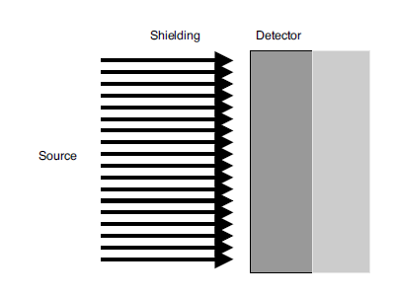
Fig. 2. Two-dimensional shielding model [11]

Theoretical consideration. The most effective materials to shield against protons are listed in table 1. Taking the density into consideration, only polyethylene (PE), aluminum, iron, and hydrogen are potential candidates for the shielding design. Other materials of interest (to attenuate high energy alpha, HZE or neutrons) are various types of PE (PE with boron or lithium), and nano-carbon fibers.

Table 1
Materials effective in shielding against energetic protons
Material | Z | Density  (gcm⁻²)
Lead | 82 | 11.37
Graphite | 12 | 1.70
Iron | 26 | 7.90
Tin | 50 | 7.30
Tungsten | 74 | 19.35
Polyethylene | - | 0.95
Hydrogen | 1 | 0.07
Aluminium | 13 | 2.71
Paraffin wax | - | 0.93
Mylar | - | 1.40

Figure 3 shows a linear proton range for various materials as a function of incoming proton energy. Lead, polyethylene and iron all demonstrate similar shielding efficiency at energies between 100 and 200 MeV. The shortest distances that the pro ton can travel are observed to take place in lead and iron, with ranges of 1 to 40 cm.PE is the next most effective shielding material, with proton ranges from 5 cm up to 100 cm in the analyzed energy region.

Fig. 3. Linear CSDA range1 of protons vs. energy for PE, H, Pb, Al, and Fe [19]
There is a series of physical barriers between the radioactive core and the environment. For instance, at the Darling Nuclear Generation Station in Canada the reactors are enclosed in heavily reinforced concrete which is 1.8m thick. Workers are shielded from radiation via interior concrete walls. A vacuum building is connected to the reactor buildings by a pressure relief duct. The vacuum building is a 71m high concrete structure and is kept at negative atmospheric pressure. This means that if any radiation were to leak from the reactor it would be sucked into the vacuum building and therefore prevented from being released into the environment.
The design of the reactor also includes multiple back-up components, independent systems (two or more systems performing the same function in parallel), monitoring of instrumentation and the prevention of a failure of one type of equipment affecting any other. Further, regulation requires that a core-meltdown incident must be confined only to the plant itself without the need to evacuate nearby residence. Safety is also important for the workers of nuclear power plants. Radiation doses are controlled via the following procedures:

- The handling of equipment via remote in the core of the reactor
- Physical shielding
- Limit on the time a worker spends in areas with significant radiation levels
- Monitoring of individual doses and of the work environment
- The ICRP recommends that the maximum permissible dose for occupational exposure should be 20 millisievert per year averaged over five years (i.e. 100 millisievert in 5 years) with a maximum of 50 millisievert in any one year. For public exposure, 1 millisievert per year averaged over five years is the limit. In both categories, the figures are over and above background levels, and exclude medical exposure.
There are four ways in which people are protected from identified radiation sources:

- Limiting time: In occupational situations, dose is reduced by limiting exposure time.
- Distance: The intensity of radiation decreases with distance from its source.
- Shielding: Barriers of lead, concrete or water give good protection from high levels of penetrating radiation such as gamma rays. Intensely radioactive materials are therefore often stored or handled under water, or by remote control in rooms constructed of thick concrete or lined with lead.
- Containment: Highly radioactive materials are confined and kept out of the workplace and environment. Nuclear reactors operate within closed systems with multiple barriers which keep the radioactive materials contained.

2.5.4 Radiation protection standards

There are three general guidelines for controlling exposure to ionizing radiation: minimizing exposure time, maximizing distance from the radiation source, shielding yourself from the radiation source. Out of the STD concepts, the latter two (Time and Distance) are more related to human factor. Besides that, ALARA (As Low As Reasonably Achievable) is a very important safety principle designed to minimize radiation doses and releases of radioactive materials. More than merely best practice, ALARA is predicated on legal dose limits for regulatory compliance, and is a requirement for all radiation safety programs. The ALARA concept is an integral part of all activities that involve the use of radiation or radioactive materials and can help prevent unnecessary exposure as well as overexposure. The three major principles to assist with maintaining doses “As Low As Reasonably Achievable” are time, distance and shielding.
Following the ICRP-60 recommendations published in 1991, the NHMRC and the National Health & Safety Commission jointly prepared new Australian Recommendations for limiting exposure to ionizing radiation and a National Standard for limiting occupational exposure. These are consistent with the Basic Safety Standards for radiation protection adopted in 1994 by various UN agencies. The revised occupational exposure limit is 20 millisieverts per year averaged over five consecutive years. (Exposure limits for members of the public from radiation-related activities remained at 1 mSv per year, which is less than the average radiation background from the environment.) These NHMRC recommendations were incorporated in the revised code in 2005.
Radiation protection standards are based on the conservative assumption that the risk is directly proportional to the dose, even at the lowest levels, though there is no actual evidence of harm at low levels, below about 100 mSv as short-term dose. To the extent that cell damage is made good within a month (say), chronic dose rates up to 100 mSv per month could also be safe, but the standard assumption, called the 'linear no-threshold (LNT) hypothesis', discounts the contribution of any such thresholds and is recommended for practical radiation protection purposes only, such as setting allowable levels of radiation exposure of individuals.
LNT was first accepted by the International Commission on Radiological Protection (ICRP) in 1955, when scientific knowledge of radiation effects was less, and then in 1959 by the United Nations Scientific Committee on the Effects of Atomic Radiation (UNSCEAR) as a philosophical basis for radiological protection at low doses, stating outright that “Linearity has been assumed primarily for purposes of simplicity, and there may or may not be a threshold dose”. (Above 100 mSv acute dose there is some scientific evidence for linearity in dose-effect.) From 1934 to 1955 a tolerance dose limit of 680 mSv/yr. was recommended by the ICRP, and no evidence of harm from this – either cancer or genetic – had been documented.
The LNT hypothesis cannot properly be used for predicting the consequences of an actual exposure to low levels of radiation and it has no proper role in low-dose risk assessment. This would be very misleading if applied to a large group of people exposed to trivial levels of radiation and even at levels higher than trivial it could lead to inappropriate actions to avert the doses. At Fukushima following the March 2011 accident, maintaining the evacuation beyond a few days did in fact lead to about 1100 deaths, according to the Japan Reconstruction Agency ^{[34]}.
Much of the evidence which has led to today's standards derives from the atomic bomb survivors in 1945, who were exposed to high doses incurred in a very short time. In setting occupational risk estimates, some allowance has been made for the body's ability to repair damage from small exposures, but for low-level radiation exposure the degree of protection from applying LNT may be misleading. At low levels of radiation exposure, the dose-response relationship is unclear due to background radiation levels and natural incidence of cancer. However, the Hiroshima survivor data published in 1958 by UNSCEAR for leukemia (see Appendix) actually shows a reduction in incidence by a factor of three in the dose range 1 to 100 mSv. The threshold for increased risk here is about 400 mSv. This is very significant in relation to concerns about radiation exposure from contaminated areas after the Chernobyl and Fukushima accidents. Figure 4 shows the cumulative reactor years of operation of Three Mile Island (TMI), Chernobyl and Fukushima [35].

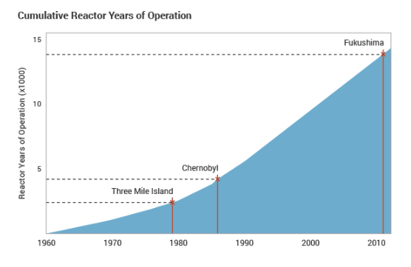
Fig. 4. Cumulative reactor years of operation of TMI, Chernobyl and Fukushima [2]
The International Commission on Radiological Protection (ICRP), set up in 1928, is a body of scientific experts and a respected source of guidance on radiation protection, though it is independent and not accountable to governments or the UN. Its recommendations are widely followed by national health authorities, the EU and the IAEA. It retains the LNT hypothesis as a guiding principle. The International Atomic Energy Agency (IAEA) has published international radiation protection standards since 1962. It is the only UN body with specific statutory responsibilities for radiation protection and safety. Its Safety Fundamentals are applied in basic safety standards and consequent Regulations. However, the UN Scientific Committee on the Effects of Atomic Radiation (UNSCEAR) set up in 1955 is the most authoritative source of information on ionizing radiation and its effects [36].
In any country, radiation protection standards are set by government authorities, generally in line with recommendations by the ICRP, and coupled with the requirement to keep exposure as low as reasonably achievable (ALARA) – taking into consideration social and economic factors. The authority of the ICRP comes from the scientific standing of its members and the merit of its recommendations. The three key points of the ICRP's recommendations are:

- Justification. No practice should be adopted unless its introduction produces a positive net benefit.
- Optimization. All exposures should be kept as low as reasonably achievable, economic and social factors being taken into considerations.
- Limitation. The exposure of individuals should not exceed the limits recommended for the appropriate circumstances.

According to the STUK studies, radiation safety aspects in the system design of a nuclear power plant can be viewed in 1) individual components and components, 2) pipelines, 3) drainage and leak collection systems, 4) treatment of resins and concentrates, and 5) special systems for reducing releases [34]. The individual systems and components shall be designed with as few work stages at high dose rate and as short duration as possible. The pipelines shall be designed so that the number of necessary vent and drain lines is as small as possible. The floor drainage system shall serve the purpose of preventing flooding on the room floors while considering variations in the room pressure and temperature. The waste (resin) treatment systems shall provide provision for any possible leakage and quick detection of leakage. A special system that can identify the release paths of radioactive substances and is efficient in collecting and decontaminating radioactive materials shall be considered in the safety design aspect [37].

3. Conclusion

Broadly speaking, quality assurance in design of a nuclear facility must be ensured to mitigate any possible harms to the members of public or radiation workers. For instances, the fabrication process of the equipment and high engineering compatible design are of utmost importance in the design aspect, no matter the core or the turbine island [30]. Simulations by computer work prior to the real construction is also indispensable and that involves the assessment of computer codes and related methods for safety analysis [30]. Therefore, this procedure would be used in design nuclear reactors to minimize the radiation exposure to the workers, civilians and environment.
We can conclude that any design of any nuclear power plant must ensure that the following will not occur – prevention of functioning of components of safety systems (i.e. shutdown devices and their guide tubes), impeding cooling of the core as well as causing unacceptable mechanical or thermal damage to the pressure boundary of the reactor coolant [30].

References
[1] http://www.atomicheritage.org/history/bombings-hiroshima-and-nagasaki-1945
[2] http://www.world-nuclear.org/information-library/safety-and-security/safety-of-plants/chernobyl-accident.aspx
[3] Los Alamos Science, “A Brief History of Radiation”, Los Alamos Science, Number 23, 1995.
[4] Shirvan, Koroush, and Eric Forrest. "Design of an Organic Simplified Nuclear Reactor." Nuclear Engineering and Technology 48, no. 4 (2016): 893-905.
[5] Get the Facts on Radiation, https://nuclear.duke-energy.com/2011/05/19/get-the-facts-on-radiation/
[6] Radiation Protection for Nuclear Employees, https://nuclear.duke-energy.com/2012/08/21/radiation-protection-for-nuclear-employees
[7] United States Nuclear Regulatory Commission, Information for Radiation Workers, https://www.nrc.gov/about-nrc/radiation/health-effects/info.html.
[8] IAEA, “Radiation Protection Aspects of Design for Nuclear Power Plants, Safety Guide, Safety Standards Series No. NS-G-1.13”, IAEA, 2005.
[9] Environmental Health & Safety Center Radiation Safety Division, Radiation Safety and ALARA.
[10] Common Myths About Nuclear Energy, https://joshuakleindukeenergy.wordpress.com/tag/radiation/, June 12, 2013.
[11] Radiation Shielding, Advances in Food Engineering http://moreira.tamu.edu/BAEN625/TOC_files/Chapt10.pdf
[12] Advisory Committee on Human Radiation Experiments, “Interim report of the Advisory Committee on Human Radiation Experiments”, Washington, DC; 1994.
[13] Lindell, B., “Ethical and social issues in risk management. In: Shinn, R. L. ed. Faith and science in an unjust world”, report of the World Council of Churches' Conference on Faith, Science and the Future. Vol. 1: Plenary presentations. Geneva: World Council of Churches; 1980:105-115.
[14] Lochard, J., and M. C. Boehler. "Optimising Radiation Protection–the ethical and legal bases." Nuclear Law Bulletin52 (1993): 9-28.
[15] Baram, Michael S. "THE USE OF COST‐BENEFIT ANALYSIS IN REGULATORY DECISION‐MAKING IS PROVING HARMFUL TO PUBLIC HEALTH." Annals of the New York academy of sciences 363, no. 1 (1981): 123-128.
[16] Maxey, Margaret N. "Radiation risks: the ethics of health protection." In Radiation protection practice. 1988.
[17] International Commission on Radiological Protection Recommendations of the ICRP: ICRP Publication No. 1. New York, Pergamon, 1959.
[18] ICRP Publication 75, “General Principles for the Radiation Protection of Workers. The International Commission on Radiological Protection”, Pergamon Press 1997.
[19] IAEA, “Radiation Protection and Safety of Radiation Sources: International Basic Safety Standards, No. GSR Part 3 (Interim)”, Vienna 2011.
[20] Deeley, T.J., THREE - Developments, in Principles of Radiation Therapy. 1976, Butterworth-Heinemann. p. 12-19.
[21] Cattant, François, Didier Crusset, and Damien Féron. "Corrosion issues in nuclear industry today." Materials today11, no. 10 (2008): 32-37.
[22] Allen, Todd, Jeremy Busby, Mitch Meyer, and David Petti. "Materials challenges for nuclear systems." Materials today13, no. 12 (2010): 14-23.
[23] Field, Kevin G., I. Remec, and Y. Le Pape. "Radiation effects in concrete for nuclear power plants–Part I: Quantification of radiation exposure and radiation effects." Nuclear Engineering and Design 282 (2015): 126-143.
[24] Shahrokhi, Amin, Tamás Vigh, Csaba Németh, Anita Csordás, and Tibor Kovács. "Radon measurements and dose estimate of workers in a manganese ore mine." Applied Radiation and Isotopes 124 (2017): 32-37.
[25] Kim, Tae-Ryong. "Safety Classification of Systems, Structures, and Components for Pool-Type Research Reactors." Nuclear Engineering and Technology 48, no. 4 (2016): 1015-1021.
[26] Celso Osimani, “Radiation Protection in Nuclear Power Plants”, JRC-Ispra, Italy, Nov. 2014.
[27] RSSC Radiation Protection, “Chapter 3: Radiation Protection”, RSSC Radiation Protection, July 2011.
[28] Francis A. Cucinotta, “Radiation Risk Acceptability and Limitations”, NASA, Dec. 2010.
[29] Roos, Matts. "Sources of gamma radiation in a reactor core." Journal of Nuclear Energy. Part B. Reactor Technology 1, no. 2 (1959): 98-104.
[30] IAEA, “Design of the Reactor Core for Nuclear Power Plants: Safety Guide No. NS-G-1.12”, IAEA Safety Standards, Vienna, 2005.
[31] T.J. Mueller et. al., “Occupational Radiation Exposure from Naval Reactors”, Department of Energy Facilities, May 2011.
[32] Sheryl Burrows and D. A. Hagemeyer, “Occupational Radiation Exposure at Commercial Nuclear Power Reactor and Other Facilities”, U.S. NRC, Washington, Dec. 2005.
[33] https://www.slideshare.net/kokilolo/2015-rp-a-final
[34] STUK, “Radiation Safety Aspects in the Design of a Nuclear Power Plant”, STUK Radiation and Nuclear Safety Authority, Helsinki, Finland, Apr. 2004.
[35] Health Effects of the Chernobyl Accident and Special Health Care Programmes, Report of the UN Chernobyl Forum, Expert Group "Health", World Health Organization, 2006 (ISBN: 9789241594172).
[36] International Atomic Energy Agency, The Radiological Accident in Goiania (1988)
[37] Allison, W. "Risk Perception and Energy Infrastructure. Evidence submitted to UK Parliament. Commons Select Committee." Science and Technology. December 22 (2011).

∗ Corresponding author. E-mail address: muhdadil@utm.my (Muhd Adil Khattak)

