 |  | Journal of Advanced Research in Materials Science |  | 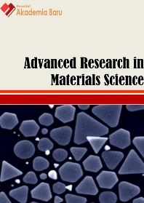
Journal homepage: www.akademiabaru.com/arms.html
ISSN: 2289-7992
Influence of enzymatic devulcanization process conditions on the tensile strength of revulcanized rubber |  |  |  |  | Open  Access
Emeliana Othman¹, Faridah Yusof^{1,}∗, Azlin Suhaida Azmi¹

¹ | Department of Biotechnology Engineering, Kulliyyah of Engineering, International Islamic University Malaysia, Kuala Lumpur, Malaysia
ARTICLE INFO |  |  | ABSTRACT
Article history:  Received 2 July 2016  Received in revised form 1 February 2017  Accepted 4 August 2017  Available online 19 November 2017 |  |  | Rubber based product has properties very different from the viscous latex of the rubber tree, Hevea brasiliensis. The properties of rubber latex are usually changed to enable it be used in production of many rubber based products such as tires, hoses, and etc. To strengthen it, the rubber undergoes vulcanization process where the addition of sulfur and heating the mixture under pressure is done which results in the formation of sulfur-bridges between the hydrocarbon chains. It makes an economic sense to recycle spent rubber products. Prior to recycling, surface devulcanization of rubber is vital to produce the acceptable reprocessed product. Devulcanization is basically a process that cleaved the monosulfidic, disulfidic or polysulfidic of vulcanized rubber. The tensile strength of the new material is of paramount important. In this study, enzymatic devulcanization of rubber was performed. Design of Experiment and analysis was conducted using Design Expert® (Version 6.0.8) software, with tensile strengths as the responses. Results showed that both factors tested, time of incubation and rubber concentration contributed significantly towards the strength of rubber products. Data shows that setting the incubation time for 4 hours with 4% w/v rubber in the incubation media results in the highest tensile strength of 10.7 MPa, an increase of 67% from the untreated control. In conclusion, the process conditions of the enzymatic devulcanization of used rubber product have been successfully optimized using tetrathionate hydrolase rich media, produced by Thiobacillus ferrooxidans. This information is important to improve enzymatic devulcanization method and finally to increase the percentage of rubber recycling.
Keywords:
rubber ,tensile strength, tetrathionate hydrolase, Thiobacillus ferrooxidans |  |  | Copyright © 2017 PENERBIT AKADEMIA BARU - All rights reserved

1. Introduction

Annually, near to a billion discarded spent tires are being produced worldwide and finding ways to dispose them is a major environmental problem [1, 2]. Spent tyres are virtually indestructible if left in the dump site as it is not biodegradable, thus it is an economic sense to recycle them. To date, recycle rubber has not been used as a replacement for new or synthetic rubber in significant quantities, largely because of the unachievable desired properties. Currently, less than 13% of the waste tires generated annually are recycled by any means. Double bond containing natural rubber molecules behaves like an unsaturated polymer whereby the tensile modulus and strength are usually very low. For many of applications, therefore, addition of an irreversible process of reinforcing phase of crosslinks such as sulfur is necessary to improve the properties of rubber [3].
Before it can be recycled, spent tires should undergo devulcanization, a process that breaks the sulfur bridges between rubber molecules [4]. Of all the devulcanization methods available, such as mechanical, chemical, microwave, bacterial and enzymatic, enzymatic are considered the most ‘green’ method. The enzyme responsible for the devulcanization steps is tetrathionate hydrolase, produced by many bacterial strains including Thiobacillus ferrooxidans. Thiobacillus ferrooxidans are autotrophic sulfur-oxidizing bacteria belonging to the family of Thiobacteriaceae and are commonly termed as colourless sulfur bacteria [5]. The ability of this sulfur oxidizing bacteria to oxidize sulfide and reduced inorganic sulfur compounds are attributed to an enzyme system present in the cell [6], by which sulphide or the reduced inorganic compounds are biologically oxidized to sulfate [7].

The main concept of this enzymatic devulcanization method is exposing the surface of a vulcanized rubber article to the enzyme, maintaining the exposure for a time sufficient to convert sulfur to sulfoxide or sulfone, and halting conversion or preventing further degradation of these groups to sulfide or sulfate. This is because the former groups are reactive or bondable with virgin rubber but the later ones are not [8].
In this study, the process conditions for devulcanization of ground tire rubber (GTR) has been optimized by varying two important parameters; the incubation time and percentage of rubber used, keeping the temperature, stirring time and amount of enzyme constant. Incubation time was chosen as a parameter because it is important to know when to stop the devulcanization process before it become wasteful. Percentage of GTR is varied to find out the most acceptable percentage of vulcanized rubber to be used per volume of incubation media. Design of Experiment was used to carry out the experimental runs with tensile strength of the revulcanized rubber as the response. Tensile strength was chosen because in rubber material production, for whatever target purposes, one of the most common tests for rubber products is its tensile strength [9].

2. Experimental procedure
2.1 Optimizing the Devulcanization Process Condition of GTR

The ground tire rubber (GTR) was first sterilized by rinsing it with 95% ethanol. Tetrathionate hydrolase rich media, produced by Thiobacillus ferroxidans cultivation was used for the devulcanization process [10]. For the devulcanization experiments, Design of Experiment (DOE) and analysis was conducted using Design Expert® (Version 6.0.8) software. Face Centered Central Composite Design (FCCCD) under Response Surface Methodology (RSM) was used by varying the effect of incubation time and % (w/v) GTR, with Tensile Strength of the revulcanized rubber as the Response as depicted in Table 1. GTR at specific % (w/v) was loaded in 250 ml shake flask followed by the addition of 100 ml tetrathionate hydrolase enzyme rich media. The mixture was incubated at 25°C, while shaking at 150rpm at a specific incubation time. Upon completion, the rubber flakes were withdrawn from the shake flasks, rinsed with distilled water and then dried at 60ºC in the oven before being used for revulcanization.

2.2 Revulcanization of GTR

The compounding of the rubber followed the conventional method and they were carried out by mixing 20g of devulcanized GTR, 80g of SMR-L, 6.0 g of zinc oxide, 0.5 g stearic acid, 3.5 g sulfur and 0.5 g 2-mercaptobenzothiazole (MBT). The tensile strength of the revulcanized rubber was conducted based on methods accorded in ISO 37:2011.

3. Results and Discussion
3.1 Face-Centered-Central-Composite Design

According to the DOE, with two parameters and at three levels, FCCCD suggested 11 experimental runs. Upon the completion of the devulcanization process, the rubber flakes were revulcanized followed by tensile strength testing. In our study, the test aims to study the effect of the interaction between the duration of incubation and % (w/v) GTR used to the degree of devulcanization, hence the strength of the new rubber product. The data obtained for tensile strength was shown in Table 1.

Table 1
Design of Experiment for devulcanization process conditions and tensile strength responses of revulcanized rubber
Run | Time of incubation  (hour) | Rubber concentration  (%) | Tensile strength  (MPa)
1 | 2 | 2 | 7.1
2 | 2 | 4 | 7.0
3 | 2 | 6 | 5.6
4 | 4 | 2 | 7.4
5 | 4 | 4 | 10.3
6 | 4 | 4 | 7.8
7 | 4 | 4 | 10.7
8 | 4 | 6 | 6.9
9 | 6 | 2 | 6.2
10 | 6 | 4 | 6.9
11 | 6 | 6 | 4.6

Data in Table 1 shows that the tensile strength of the revulcanized rubber varies from 4.6 to 10.7 MPa. Run 7 gives the highest tensile strength with incubation time and % (w/v) GTR set at 4 hours and 4 % (w/v) GTR respectively, which is also the middle point of the tested range. The second highest reading was observed in run 5 which was set at similar condition to run 7. The lowest reading was obtained from run 11 where incubation time was set for 6 hours and 6% (w/v) GTR, and the tensile strength was found to be less than half compared to the highest. For comparison, a control sample, which has not been devulcanized, but was revulcanized, gave the strength of 6.4 MPa.
From the ANOVA analysis shown in Table 2, it was found that the model F-value of 5.76 is large and implies that the model is significant. The significance of each factor was evaluated based on the p-value data [11]. The term with p-value less than 0.0500 indicates that the model term is significant and in this study, the quadratic term of both factors; A², and B² were considered as significant terms. The lack-of-fit value of 0.18 was high and considered as insignificant with respect to pure error. The R-squared value (0.7935) for this model can be considered as high and that this model could predict about 79.35 percent of response variability under the experimental data. The value of adjusted-R² was 0.6558 indicates that the model has 65.56 percent of flexibility in comparing the explanatory power of regression models that contain different numbers of predictors. The adjusted-R² and the predicted-R² having less than 0.2 in difference, shows that there is a reasonable agreement between the two data. A high adequate precision (6.1455) obtained shows that the model can be used to navigate the design space.

Table 2
Analysis of variance (ANOVA) for tensile strength of revulcanized GTR in RSM FCCCD optimization based on the best-fitted quadratic model
Source | Squares | DF | Mean Square | F-Value | P-value
Model | 25.91 | 4 | 6.48 | 5.76 | 0.0298 | significant
A | 0.67 | 1 | 0.67 | 0.59 | 0.4705
B | 2.16 | 1 | 2.16 | 1.92 | 0.2150
A² | 9.40 | 1 | 9.40 | 8.36 | 0.0276
B² | 7.55 | 1 | 7.55 | 6.72 | 0.0411
Residual | 6.74 | 6 | 1.12
Lack of Fit | 1.80 | 4 | 0.45 | 0.18 | 0.9284 | not significant
Pure Error | 4.94 | 2 | 2.47
Cor Total | 32.66 | 10

The following Equation 1 represents the mathematical prediction model for the tensile strength that was generated based on the ANOVA with A and B as the coded factors. This equation represents a linear second-order model that describes a twisted plane with curvature, arising from the quadratic terms as follows:

$R=9.31-0.33A-0.60B-1.93A^{2}-1.73 B^{2}$ (1)

where R is the experimental response (tensile strength) to be optimized, A and B are the linear terms, and A² and B² are the quadratic effect.
A 3-D surface plot in Figure 1 is very valuable for studying the interaction effects of the factors on the responses. As can be perceived, the interaction of time incubation and % (w/v) GTR yields a wide range of high tensile strength which lies in the middle of the response surface. At the maximum incubation time and minimum % (w/v) GTR, the tensile strength was found to be at its minimum as described by the model response. Conversely, at the minimum incubation time and maximum % (w/v) GTR, the tensile strength was also at its minimum. The tensile strength of the revulcanized rubber shows an augment as the incubation time and % (w/v) GTR moving towards the middle point of the tested range. The elliptical surface plot portrays the mutual interaction between the maximum tensile strength and each of the two variables.

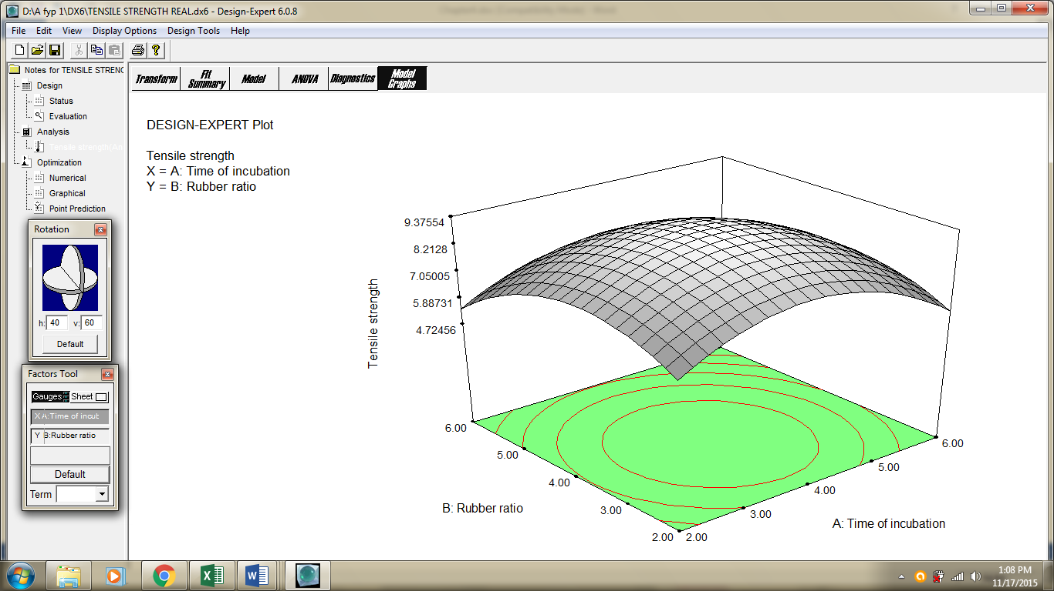
Fig. 1. A 3-D graph showing the effect of time of incubation and percentage of rubber concentration on tensile strength

Tensile strength is the maximum tensile stress reached in stretching a test piece, usually a flat dumb-bell shape, to its breaking point [12]. The tensile strength of the revulcanized rubber is an important test as it is highly related to the degree of devulcanization. In general, factors that influence the tensile strength of polymer are test temperature, strain rate, and loading history of sample. It is found that increasing of strain rate resulted in increasing of stiffness and tensile strength of a material but reduction in its toughness. The tensile properties of rubber may be influence by few factors such as type of polymer used, molecular orientation of crosslink, effect of fine particle fillers, presence of plasticizers, degree of polymerization or vulcanization and etc. [13].
Maintaining a ‘sufficient exposure time’ of the enzyme with the rubber and adequate amount of GTR per media volume were important to cleave the sulfur bridges, converting the sulfur to sulfoxide or sulfone. ‘Sufficient exposure time’ here means that there is no further degradation of these surface sulfoxide or sulfone to sulfide or sulfate, whereby the later ones are undesirable [14]. Results in Table 1 also imply that increasing the time of devulcanization leads to augmentation to sulfide or sulfate production which leads to decreasing of tensile strength of the revulcanized rubber. As time of incubation increased, more sulfur conversion reached the sulfide or sulfate phases, reducing the amount of ‘active’ functional group on the surface necessary for revulcanization. Sufficient exposure time ensure a high and proper sulfur bridges were formed between the devulcanized rubber and the new rubber matrix. A previous study showed that the tensile strength would reach its maximum as the density of crosslinks increased [15].
As there was no study that featured tetrathionate hydrolase enzyme devulcanization, the closest comparison could be made is with bacterial devulcanization. A study showed that during devulcanization, the conversion to sulfate reached its maximum after six days of incubation [16]. This observation is in agreement with the findings by Romine et al. [8] where they reported that the rubber devulcanization process which used a mixed culture of Thiobacillus ferrooxidans and Thiobacillus thiooxidans, showed that the mechanical strength of new revulcanized rubber incubated at 72 hours was much higher compared to the ones incubated at 168 hours. This supported the findings that longer incubation is actually not necessary in terms of devulcanization. But it is now certain that if enzymes are used directly, the time of devulcanization can be shortened tremendously, from days to hours, as there was no requirement to wait for the bacterial growth.

4. Conclusion

The RSM was successfully employed to optimize the process condition of devulcanization and this was shown by the data obtained on the tensile strength study of revulcanized rubber. Under optimal conditions, tensile strength of 10.7 MPa was achieved and it is close to the predicted value. The highest strength of revulcanized rubber was found to be 10.7 MPa, an increase of 67% compared to non-devulcanized control, and that was achieved when 4% (w/v) sample was incubated for 4 hours while stirring. Application of RSM for optimization studies is effective in understanding the interaction effects between the incubation time and % (w/v) GTR used.

Acknowledgement
This research was supported by a research grant E-ScienceFund (SF12-020-0049) granted by the Ministry of Science, Technology and Innovation, Malaysia.

References
[1] http://recyclenation.com/2010/06/sea-rubber-truth-tire-recycling, Date 16.11.2017.
[2] Adhikari, B., De, D. & Maiti, S. 2000. Reclamation and recycling of waste rubber. Progress in Polymer Science, 25 (7), 909-948.
[3] Urushihara, Y., Li, L., Matsui, J., & Nishino, T. 2009. In situ observation of filler displacement during tensile deformation of nanosilica-filled natural rubber using field-emission scanning electron microscope. Composites Part A: Applied Science and Manufacturing, 40(2), 232-234.
[4] CalRecovery Inc. 2004. Evaluation of Waste Tire Devulcanization Technology. A report prepared for California Integrated Waste Management, USA.
[5] Kuenen, J.G. 1975. Colourless sulfur bacteria and their role in the sulfur cycle. Plant Soil., 43, 49-76.
[6] Kurosawa, H., Endo, S., Hirano, T., Nakamura, K., Amano, Y. 1997. Stabilization of freeze-dried Thiobacillus thiooxidans cells as a bacterial deodorant for removal of hydrogen sulphide. J. Ferment. Bioeng., 83(2), 213-215.
[7] Das, S.K., Mishra, A.K., Tindall, B.J., Rainey, F. A. and Stackerbrandt, E. 1996. Oxidation of thiosulfate by a new bacterium Boseathiooxidans (strain B1-42) gen nov., sp nov.: Analysis of phylogeny based on chemotaxonomy and 16S Ribosamal DNA sequencing. Int. J. Sys. Bacteriol., 46(4), 981-987.
[8] Romine, R. A., M. F. Romine, & L. Snowdon-Swan.1995. Microbial processing of waste tyre rubber. Rubber Division 148th Fall Technical Meeting, Paper 56, Cleveland, Ohio. 17-20 October 1995. 13
[9] De, Sadhan K., and Jim R. White, eds. Rubber Technologist's Handbook. Vol. 1. iSmithers Rapra Publishing, 2001.
[10] Othman, E., Yusof, F. and Azmi, A. S. 2015. Application of Plackett-Burman Design for Screening of Parameters for the Production of Tetrathionate Hydrolase by Thiobacillus ferrooxidans. Journal of Engineering Science and Technology 10 (2015): 12-21.
[11] Montgomery, D. C. 2001. Design and Analysis of Experiments (fifth edition), NY: Wiley
[12] Smith, R.H. 2008. Metallic coefficient of friction equation does not apply to rubber. Analyzing Friction in the Design of Rubber Products and Their Paired Surfaces .1: 45-99
[13] Groover, M. 2010. Rubber-Processing Technology. In Fundamental of modern engineering: Materials, Process and System(4th ed.). John Wiley & Sons.
[14] Romine, Robert A., and Lesley J. Snowden-Swan. Method for the addition of vulcanized waste rubber to virgin rubber products. U.S. Patent 5,597,851, issued January 28, 1997.
[15] Gonzalez, Ramon, Juan C. Gentina, and Fernando Acevedo. 2004. Biooxidation of a gold concentrate in a continuous stirred tank reactor: Mathematical model and optimal configuration. Biochemical Engineering Journal, 19(1), 33-42.
[16] Torma A. E, and D. Raghavan. 1990. Biodesulfurization of rubber materials. Bioprocess Engineering Symposium, American Society of Mechanical Engineers, Bioengineering Division. 16, 81–87.

∗ Corresponding author. E-mail address: yfaridah@iium.edu.my (Faridah Yusof)

