 |  | Journal of Advanced Research in Fluid Mechanics and Thermal Sciences |  | 
Journal homepage: www.akademiabaru.com/arfmts.html
ISSN: 2289-7879
Improvement of Immobilization of fat, oil and grease (FOG) by calcium alginate |  |  |  |  | Open  Access
Mohammed Saedi Jami^{1,}*, Nurul Alia Fazil¹, Masashi Iwata²

¹ | Bioenvironmental Engineering Research Center (BERC), Department of Biotechnology Engineering, International Islamic University Malaysia, P. O. Box 10, 50728 Kuala Lumpur, Malaysia
² | Department of Chemical Engineering, Graduate School of Engineering, Osaka Prefecture University, Japan
ARTICLE INFO |  |  | ABSTRACT
Article history:  Received 2 July 2016  Received in revised form 1 February 2017  Accepted 4 August 2017  Available online 23 November 2017 |  |  | Current wastewater pre-treatment plant system handling FOG consumes high energy and time. This study aims to introduce a new FOG wastewater pre-treatment by immobilizing the FOG in a calcium alginate gel beads. Using Design-Expert software, Response surface methodology (RSM) based on face centred central composite design (FCCCD) was used to optimize two important variables; pH of FOG and concentration of sodium alginate whereas the oil entrapment efficiency (OEE) was used as a response. The mixtures of synthetic FOG wastewater and sodium alginate were dropped in calcium chloride solution in droplets form to produce gel beads. The optimum combination for having highest OEE percentage at 87.27% was found to be at pH 4.7 and 10000 ppm concentration of sodium alginate. Moreover, coating the gel beads with chitosan has reduced the FOG loss during mechanical expression from 23.73 % to 12.58 %. The gel beads were dissolved completely in phosphate buffer solution of pH 5, 8 and 9. This technique can be applied for easier FOG removal, for it has high OEE percentage and the final gel is also biodegradable.
Keywords:
Immobilization, FOG, mechanical expression, alginate |  |  | Copyright © 2017 PENERBIT AKADEMIA BARU - All rights reserved

1. Introduction

Domestic household and Food service establishment (FSE) is a major contributor to the disposal of wastewater containing significant amount of FOG in the form of grey water or sullage [1 - 4]. According to Capital Regional District (CRD), an area of British Columbia, Canada, in 2008, they estimated about 1,000,000 kg of FOG deposited from residential area only triglyceride is a three fatty acid molecules with one glycerol where glycerol is also referred to as glycerin; syrupy, trihydroxy alcohol (1,2,3 propanetriol) that exists in natural oils as the base[5 -7]. FOG coming from FSE and residential areas are two types; “yellow” grease which is inedible and unadultered spent FOG like oil used for deep frying and “brown” grease which is a floatable FOG [5].
For many years, FOG causes many problems such as sewer pipe blockage that could lead to sewer overflow due to reduced capacity. Sewer pipes can also burst because of high pressure. Removal of blockade made of FOG that sticks to the insides of the pipes requires lots of money for maintenance although the problem can be prevented if FOG was deposited properly. Indah Water Konsortium (IWK) of Malaysia reported that in 2010, 22184 numbers of blockage are reported to the company which is very high in number [8].
Not all FOG hardened in the sewers and pipes. Some will be transported to the municipal wastewater treatment plant. Many methods on treating FOG containing wastewater have been employed in the past years such as floatation, coagulation, biological treatment, membrane separation technology, combinations of mentioned technique and etc [9-11]. Another potential wastewater treatment method is immobilization of FOG in calcium alginate, where the process is a combination of chemical and physical process. This study applies the encapsulation of FOG using calcium alginate, where the gels are formed by crosslinking the alginate with calcium ions.

2. Experimental Study
2.1 Experimental Flowchart

The project aims to immobilize FOG by encapsulation in calcium alginate beads. The experiment began with verifying that FOG can be immobilized in calcium alginate beads, followed by optimization of the system by varying FOG pH and sodium alginate solution concentration. Then optimized system undergoes beads coating with chitosan. Lastly, the alginate beads (without coating) are tested for its biodegradability properties. The summary of the methodology is depicted in Figure 1.
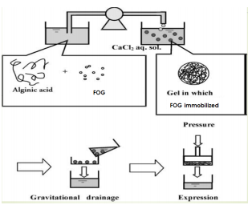

Fig. 1. Schematic representation of FOG removal process

2.2 Methodology

The immobilization process consists of the following procedures (Figure 1). A 10 g of model FOG (vegetable oil) was mixed with 10 ml distilled water and then mixed with sodium alginate aqueous solution. This mixture is added drop wise to a 10000 ppm calcium chloride aqueous solution, resulting in calcium alginate gel to encapsulate FOG in calcium alginate gel. The gel suspension is dehydrated gravitationally, followed by mechanical expression of gel particles. During the expression, the FOG remains in the gel. Optimization of the gelation process was done by Design Expert software with Face Centred central composite design (FCCCD) by Response surface methodology (RSM) with two manipulated factors which are pH of the FOG and sodiumalginate concentration ranging between pH 2 to pH 12 and 1000 ppm to 10000 ppm concentration. The FOG was measured using hexane extraction method. Then the optimized gel was used for chitosan coating (0.5% w/v) by adding the beads into chitosan solution for one hour with constant stirring and followed by mechanical expression of the beads. Lastly, the beads formed were put under biodegradability test using phosphate buffer of pH 5, 6.5 and 8.

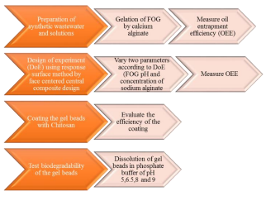
Fig. 2. Flowchart of methodology

3. Results and Discussion
3.1 Encapsulation of FOG and Process Optimization

First run of the experiment was conducted to confirm that there was immobilization of FOG in the calcium alginate beads, with 94% oil entrapment efficiency (OEE). This finding proved that immobilization of FOG can be done by calcium alginate beads. Figure 3 (a) and (b) show the relationship between oil entrapment efficiency (OEE) in percentage, FOG pH and concentration of sodium alginate solution.
The 3D graph has elliptical like shape. Higher concentration of sodium alginate solution will have higher OEE%, and this finding is same as found by Iwata [12], where the research was to immobilize PMMA particles in calcium alginate beads, and increase in concentration of sodium alginate had higher PMMA particle entrapment. On the other hand, higher FOG pH will result in lower OEE %. Lower pH has better OEE than FOG at basic pH but the natural pH of the substrate, pH 4.7 has highest OEE %. Based on Iwata and Jami [13], their findings also does not have a definite trend on pH, the results were rather fluctuating. Maximum OEE % was found at 87.27 %, with FOG pH 4.7 and sodium alginate solution concentration at 10000 ppm. FOG entrapment efficiency was calculated using Eq. (1),

OEE = ((Initial amount of FOG – Final amount of FOG) / (Initial amount of FOG)) x 100% (1)

3.2 Chitosan Coating Effect

Beads with optimum OEE % were chosen to be coated with chitosan. Without coating, the FOG loss during mechanical expression was recorded to be 23.73 %. With chitosan coating, the FOG loss was reduced to 12.58 %. With chitosan coating, approximately 47 % improvement was recorded. Previous study [14] also showed decrease in substrate release from the beads, from 100 % release without chitosan coating to 44 % release of substrate with coating after 18 hours. These results support the hypothesis that chitosan coating will reduce FOG loss from calcium alginate beads. The measurement of FOG release was calculated using the formula;

FOG release=100-OEE % (2)

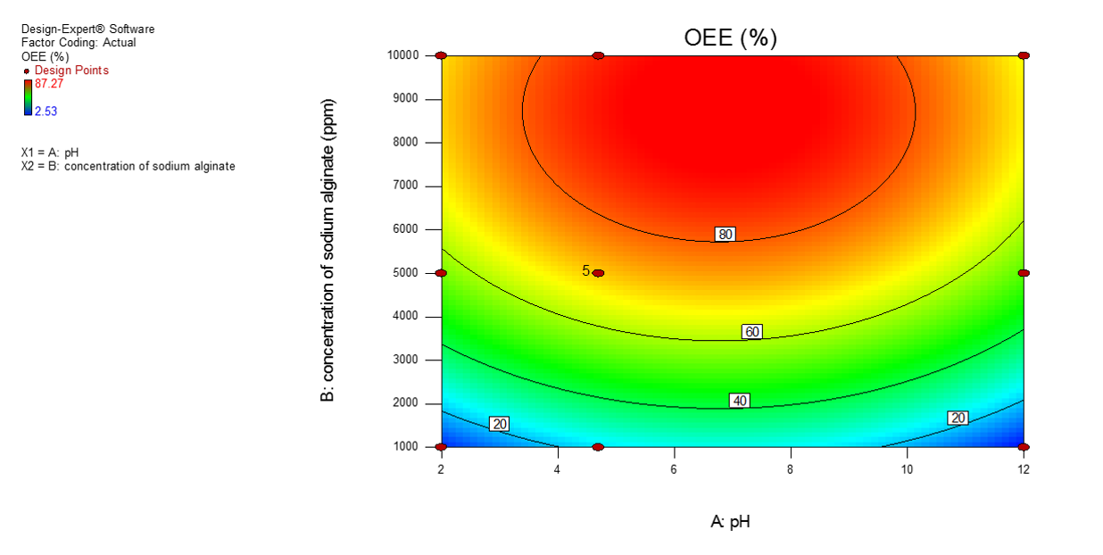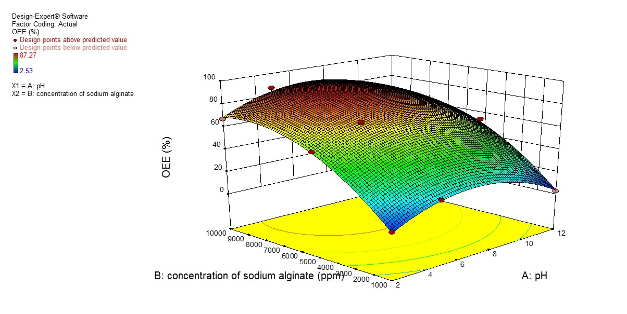

Fig. 3. (a) Contour graph representation of sodium alginate concentration, FOG pH and OEE% (b) 3D graph representation of Sodium alginate concentration, FOG pH and OEE %

3.3 Biodegradability Test

Buffer solutions of pH 5, 6.5, 8 and 9 were prepared and 1 g of beads containing FOG was loaded in each buffer. The buffer solution was then shaken at 125 rpm for three hours. The beads completely dissolved in buffer with pH 5, 8 and 9. This result was partially supported by the findings of Singhal et al. [15], where their findings showed complete beads dissolution in phosphate buffer pH 8 only, and the beads did not dissolve in pH 5 buffer. When dissolving empty beads in buffer, the beads dissolved in pH 5 and 8 buffer. Difference in these findings may be due to the difference in the type of substrate, where Singhal et al. have acyclovir drug and olive oil as the substrate.

4. Conclusion

FOG is a threat to the environment when not disposed properly. Hardened FOG in the sewer pipes and drains could cause odour problem, overflows and reflux of wastewater to the environment. FOG that enters wastewater treatment plants requires more energy and time for FOG removal using current technology. To remedy these problems, this study aims to introduce a new possible FOG wastewater treatment/pre – treatment by immobilizing FOG in calcium alginate beads. It has been proved that FOG indeed can be encapsulated in calcium alginate beads. Process optimization has found that this system works best with FOG at its natural pH, pH 4.7 with sodium alginate solution concentration of 10000 ppm. To eliminate the FOG leakage during mechanical expression during removal of excess water, the gel beads were coated with chitosan solution and a 10 % reduction of FOG loss was found. The gel beads are verified to be non-hazardous to the environment due to their biodegradability in buffer solution with pH 5, 8 and 9 which are in the range of river water in Malaysia that have pH values of pH 5 to pH 9.
References
[1] Montefrio, Marvin Joseph, Tai Xinwen, and Jeffrey Philip Obbard. "Recovery and pre-treatment of fats, oil and grease from grease interceptors for biodiesel production." Applied Energy 87, no. 10 (2010): 3155-3161.
[2] Dumore, N., & Mukhopadhyay, M. (2012). Removal of oil and grease using immobilized triacylglycerin lipase. International Biodeterioration & Biodegradation, 68, 65-70. doi:10.1016/j.ibiod.2011.12.005
[3] Husain, I., Alkhatib, M., Jammi, M., Mirghani, M., Zainudin, Z., & Hoda, A. (2014). Problems, Control, and Treatment of Fat, Oil, and Grease (FOG): A Review. Journal Of Oleo Science, 63(8), 747-752. doi:10.5650/jos.ess13182
[4] Nisola, G., Cho, E., Shon, H., Tian, D., Chun, D., Gwon, E., & Chung, W. (2009). Cell Immobilized FOG-Trap System for Fat, Oil, and Grease Removal from Restaurant Wastewater. Journal Of Environmental Engineering, 135(9), 876 -884. doi:10.1061/(asce)0733-9372(2009)135:9(876)
[5] Waterboards,. Fats, oils and greases (FOG) management and Control program. Colorado: Waterboards. [Online].From:http://www.waterboards.ca.gov/rwqcb7/water_issues/programs/pretreatment/docs/intro_fog_inspections.pdf [Accessed on 20 November 2015]
[6] Zarith Elda, A. (2012). Immobilization of Oil and Grease in Sodium Alginate Gel as A Potential Wastewater Treatment Method (Undergraduate) Unpublished thesis. International Islamic University Malaysia.
[7] Williams, J., Clarkson, C., Mant, C., Drinkwater, A., & May, E. (2012). Fat, oil and grease deposits in sewers: Characterisation of deposits and formation mechanisms. Water Research, 46(19), 6319-6328. doi:10.1016/j.watres.2012.09.002
[8] Indah Water Konsortium Sdn. Bhd., 2010. Sustainability Report – 2010. [Online]. From https://www.iwk.com.my/cms/upload_files/resource/sustainabilityreport/SustainabilityReport2010.pdf
[Accessed on 21 November 2015]
[9] Yu, Li, Mei Han, and Fang He. "A review of treating oily wastewater." Arabian journal of chemistry 10 (2017): S1913-S1922.
[10] Lan, W. U., Gang, G. E., & Jinbao, W. A. N. (2009). Biodegradation of oil wastewater by free and immobilized Yarrowia lipolytica W29. Journal of Environmental Sciences, 21(2), 237-242.
[11] Mueller, S. A., Kim, B. R., Anderson, J. E., Gaslightwala, A., Szafranski, M. J., & Gaines, W. A. (2003). Removal of oil and grease and chemical oxygen demand from oily automotive wastewater by adsorption after chemical de-emulsification. Practice Periodical of Hazardous, Toxic, and Radioactive Waste Management, 7(3), 156-162.
[12] Iwata, Masashi. "Solid–liquid separation by use of particle immobilization in calcium alginate gel." Separation science and technology 38, no. 4 (2003): 837-850.
[13] Iwata, M. and Jami, M. 2009. Removal of Colloidal Particles from Colloidal Waste by Use of Particle Immobilization in Gel. Filtration & Separation Symposium and Exhibition in collaboration with INCHEM Tokyo 2009 (FSJA F/S Symposium), Tokyo, Japan. 19-21 November 2009
[14] Shu, X. Z., and K. J. Zhu. "The release behavior of brilliant blue from calcium–alginate gel beads coated by chitosan: the preparation method effect." European Journal of Pharmaceutics and Biopharmaceutics 53, no. 2 (2002): 193-201.
[15] Singhal, Peeush, Kapil Kumar, Manisha Pandey, and Shubhini A. Saraf. "Evaluation of acyclovir loaded oil entrapped calcium alginate beads prepared by ionotropic gelation method." Int J Chem Tech Res 2, no. 4 (2010): 2076-85.

* Corresponding author. E-mail address: saedi@iium.edu.my (Mohammed Saedi Jami)

