 |  | Journal of Advanced Research Design |  | 
Journal homepage: www.akademiabaru.com/ard.html
ISSN: 2289-7984
Preliminary analysis of conformity of LADM for modelling 3D/4D situation |  |  |  |  | Open  Access
Babalola Sunday Oyetayo^{1,2,}∗, Abdulrahman Alias¹, Choon Liant Tan¹, Shuaibu Umar³, Mohammed Jawalludeen Sani¹
¹ | Faculty of Geo-information and Real Estate, Universiti Teknologi Malaysia, 81310 Johor Bahru, Johor, Malaysia
² | Department of Surveying and Geoinformatics, Federal University of Technology, Akure, Ondo State, Nigeria
³ | Federal Polytechnic Bauchi, Bauchi State, Gwallameji Village, Off Dass Road, Bauchi-Tafawa Balewa, 0231, Bauchi, Nigeria
ARTICLE INFO |  |  | ABSTRACT
Article history:  Received 6 July 2017  Received in revised form 2 September 2017  Accepted 2 October 2017  Available online 1 November 2017 |  |  | One of the prime inspirations for this work emerge from the need to deal with our common assets (the Land). To build up a formal approach that can be utilized to address the issues emerges from a mind boggling circumstance in land administration. The capacity to track the progressions as it is connected to land everywhere throughout the year. A considerable lot of the land exchanges are as yet in light of 2D ideal models that have frustrated fast advancement in thickly urban condition. The consideration of 3D enhanced the functionalities of different models. Be that as it may, the dynamic idea of the land has an imperative part in the advancement of the land administration framework. One of the significant reason the expansion in intricacy in land utilize required that Land Administration Domain Model (LADM) concept in land administration has an enhanced limit is to deal with the current 2D and 3D. The need to talk about time dimension emerges from the way that individuals relationship to the land has an exceptionally powerful nature, all the LADM packages has time (Temporal) components. LADM completely bolster forming (historical information) as all classes inherit from VersionObject, and all LA_RRR object have the quality TimeSpace. 2D/3D space and time incorporation is not profoundly integrated into a 3D/4D spatiotemporal portrayal. The preparatory test case in this study affirmed the conceivable outcomes of having a move or development (with time) of characteristic limits from their underlying positions. Thus, the dynamic idea of the land in connection to man, the benefits of this model to the land proprietors, land merchants, and the administration can't be over stressed. This study tries to clarify the current 2D/3D approach and broke down preparatory requirements for 4D with a specific end goal to see the estimation of the approach. The primary future research exertion focuses on melding on the most proficient method to coordinate the model completely into Country profile in the study area.
Keywords:
LADM, land administration, temporal, dimension, 3D/4D model |  |  | Copyright © 2017 PENERBIT AKADEMIA BARU - All rights reserved

1. Introduction

The dynamic idea of land and its association with a man is getting to be plainly prevalent in recent time. The accessible space is step by step been possessed because of urban development and city unpredictability. Additionally, the enthusiasm of individuals in land expands all the live long day. Government obtain lands for formative purposes and place enactment on singular proprietors in light of the fact that the ability to control land is vested in the government. Land administration is at the cutting edge of the answer for help in land multifaceted nature and disaster management as it changes with time. Responsibility for, the rights, restrictions and responsibilities (RRR) changes after some time. The procedure of information securing for authoritative reports is at that specific time. Land enlistment is done keeping in mind the end goal to have a lawful support for the responsibility for and property requires some serious energy.
One of the prime inspiration for this work emerge from the need to deal with our normal assets (the Land). To build up a formal approach that can be utilized to address the issues emerges from an intricate circumstance in land administration and the capacity to track the progressions as it is connected to land all finished years [1]. The world is never static, the complexities in land administration required a model fit for taking care of more mind boggling land administration where time as a transient measurement will be incorporated [2]. The expansion in unpredictability in land utilize required that Land Administration Domain Model (LADM) idea in land administration has an enhanced ability to deal with the current 2D and 3D [3]. The need to talk about time dimension emerges from the way that individuals’ relationship to the land has an extremely powerful nature [4]. The presentation of the fourth dimension by [4] and [5] in cadastre using Turkey, Netherland and Australia as the case study has been relevant for utility network.
Land administration as indicated by [6] is an action including individuals and their association with the land. This relationship is of their rights, restrictions and responsibilities (RRR). Land administration is an installed term typically utilized via land related callings: Geoinformatics, Surveying and Mapping, Planning, Estate Valuation, Land Law, Land Valuation and Taxation. Thusly, it is intended to help exchanges of privileges of individuals, individual, formal and informal, country and urban culture in connection to land. The data identified with the land matter ought to likewise be accessible to everybody including in land exchanges anytime. Access to this data gifts security of the exchange and gives the likelihood to distinguish the exchange [7]. In any case, land been restricted assets, needs a fleeting or dynamic measurement that can be utilized for the static part of the land. LADM bolsters both 2D and 3D, yet there are limitations in 2D data. These restrictions are clearly known for the surface, above and underground utilities, for example, a passage, flat units, underground shopping centre; underground auto stop, underground water, and mineral assets [5]. There ought to be a temporal dimension to demonstrate the dynamic idea of the land in database refreshing [8]. Survey plan are drawn in view of 2D that has hampered heaps of information control in the database administration framework. Exclusion of time measurement in the land administration framework in most country has made land administration so troublesome for the land director. Along these lines, this paper is preparatory study of the congruity of LADM in modelling 3D/4D that is, the temporal (time) dimension for LADM. Illustrations are given in moving boundaries (stream wandering). In section 2 of this study, Malaysia land administration framework, LADM country profile and temporal (time) dimension aspect of LADM was broke down. Section 3 clarifies the 2D/3D models while Section 4 depicts the temporal dimension of LADM, the necessities and the present 3D/4D circumstance was talked about in section 5, the discussion and conclusion are made in section 6.

2. Malaysian Land Administration System

Land is restricted to airspace, on surface and underground (counting air space) of the earth and all substances made up that surface, the earth underneath the surface and all substances at first glance, all vegetation and other common items, regardless of whether requiring the periodical use of work to their creation, and whether on or beneath the surface, all things appended to the earth or for all time secured to anything joined to the earth, whether on or underneath the surface, and land secured by water [9]. Land is been viewed as riches, as an item, as a rare asset and as a group rare asset. Land is a significant asset for humankind as life relies on upon having land in which to live and work. Land adds to riches and monetary improvement, as well as a feature of the social and political texture that manages all groups. In this manner, land must be regulated and overseen for the advantages of all. Customarily, the Malaysian cadastre and land administration framework has diverse structures and approvals. The control for land enrolments are in under the administration of the state government while cadastral review and mapping is under the federal government. (Land Office) (Department of Survey and Mapping Malaysia) Broadly, we can state their obligations covers four procedures or segments in land administration, in particular land enrolment, land valuation, land use planning, cadastral surveys and mapping. In any case, every nation has duty upon and on her property organization framework [9]. The parcel bounded system practise in Malaysia of (2D) only gives fundamental land and property data about the lots and land parcels. The computerized cadastral maps, registration of title, content survey and mapping and textural record data about lots and land parcel are still 2D. The figure beneath demonstrate the organization of land administration in Malaysia created from [10]

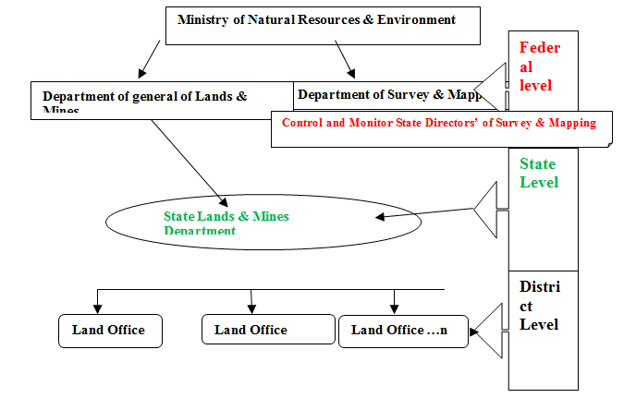
Fig. 1. Organizational Structure of Land Administration in Malaysia [10] Modified
Truly, [9] trusted that the term 'land administration', presented in the 1990's, most likely turned out to be all the more broadly utilized after the United Nations Economic Commission for Europe in 1996 framed a specially appointed gathering of specialists known as the 'Meeting of Officials in Land Administration. From that point forward, the significance of land administration expanded after 1990. In this way, land administration in present day vote based systems moved their specialized concentration and started to draw in experts from the orders of building, financial aspects, political and sociologies, law and PC innovation and also universal associations, and national governments. Earnestly, Land administration frameworks at first started in light of the fact that administrations required rational and reasonable assessment accumulation frameworks which they created to benefit land markets. In any case, it has moved toward becoming premise of conceptualizing rights, restrictions and responsibilities identified with individuals, strategies and places in help of supportability and additionally land and property. It has made a manageable improvement since there must be a protected and finish documentation or portrayal of lawful and physical land objects.
There has been improvement in land administration in Malaysia throughout the years. In 2005 government affirmed an e-Cadastre extend under the ninth Malaysian Development Plan (2006-2010. The execution was completed by Department of Survey and Mapping Malaysia (DSMM), in accordance with the administration's yearning to have a completely advanced Malaysia by 2015. Today, e-cadastre has achieved Coordinated Cadastral System, Virtual Survey System and Cadastral Data Integrity System to land administration in Malaysia. In perspective of this, there has been arrangement of research on the change in usage and joining of 3D circumstances [11]. The results and the advantages of these looks into are seen in the current advancement and production of the LADM Malaysian nation profile.
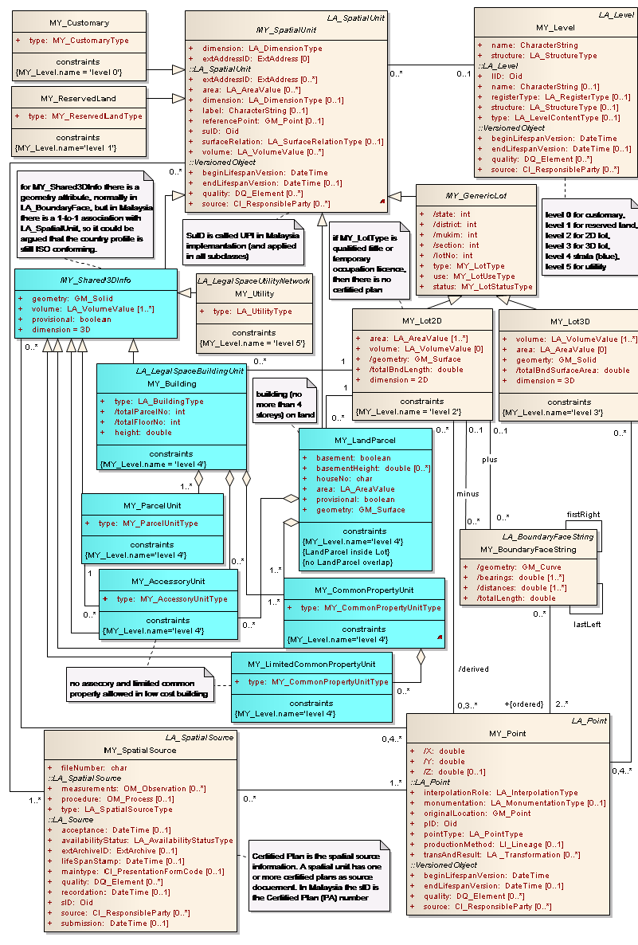
Fig. 2. Malaysian Country Profile [10] Details of spatial side of model
2.1 2D/3D Models
The weight and intricacy of land particularly in urban areas where there are high business exercises have prompted covering, interlocking building, and developments. The difficulties are the means by which the conventional 2D model will have the capacity to adapt to these difficulties. International Federation of Surveyors (FIG) concern is that land administration frameworks in a large portion of the nations are not sufficient to adapt to steadily expanding scope of multifaceted nature of rights, restriction and responsibilities (RRR). Huge numbers of the land exchanges are as yet in light of 2D standards [12]. The paradigm have been re-examined and changed in accordance with the present automated process. The developing enthusiasm for the 3D display is caused because of the quantity of underground stopping places, shopping centres, working above and beneath, streets and railroads and other multilevel building. The outline, the advancement and the usage of areas make the interest for 3D demonstrate more valuable in the current innovative improvement. The real confinement of the 2D display is in the region of perception or portrayal.
A 3D cadastre is said to be a cadastre that registers and offers comprehension to rights, restrictions, and responsibilities on parcel, as well as on 3D property units[12]. In this way, a 3D cadastre would have the capacity to deal with so much circumstances as covered structures and utilities that keep the property from being enlisted by legitimate and authoritative viewpoints utilizing a 2D cadastre. 3D has gotten heaps of change late time to the investigation of the dimensional model. Notwithstanding, the expansion of time measurement will build the change and the utilities of the models. The Land is static yet the word is dynamic, the proprietorship is never lasting. Rights, restriction and responsibilities in connection to land are an element of time. The costs changes after some time, proprietorship changes likewise over the long haul, the measurement, and the archive is adjusted over the long run. In this way, the time dimension should have been incorporated into 3D to deal with the dynamism idea of the land in the land administration framework.
There has been a progression of fruitful studies on 2D/3D in cadastral and land administration framework, 3D city displaying et cetera [13], [14], [15] and [16]. These studies have likewise been the establishment for the vast majority of different investigations identified with dimensions on the grounds that 2D and 3D are constantly pertinent in cadastral and land administration framework [12]. In this manner, we considered 2D/3D spatial information as an underlying information required for this study.

2.2 Temporal (Time) Dimension and LADM

In this section, we investigated the temporal (time) or 4D aspect of LADM. We attempted to clarify the requirements for the extra 1D to the current 3D, that is, time dimension and give some striking cases as identified with the land administration framework. For a considerable length of time, a few part of time measurement have been examined in Geographical Information System (GIS)/Cadastral Information System (LIS) and in other research ranges from [17], [18], [5], [2], [4], [19], [7], [12] and [20].
Land management/administration, Land Registration/cadastre framework are not the same in each area and nations of the world, however the procedures included takes some time. This may be issue in a country where there is no efficient land administration and registration framework. In Administrative Package (LADM) with its conceptual class LA_RRR, with three subclasses LA_Right, LA_Restriction and LA_Responsibilty and class LA_BAUnit [2] and [4]. Here, a right is a formal or casual qualification. Cases of these are proprietorship rights; tenure rights, and standard rights, rights in numerous classifications. It can be superseded over a period; it can be covering et cetera. These are components of worldly (time) aspect of land administration. As it were, there is the period for the rights to be legitimate or not to be substantial. A confinement is additionally a formal or casual which is completely appended to the comfortable specific time. A responsibilities is an obligation to do, for instance, to keep up a landmark. Likewise, in class LA_BAUnit, comprise of at least zero spatial units (parcel) which (at least one) rights. For instance, a land utilize right, responsibilities or restrictions are related with time are joined. The angle which is all around seen in the fundamental property unit with three spatial units, (a condo, a carport and a provincial bundle) [21]. The rights as clarified in these classes are viewed as capacity of time. Thusly, time is thought to be the fourth dimension from the current 2D and 3D (x, y and z). The reconciliation of time dimension into the current measurement has been the real concern as a result of the neatness that might be included. Never the less, most questions acquire tmin-tmax temporal components.
The Spatial Unit Package is likewise significant to the temporal aspect of LADM as one of the concentration in this paper. The classes includes in this package are as per the following; LA_SpatialUnit, LA_SpatialUnitGroup, LA_Level, LA_Legal-SpaceNetwork, LA_LegalSpaceBuilding and LA_RequiredRelationshipSpatialUnit. For every one of the classes said above, it is noticed that the temporal characteristics of each class appear to be comparative. They might be displayed similarly particularly while considering the historical backdrop of the database, database refreshing and history of responsibility for spatial unit [26].
The Spatial Unit Package makes them review and Spatial Representation Subpackage with LA_Point, LA_BoundryFaceString and LA_SpatiapSource as their classes [21]. A basic investigation of Surveying and Spatial Representation demonstrated that temporal (time) is a standout amongst the most imperative measurements of this package. The information acquired on the field is right then and there; the boundary so determined is at the moment, and the date of study report for which is it legitimate is additionally right then and there. The consideration of time (worldly) the fourth dimension, will enhance the unwavering quality of information and the report gotten after the field perception.
The main class of Party Package is class LA_Party, LA_GroupParty and LA_PartyMember are its specializations and optional association respectively. Party in a straightforward term are aperson, group of individual characteristic and non-regular, metropolitan, state or group. In [4] individuals, the land relationship has an exceptionally powerful nature. Individuals have a constrained time to live as individuals are conceived an offspring, individuals likewise die, the land stays as it is yet the proprietorship changes after some time.
Therefore; fundamental managerial unit: rights, restrictions, responsibilities (RRR) ownership, land use and use rights. Individuals and association: Spatial unit; structures, packages and utility systems. Looking over; the spatial portrayal as indicated by [22] and [4] has temporal elements that must be incorporated to get together with constantly expanding urban development and city complexities. LADM completely bolster forming (historical information) as all classes inherit from VersionObject (with the exception of source documents) of ISO 19152, figure 3 underneath and all LA_RRR question have the characteristic TimeSpace of ISO19152. It has been noted before that; 2D/3D space and time combination is not profoundly incorporated into a 3D/4D spatiotemporal portrayal. This investigation tries to investigate the current 2D/3D and dissected how 3D/4D can be incorporated to see the values of this approach. The principle look into exertion focuses on intertwining on the most proficient method to incorporate the model completely into LADM Malaysian Country profile.

Fig. 3. Classes Versioned Object with subclasses [4]
3. The Current 3D/4D Situation

In our testing illustration, we utilize the parcel with a natural boundary that can move after some time. The boundary are said to be imaginary lines that separate proprietors land allocate. The boundary lines are settled lines so that the limits stay changeless images of lucidity between the two adjoining (land parcel) (formal or informal).
Notwithstanding, it not generally on account of characteristic boundaries, the limit might be dislodged because of human exercises on the field or by common marvels as on account of stream wandering. The normal limit of a parcel may characterize precisely by this present reality question or check at a point in time however just settled at a moment of estimation when the overview is done [4]. A boundary can be a spatial boundary, in the customary sense, the partition between 2 parcels, yet a boundary can likewise be temporal boundary [17]. It may not look so muddled in some created nations but rather substantially more questionable in some other creating nations. It could be blended boundaries, if there should be an occurrence of dynamic questions; a moving stream as limit. It likewise happen when a gathering or gatherings are guaranteeing possession past his limits (Land dispute).
Two GPS receivers were utilized to acquire the data in a static mode for 30minetes each. The raw data got were changed over to RINEX format and was transferred to the magicGNSS cloud framework workspace, and utilize various apparatuses for post-handling and show of results. The two receivers were set on the bank of the stream abandoning one meter each to the waterway. The outcomes demonstrated a change in the situating precision by incorporating GLONASS perceptions when contrasted and Bernese 5.0(PPP) comes about.
MagicGNSS is a web application for GNSS information preparing joining with high accuracy situating additionally including honesty exhibit. MagicPPP benefit grants GNSS clients to decide their position or direction with centimetre-level precision. MagicPPP actualizes imaginative calculations created by GMV in light of exact circle assurance, time synchronization and situating [23]. PPP remains for Precise Point Positioning. It is a method that permits computing the directions of remain solitary Global Positioning System (GPS) collector or station, without the requirement for helper information from reference or base stations. PPP depends on the use of exact satellite circle and clock solutions from IGS (the International GNSS Service) and preparing double recurrence code and transporter estimations utilizing the most definite revisions and geophysical models. PPP computes the receiving wire organizes, and furthermore the collector clock and the peak tropospheric delay, together with the stage ambiguities. The directions and clock evaluated by PPP are given in a worldwide and perceived reference framework [23].
In the interim, the precision acquired relies on upon the quantity of hours or days on a station during observation. For this situation, the two positions set up were forever set apart in other to decide the separation long between the two purposes of the two end of the stream. The point decided are left for couple of years to have the capacity to decide the adjustments in the width of the waterway throughout the years because of stream winding. In any case, it is imperative to note and keep the record of the time and date as this is the deciding element for the period of the year when the
Observation can be done again. The main future research activity will centre on how the 4D could be integrated into the country profile in the study area. Our next study will be to develop a prototype using a relatively large scale land acquisition where there are natural boundaries, many owners (LA_Party) and boundaries demarcations (LA_BoundarySource.
Figures 4 below show example of river meandering. The imagery of a flowing river in University Teknologi Malaysia (UTM) for 2013 and 2016 were digitized using ArcGIS 10.2.1. The two digitized maps were overlaid upon each other to show that there have been changes in the width of the water over the years. We can, therefore, conclude that, there can be changes in the natural boundaries over the years due to natural or artificial factors. However, the significant of the time T (Temporal) is that changes may depend on season and period of the year.
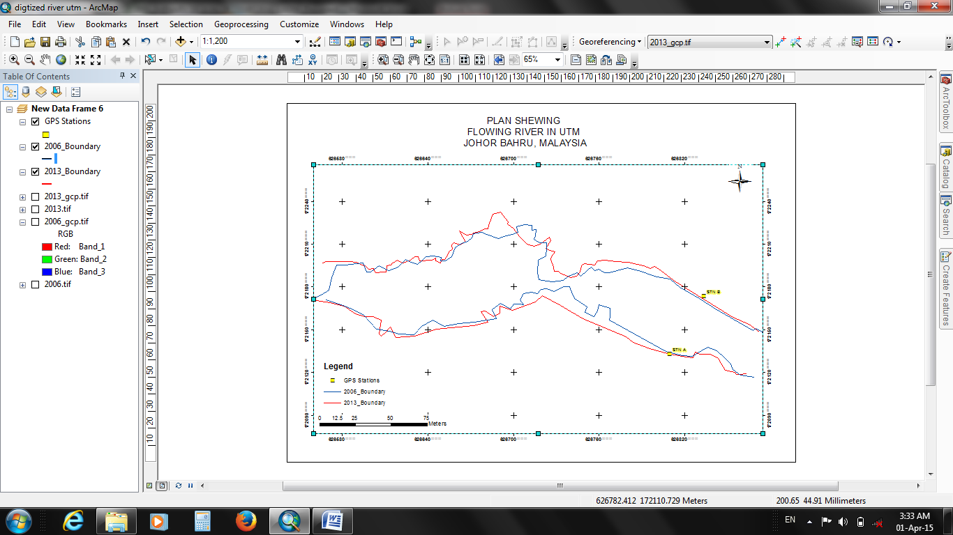
Fig. 4. Digitized plan of flowing river in UTM

Fig. 5. KOMTAR, Penang [24]
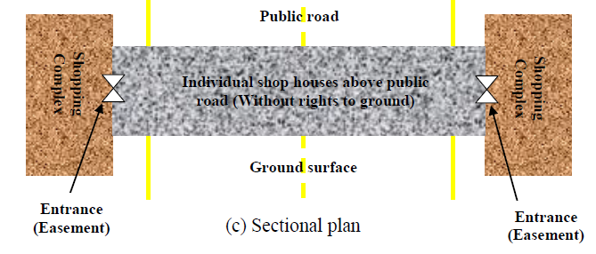
Fig. 6. Shop houses above public road [24]

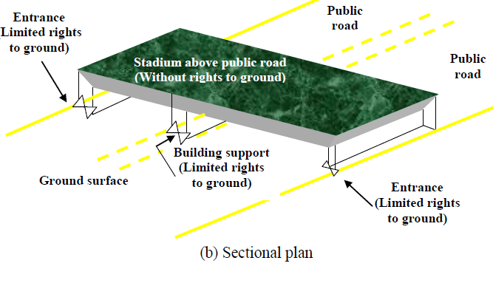
Fig.7. Building above public road [24]
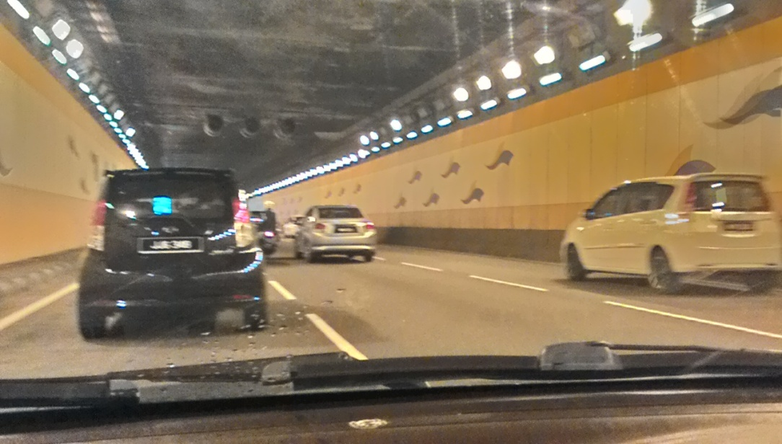
Fig. 8. Underground roads [25]
4. Discussions

The developing weight ashore, the urban city complexities and rising area esteems have caused an expanding in need and interest for 4D in land administration framework. There are different 3D situations in which time as temporal measurement are to be appended. In figure 5 and 6 rights are given to proprietors of the shop houses over an open street. Here, the individual shop houses above Open Street are given separate titles without having any privilege to the ground surface. The proprietors of the individual shop houses are given an easement to get to their properties from the contiguous properties for a timeframe. Time is considered as an element for the privilege due to the need it's appended to the building.
The second situation is with respect to a building (e.g. eatery, indoor stadium) over an open street (see Figure 7). Here, the working over people in general street is given a different title without rights to the ground surface, yet the passage to the (building backing) and others building support (e.g. solid shaft) are given restricted rights to the ground surface. Figure 8 is a case of underground roadway. Ordinary exercises are going at first glance. The imperative inquiry here is that, to what extent will the structures over the underground remain? At what timeframe will it be considered for substitution or recreation? Time is should have been incorporated to recreate history, oversee occasions in support forms and to reflect reality if there should be an occurrence of fleeting rights.
It was noted by [17],[7], [4]and [26] that the 4D structures are not yet accessible in software packages DBMS, GIS and CAD frameworks) that can be utilized to store, alter and control, investigated and inquiry 4D information. An option would have been 3D spatial attributes and separate worldly qualities if there is a characteristic assurance that the outcome is a 4D partition. Be that as it may, there have been arrangement of concentrates on how best to acquire better outcome for 4D information controls [27], [28], [29], [30] and [31].

5. Conclusion

All in all, this study has demonstrated that there is need to incorporate the time measurement (temporal dimension) into LADM so as to deal with the unpredictable circumstances in land administration framework. Our next research will concentrate on the most proficient method to answer these four inquiries.
1. The most effective method to store the 4D information (what display and the product to be utilized, DBMS augmentation)
2. The most effective method to alter and control the 4D information (which CAD devices augmentation)
3. The most effective method to investigate, question, imagine the 4D information (which GIS augmentation)
4. The most effective method to introductory make 4D information (from existing 3D and temporal records)

References
[1] Babalola, S. O., A. Abddul Rahmanb, and T. L. Choonc. "A brief review of land administration domain model and its temporal dimension." Journal of Advanced Review on Scientific Research| Vol 6, no. 1 (2015): 1-15.
[2] Lemmen, Christiaan Herman Jacobus. "A domain model for land administration." (2012).
[3] Döner, Fatih, Rod Thompson, Jantien Stoter, Christiaan Lemmen, Hendrik Ploeger, Peter van Oosterom, and Sisi Zlatanova. "4D cadastres: First analysis of legal, organizational, and technical impact—With a case study on utility networks." Land Use Policy 27, no. 4 (2010): 1068-1081.
[4] Van Oosterom, Peter, Hendrik Ploeger, Jantien Stoter, Rod Thompson, and Christiaan Lemmen. "Aspects of a 4D cadastre: a first exploration." In In: Peoceedings of Shaping the Change, XXIII international FIG congress. 2006.
[5] Döner, Fatih, Rod Thompson, Jantien Stoter, Christiaan Lemmen, Hendrik Ploeger, Peter van Oosterom, and Sisi Zlatanova. "Solutions for 4D cadastre–with a case study on utility networks." International journal of geographical information science 25, no. 7 (2011): 1173-1189.
[6] Dale, P. and J.D. McLaughlin, Land Administration System. 1999, UK: Oxford University Press.
[7] Siejka, M., M. Ślusarski, and M. Zygmunt. "3D+ time Cadastre, possibility of implementation in Poland." Survey review 46, no. 335 (2014): 79-89.
[8] Lemmen, Christiaan, Peter Van Oosterom, and Rohan Bennett. "The land administration domain model." Land Use Policy 49 (2015): 535-545.
[9] Tan, Liat Choon, and Kam Seng Looi. "Towards a Malaysian multipurpose 3D cadastre based on the Land Administration Domain Model (LADM)–an empirical study." In Proceedings of the 5th FIG Land Administration Domain Model Workshop, pp. 24-25. 2013.
[10] Zulkifli, Nur Amalina. "Adoption of Land Administration Domain Model for Land Administration in Malaysia." PhD diss., Universiti Teknologi Malaysia, 2014.
[11] Rahman, Alias Abdul, Teng Chee Hua, and P. J. M. Van Oosterom. "Embedding 3D into multipurpose cadastre." In Proceedings of the FIG Working Week 2011" Bridging the Gap between Cultures" & 6th National Congress of ONIGT, Marrakech, Morocco, 18-22 May 2011. International Federation of Surveyors (FIG); Ordre National des Ingénieurs Géomètres Topographes (ONIGT), 2011.
[12] Stoter, J.E., 3D Cadastre, in Geo-information and Land Development, T.U. Delft, Editor. 2004, Technische Universiteit Delft PhD thesis: Delft. p. 334.
[13] Abdul-Rahman, Alias. "The design and implementation of a two and three-dimensional triangular irregular network based GIS." PhD diss., University of Glasgow, 2000.
[14] Griffith-Charles, Charisse, and Michael Sutherland. "Analysing the costs and benefits of 3D cadastres with reference to Trinidad and Tobago." Computers, Environment and Urban Systems 40 (2013): 24-33.
[15] Van Oosterom, P., L. Christiaan, and U. Harry, ISO 19152 2012, Land administration domain model published by ISO, in FIG Working Week 2013.Environment for Sustainability. 2013: Abuja, Nigeria.
[16] Paulsson, Jenny, and Jesper M. Paasch. "3D property research from a legal perspective." Computers, Environment and Urban Systems 40 (2013): 7-13.
[17] Doner, Fatih, Rod Thompson, Jantien Stoter, Christiaan Lemmen, Hendrik Ploeger, and Peter van OOSTEROM. "4D land administration solutions in the context of the spatial information infrastructure." Proceeding FIG Working Week (2008).
[18] Döner, Fatih, Rod Thompson, Jantien Stoter, Christiaan Lemmen, Hendrik Ploeger, Peter van Oosterom, and Sisi Zlatanova. "4D cadastres: First analysis of legal, organizational, and technical impact—With a case study on utility networks." Land Use Policy 27, no. 4 (2010): 1068-1081.
[19] Peuquet, D.J., Representation of Space and Time. 2002, New York USA: Guilford Publisher.
[20] Worboys, Michael F. "A unified model for spatial and temporal information." The Computer Journal 37, no. 1 (1994): 26-34.
[21] Van Oosterom, P. J. M., C. H. J. Lemmen, H. T. J. A. Uitermark, G. Boekelo, and G. Verkuijl. "Land administration standardization with focus on surveying and spatial representations." American Congress on Surveying & Mapping/ESRI, 2011.
[22] Lemmen, Christiaan, and Peter Van Oosterom. "Version 1.0 of the FIG core cadastral domain model." (2006).
[23] MagicGNSS, http://magicgnss.gmv.com/ppp/ and http://magicgnss.gmv.com 2013.
[24] Tan, Liat Choon. "Towards developing a three-dimensional cadastre for three-dimensional property rights in Malaysia." (2013).
[25] Oyetayo, Babalola Sunday, Choon Tan Liat, Abdulrahman Alias, Ayeni Winston, and Ajayi Gabriel. "An Analysis of 3d Situation as A Prospect for Land Administration Domain Model (Ladm) in Nigeria: A Malaysian Initiative." Jurnal Teknologi 77, no. 14 (2015): 7-13.
[26] Vučić, Nikola, Miodrag Roić, and Danko Markovinović. "Towards 3D and 4D Cadastre in Croatia." In 4th International FIG 3D Cadastre Workshop. Demands for a spatial information infrastructure fit for Cadastre, vol. 2034, p. 7642. 2014.
[27] Renolen, Agnar. Concepts and methods for modelling temporal and spatiotemporal information. NTNU, 1999.
[28] Heres, L., Time in GIS Issues in spatio-temporal modelling. Vol. 47. 2000, The Netherlands: Geodesy is the continuation of Publications on Geodesy New Series.
[29] Çelik, Rahmi Nurhan, N. Necla Uluğtekin, and Caner Güney. "4D Geo-referenced Database Approach for GIS." (2004).
[30] Naik, Gopal M., M. Aditya, and Suman B. Naik. "Integrated 4D Model Development for Planning and Scheduling of a Construction Project using Geographical Information System." In International Conference on Construction and Project Management. 2011.
[31] Ohori, Ken Arroyo, Hugo Ledoux, and Jantien Stoter. "Modelling higher dimensional data for GIS using generalised maps." In International Conference on Computational Science and Its Applications, pp. 526-539. Springer, Berlin, Heidelberg, 2013.

∗ Corresponding author. E-mail address: Babalola Sunday Oyetayo (omooroloba@gmail.com)

