 |  | Journal of Advanced Research Design |  | 
Journal homepage: www.akademiabaru.com/ard.html
ISSN: 2289-7984
Municipal solid waste characteristics in Taman Universiti, Skudai, Johore, Malaysia |  |  |  |  | Open  Access
Edward Hingha Foday Jr^{1,2,}*, Nurul As’shikin Ramli², Hairu Nabilah Ismail², Nulhazwany Abdul Malik², Hazlami Fikri Basri², Fatihah Syahirah Abdul Aziz², Nurul Sakinah M. Nor², Fairoz Jumhat²
¹ | Department of Social Studies, Eastern Polytechnic, Private Mail Bag, Kenema City, Sierra Leone
² | Faculty of Civil Engineering Universiti Teknologi Malaysia, UTM Skudai, 81310 Johor Bahru, Malaysia
ARTICLE INFO |  |  | ABSTRACT
Article history:  Received 3 July 2017  Received in revised form 12 September 2017  Accepted 14 October 2017  Available online 8 November 2017 |  |  | Malaysia is one of the developing countries that are facing an increase population with an increasing and significant generation of waste. Environmental problems may arise when the solid waste management is improper. The rate of generation is increasing and the composition is also changing as the nation becomes more urbanized and industrialized. The objective of this study is to present the data of municipal solid waste (MSW) generated in Taman Universiti, Skudai, Johor Bahru, Malaysia. The composition of MSW was studied by segregating it into different components such as food waste, paper, glass, plastics, metal and tin aluminums. It was observed that Taman Universiti area produced around 40% plastics waste which was the highest component compared to other waste, followed by food waste and papers with 38.2% and 21% respectively. Meanwhile, food waste was recorded the highest moisture content with 38.2% while glass had the lowest moisture content with 0.4%. The reliable estimate of MSW generated is important for proper waste management planning. These data could enhance in implementation of waste management system in that area.
Keywords:
Municipal Solid Waste (MSW), waste component, waste management |  |  | Copyright © 2017 PENERBIT AKADEMIA BARU - All rights reserved

1. Introduction

Generally, the rate of waste generation is increasing rapidly which is being influenced by population growth and rapid urbanization. According to Economic Planning Unit (2006), the average per capita generation rate increased from 0.67 kg/capita/day in 2001 to 0.8 kg/capita/day in 2010. Many factors contribute to Municipal Solid Waste (MSW) generation; this includes urban population, economic development, administrative systems, geographic location and rate of consumption. These factors cover human activities, markets, industries and other social activities. The consequence of rapid urbanization and industrialization have changed the characteristics of solid waste generation and as such the solid waste management systems need to be updated to suit the waste quality, quantity and waste composition. The knowledge of quantity and composition of municipal solid waste are fundamental for the planning of waste management system. These will help in planning and deciding solid waste management practice in a country.
Waste composition can differ significantly between cities owing to differences such as climate; culture, living standard and dietary habit. In China for example, there have been a number of published papers which have reviewed the trend of MSW generation and composition including waste collection, recycling and disposal in different cities. The difference waste composition may be attributed to difference in sampling and categorization.

2. Municipal Solid Waste Management in Malaysia
Solid waste can be categorized into four main (4) groups which are municipal wastes, industrial wastes, hazardous or scheduled waste and agricultural wastes. In Malaysia, Solid Waste and Public Cleansing Management Act 2007 (Act 672) was passed by the Parliament on July 17, 2007 and gazetted on August 30, 2007. This Act gives the executive authority to the Federal Government to carry out the responsibilities on the management of solid waste and public cleansing. National Solid Waste Management Department (NSWMD) or Jabatan Pengurusan Sisa Pepejal Negara (JPSPN) under Ministry of Urban Wellbeing, Housing and Local Government which is an integrated solid waste management system at the national level was established under Act 672. The functions of NSWMD are to propose policies, plan and strategize in respect of solid waste and public cleansing management and to exercise regulatory function as specified in Act 672 and any regulation made under the act. The Government decided to privatize and integrated waste management system in order to be responsible for infrastructure and related solid waste management services, implementing waste management hierarchy in minimizing solid waste through 3Rs concept (Reduce, Reuse and Recycle) and public awareness. There are four company concessions and they are as follows:
- Alam Flora Sdn. Bhd, (AFSB) – Central and East Regions
- Southern Waste Management Sdn Bhd (SWM)- Southern Region
- Environment Idaman Sdn. Bhd – Northern Region
- MMC (Sabah and Sarawak)

Solid wastes need to be characterized by sources, generation rates, types of wastes produced, and composition in order to monitor and control prevailing waste management systems while improving the existing system. The complexity of the waste composition and the increasing per capita of the waste generation are challenges of waste management particularly in developing countries like Malaysia. Table 1 shows the MSW generation in Peninsular Malaysia. According to the Table 1, in 2015, Selangor was the highest MSW generation with 1,772,500 tonnes/year and followed by Johor with 1,590,000 tonnes/year. The increase in MSW generation is caused by population and economic factors. Usually waste management decisions are based on house-hold waste, which constitutes a small portion of the total waste stream. The real amounts of solid waste are important for designing appropriates waste treatment and disposal strategy. Therefore knowledge on quantity and composition of municipal solid waste are needed in planning of waste management systems. The study on quantity and composition of municipal solid waste will help in deciding a better solid waste management practice for that particular area.

Table 1
MSW generation by states in Peninsular Malaysia in thousand tonnes

States | 1998 | 1999 | 2000 | 2007 | Average growth rate (1998-2000 in %) | 2010 | 2015 | 2020
Kuala Lumpur | 1058 | 1070 | 1062 | 1168 | 1.14 | 1202 | 1262 | 1322
Selangor | 1169 | 1204 | 1240 | 1504 | 3.04 | 1595 | 1772.5 | 1950
Pahang | 202 | 206 | 210 | 239 | 1.98 | 250 | 270 | 290
Kelantan | 123 | 126 | 120 | 110 | -1.22 | 87 | 72 | 42
Terengganu | 119 | 122 | 125 | 147 | 2.52 | 155 | 170 | 185
Negeri Sembilan | 267 | 278 | 291 | 387 | 4.69 | 411 | 471 | 531
Melaka | 208 | 216 | 225 | 293 | 4.30 | 310 | 352.5 | 395
Johor | 927 | 956 | 1005 | 1321 | 4.49 | 1395 | 1590 | 1785
Perlis | 28 | 28 | 29 | 33 | 1.79 | 34 | 36.5 | 39
Kedah | 569 | 569 | 631 | 873 | 5.49 | 941 | 1096 | 1251
Pulau Pinang | 611 | 611 | 648 | 785 | 3.03 | 833 | 925.5 | 1018
Perak | 719 | 719 | 763 | 926 | 3.06 | 983 | 1093 | 1012
Total | 6000 | 6137 | 6378 | 7655 | 2.86 | 8196 | 9111 | 9820

3. Methodology

In this study, Jalan Penyiaran Taman Universiti Skudai has been chosen, because it consist major producers of management solid waste which are household waste. Some of the houses at Jalan Penyiaran are terrace and double storey terrace houses. For this study the double storey terrace houses were selected, so that the data collected is reliable in order to determine the waste composition that is generated in the double storey terrace houses. The location that is selected are Jalan Penyiaran 5 and 7 as shown in Figure 1. The waste from 20 residential houses were collected by two groups. Figure 2 shows the stages from the waste collection process to the weighing process of the waste. The wastes were brought to the public field for sorting and weighing process. After that, the waste was scattered on the plastics which was used to divide the wastes as per category. In segregation process, the wastes were separated into 6 compositions, such as paper, glass, plastic, metal, organic waste such as food and others. Different types of waste were put separately into the plastic bags and each of the waste composition was weighed and all the data were recorded. Data collected were analyzed to study the composition of solid waste generated in this particular study area. For this study, the major physical characteristics measured in waste are:

(1) Density
(2) Size distribution of components
(3) Moisture content.

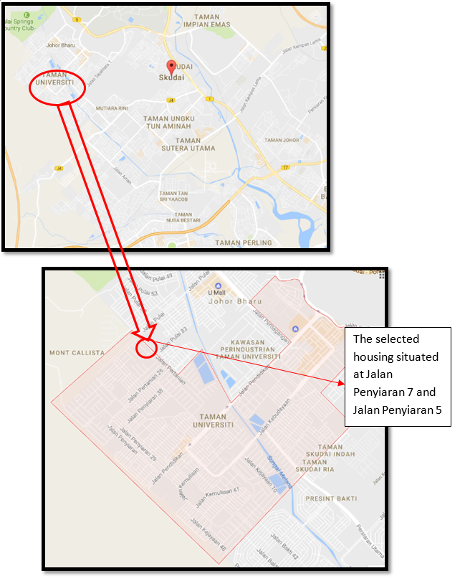
Fig. 1. The location of selected area for collection waste

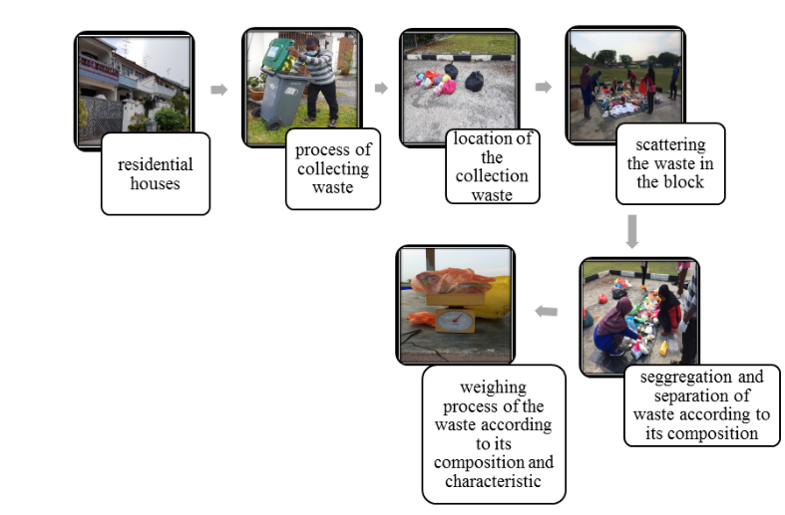
Fig. 2. Methodology for Collected Data

4. Results and Discussion
4.1 Bulk Density

The estimation of bulk density of the Municipal Solid Waste from Taman Universiti was determined by weighing the mass of the samples using weighing balance. The samples consist of food waste, tin cans, paper, plastic, glass, metal and other waste. The bulk density can be determined by using equation 1:

Bulk Density of solid waste = Total Mass / Total Estimated Volume (1)

where the estimated volume obtained by equation 2

Estimated volume = mass of each samples x typical bulk density (2)

Table 2 indicates the results from bulk density estimation analysis of each composition waste collected from Taman Universiti. Bulk density is defined as the dry weight of waste per unit volume. Bulk density considers both the solids and the pore space whereas particle density considers only the mineral solids. Waste bulk density also depends on the moisture content, composition and relative distribution of municipal wastes. Note that the density of waste changes as it moves from the source of generation to the point of ultimate disposal, and such factors are storage methods, salvaging activities, exposure to weather, handling methods and decomposition influence the density. The main objective of analyzing the density is to know the estimate volume for landfill during the disposal of the waste.
From the analysis, the bulk density of the solid waste is 99 kg/m³. Plastic is the highest volume among the waste. The main reason is because of the behaviour of people and most of the people living in Taman Universiti always buy food at the restaurant, markets, etc and eat at home. Thus, the food waste generation is also high. In conclusion, plastic and food waste are the main contributor of the volume and bulk density.

Table 2
Bulk Density of Waste Composition
Waste Composition | Mass (kg) | Typical Bulkage Density (kg/m³) | Volume (m³)
Food waste | 1.23 | 300 | 0.0041
Tin cans | 0.22 | 90 | 0.0024
Paper | 0.80 | 90 | 0.0089
Plastics | 1.56 | 60 | 0.0260
Glass | 0.20 | 200 | 0.0010
Metal | 0.20 | 350 | 0.0006
Others | 0.09 | 180 | 0.0005
TOTAL | 4.30 |  | 0.0435
*Typical bulk density adopted from Peavy et al., 1985
Bulk Density of solid waste = Mass / Total Estimated Volume
= 4.3 kg / 0.0435 m³
= 98.8~ 99 kg/m³

4.2 Moisture Content

The percentage of moisture content of the MSW from Taman Universiti was determined by weighing 10 g of the samples into a pre weighed dish before the samples were dried in an oven at 105ºC for 1 hour. The experiment was repeated for each components of the MSW. The percentage of moisture content was calculated using Equation 3.

Moisture content (%) = [(a-b)/b] x 100 (3)
where;
a = initial mass of sample as delivered
b = mass of sample after drying

Table 3 shows the results from moisture content analysis of each composition waste collected from Taman Universiti. The moisture content is measure with the amount of water lost from the materials upon drying to a constant weight. The waste bulk density which depends on the moisture content, composition and relative distribution of municipal wastes are directly affected by physical and chemical properties of material which enable them to absorb the exiting water in the environment. From the laboratory analysis results, food waste recorded the highest reading among all with 38.2 % while glass have the lowest moisture content with only 0.4%.

Table 3
Moisture Content Data for Solid Waste at Taman Universiti, Skudai
Component | Moisture (%)
Plastic | 1.7
Paper | 8.0
Food Waste | 38.2
Glass | 0.4
Aluminium | 2.0
Metal | 0.6
Other non-recyclable | 9.9

4.3 Composition of Waste

This section presents the result for the composition of each of the municipal solid waste (MSW) which was analyzed during the study. Based on the collection that was done in Taman Universiti, Skudai, we can conclude that the highest waste generated in this study area is Plastics. Apart from that, the second highest MSW generated are food waste and paper. These three (3) categories give the highest percentage and weight on MSW in Taman Universiti as shown in Figure 3 and Figure 4, respectively.
Plastic wastes were at the highest composition MSW because of the usage of plastics as the wrapper of foods, as plastic bags to carry groceries and other goods. Therefore, the biodegradable plastics can be used to reduce the amount of plastics in MSW.
The second highest compositions are food waste and papers. This study area is a high populated residential area, where most of the dwellers have their meals at home instead of having it in restaurant or cafeteria. This has enhanced the production of food waste. One of the mitigation measures to reduce the amount of food waste is by composting them which can act as fertilizer. While for papers, the recycle program is the best way to reduce the amount of paper in MSW.

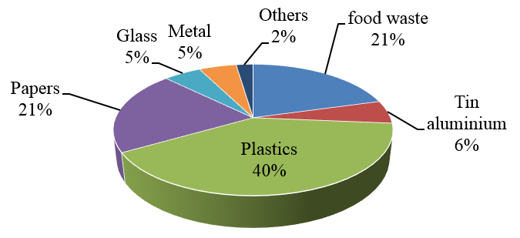

Fig. 3. Percentage Composition of Waste (%)

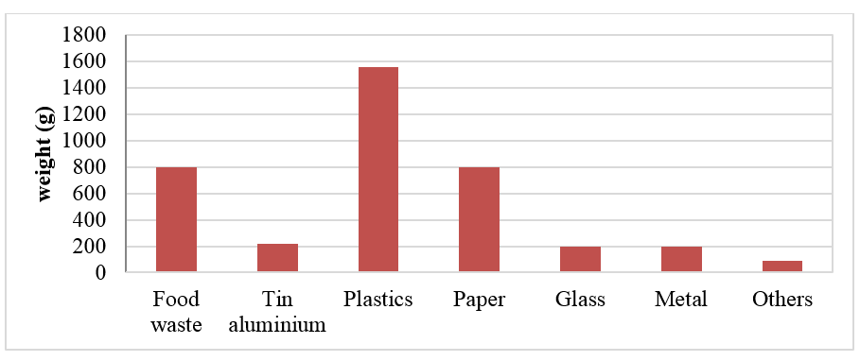
Fig. 4. The composition of waste (g)
5. Conclusion
According to the data on the composition of waste from study area, it observed that disposal waste is mainly consisting of plastic, food waste, and paper which all together account for about 82 percent of the dumped MSW. Plastics waste was at the highest composition MSW because of the usage of plastics widely for use as wrapper of foods, as plastic bags that carry the groceries and other goods. Food waste was recorded the highest reading among all with 38.2 % of moisture content. It is directly affected by physical and chemical properties of material which enables it to absorb the exiting water in the environment. The reliable estimate of solid waste generation is very important for proper waste management planning. These data from this study could enhance in implementation of waste management system in the study area.

References
[1] Wang, Hongtao, and Yongfeng Nie. "Municipal solid waste characteristics and management in China." Journal of the Air & Waste Management Association 51, no. 2 (2001): 250-263..
[2] Manaf, Latifah Abd, Mohd Armi Abu Samah, and Nur Ilyana Mohd Zukki. "Municipal solid waste management in Malaysia: Practices and challenges." Waste management 29, no. 11 (2009): 2902-2906.
[3] Samah, M. A. A., L. A. Manaf, P. Agamuthu, W. N. A. Sulaiman, and A. Ahsan. "Real data composition of municipal solid waste (MSW) generated in Balakong, Selangor, Malaysia." Life Science Journal 10, no. 4 (2013): 1687-1694.
[4] Chen, Xudong, Yong Geng, and Tsuyoshi Fujita. "An overview of municipal solid waste management in China." Waste management30, no. 4 (2010): 716-724.
[5] Zhang, Dong Qing, Soon Keat Tan, and Richard M. Gersberg. "Municipal solid waste management in China: status, problems and challenges." Journal of environmental management 91, no. 8 (2010): 1623-1633.
[6] Periathamby, Agamuthu, Fauziah Shahul Hamid, and Kahlil Khidzir. "Evolution of solid waste management in Malaysia: impacts and implications of the solid waste bill, 2007." Journal of material cycles and waste management 11, no. 2 (2009): 96-103.
[7] Tarmudi, Zamali, Mohd Lazim Abdullah, Md Tap, and Abu Osman. "An overview of municipal solid wastes generation in Malaysia." Jurnal Teknologi 51, no. F (2009): 1-15.
[8] Johari, Anwar, Saeed Isa Ahmed, Haslenda Hashim, Habib Alkali, and Mat Ramli. "Economic and environmental benefits of landfill gas from municipal solid waste in Malaysia." Renewable and Sustainable Energy Reviews 16, no. 5 (2012): 2907-2912.
osmotic adjustment during intermittent soil drying sustain grain yield of field grown wheat
osmotic adjustment during intermittent soil drying sustain grain yield of field grown wheat
osmotic adjustment during intermittent soil drying sustain grain yield of field grown wheat
United Nations Environment Programme(UNEP)(2013), Municipal Solid Waste Composition
United Nations Environment Programme(UNEP)(2013), Municipal Solid Waste Composition
United Nations Environment Programme(UNEP)(2013), Municipal Solid Waste Composition
Ali M, Jensen CR, Mogensen VO, Andersen MN, Henson IE (1999) bulk density and
Ali M, Jensen CR, Mogensen VO, Andersen MN, Henson IE (1999) bulk density and
Ali M, Jensen CR, Mogensen VO, Andersen MN, Henson IE (1999) bulk density and
[9] Ali, M., C. R. Jensen, V. O. Mogensen, M. N. Andersen, and I. E. Henson. "Root signalling and osmotic adjustment during intermittent soil drying sustain grain yield of field grown wheat." Field Crops Research 62, no. 1 (1999): 35-52.
Analysis Study Juba, South Sudan April 2013.
Analysis Study Juba, South Sudan April 2013.
Analysis Study Juba, South Sudan April 2013.
Field Crops Research 62, 35–52.
Field Crops Research 62, 35–52.
Field Crops Research 62, 35–52.
Journal of Sustainable Development, 5-7.
Journal of Sustainable Development, 5-7.
Journal of Sustainable Development, 5-7.
[10] Kalanatarifard, Amin, and Go Su Yang. "Identification of the municipal solid waste characteristics and potential of plastic recovery at Bakri Landfill, Muar, Malaysia." Journal of Sustainable Development 5, no. 7 (2012): 11.

* Corresponding author. E-mail address: Edward Hingha Foday Jr (edwardjfoday@yahoo.ca)

