 |  | Journal of Advanced Research in Applied Sciences and Engineering Technology |  | 
Journal homepage: www.akademiabaru.com/araset.html
ISSN: 2462-1943
Confirmatory factor analysis of value management current practice in the Nigerian construction industry |  |  |  |  | Open  Access
Bruno Lot Tanko^{1,3,}∗, Fadhlin Abdullah¹, Zuhaili Mohamad Ramly¹, Wallace Imoudu Enegbuma²

¹ | Department of Quantity Surveying, Faculty of Built Environment, Universiti Teknologi Malaysia, 81310 Skudai Johor, Malaysia
² | Faculty of Engineering, Computing and Science, Swinburne University of Technology, 93550 Kuching, Sarawak, Malaysia
³ | Department of Quantity Surveying, University of Jos, Jos, 930222, Nigeria
ARTICLE INFO |  |  | ABSTRACT
Article history:  Received 8 July 2017  Received in revised form 16 August 2017  Accepted 16 September 2017  Available online 19 November 2017 |  |  | Value management explicitly targets to optimize value by providing necessary functions at the least cost without sacrificing quality and performance. However, the activities/methods of this technique in emerging economies are here and there related to informal methodology. Therefore, the occurrence of these activities in an evolving economy requires investigation. The exploration of the extent to which the measured variables influenced the latent factors informed the need for this study. Data was retrieved via self-administered questionnaire from 344 registered and practicing construction professionals in Nigeria. The data was analyzed using SPSS for descriptive analysis and Structural Equation Modelling (SEM). Kaiser-Meyer-Olkin measure of sampling adequacy revealed that the internal consistency of the developed research instrument was appropriate. Confirmatory factor analysis indicates satisfactory goodness of fit among acknowledged determinants of the model. Furthermore, the study revealed three (3) phases of the activities/methods of value management in the Nigerian construction industry which include: information, information/function analysis, and creativity/evaluation/development/presentation phases. This means that value management activities and methods are being practiced in Nigeria, however not as per the typical methodology or standard. The need to carry out the practice according to the formal value management methodology is therefore recommended.
Keywords:
Current practice, value management, construction industry, Nigeria |  |  | Copyright © 2017 PENERBIT AKADEMIA BARU - All rights reserved

1. Introduction

Value Management (VM) is one of those philosophies used to explicitly optimize value by giving the required performance at a lower cost without influencing quality and performance of a scheme. VM which was at first known as value analysis (VA) by Lawrence [1], was intended to enhance value without sacrificing intended functions. Consequently, most clients are now concern with value philosophies in order to achieve the best from their ventures. VM has been practiced in numerous nations like the USA, UK, Australia, China, Saudi Arabia, Malaysia, and Hong Kong. Karim et al. [2] noticed that, VM practices have extended and have been broadly acknowledged and carried out in many nations. In fact Luvara and Mwemezi [3] submitted that VM has existed for more than fifty years and its application has recorded a lot of successes especially in the United Sates’ public projects. Conversely, according to a study by Olanrewaju [4] on one hundred and fifty two construction practitioners in Nigeria, VM has not been formally practiced but could facilitate the identification of client value system. Thus, most VM activities carried out by Nigerian construction organisations/firms seem not to conform to a typical formal VM methodology.
In any case, VM has picked up a substantial level of awareness in Nigeria, resulting to the suggestion for its implementation by a few researchers. As per Oke and Ogunsemi [5], VM is at present a part of Quantity Surveying scholastic educational modules of higher establishments yet has not been consolidated in the Nigerian construction works. In any case, Kolo and Ibrahim [6] articulate that, VM could be adopted in Nigeria, if the construction industry could connect with stakeholders on a team-oriented premise, executes viable development programs, investigates partnering forces and fortifies client organisations. In this way, Karim et al. [2] propelled that VM has been acknowledged comprehensively, and associations are currently surveying their qualities and shortcomings so as to quicken towards a superior VM usage. In this way, this paper looks to examine the current practice (CP) of value management activities/methods (CPA1 to CPC21) in the Nigerian construction industry.

2. The Practice of Value Management

According to Society of American Value Engineers [7], VM job plan outlines sequential phases to be followed which support team synergy within a structured process. Figure 1 shows the actions that are usually carried out during each phase of the job plan. These activities would stimulate the team to find ideas and develop them into alternatives, identify project’s basic and secondary functions, and to provide information necessary for the successful execution of the next phase. A previous stage may be re-examined as the team gains further information about the project.

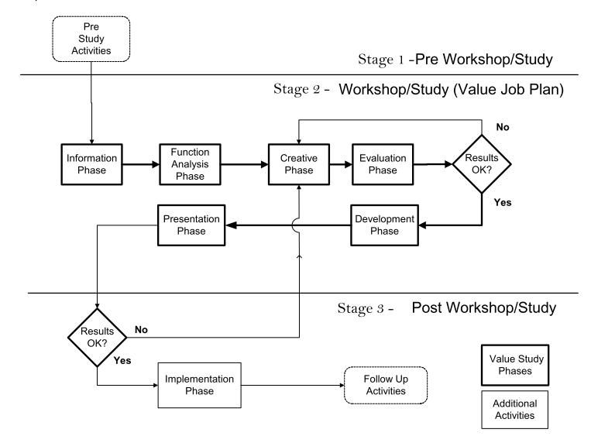
Fig. 1. Value Study Process Flow Diagram, Source: SAVE International [7]

Therefore, the execution of a VM methodology is basic with a specific end goal to accomplish the objectives of applying VM. The VM session is usually executed by a multi-disciplary group of construction professionals (Architect, Quantity Surveyors, Builders, and Engineers), the client (owner), and the end-user. The session is essentially separated into three phases (Preparation, the Job Plan, and Presentation) as depicted in Figure 1.

2.1 Stage 1: Pre- Workshop (Preparation)

The preparatory stage is committed to obtaining information on the proposed project for effective running of the workshop. Information such as timing, function, constraints, background, objectives, location, cost, and the scope of the project are usually obtained at this stage. The project stakeholders must actively participate in this stage of the workshop. Dedicated roles should are assigned to stakeholders (e.g., clients, consultants) and each stakeholder should prepare background information on how the project is related to them [8].

2.2 Workshop (6-Phase Job Plan)

The structured procedure of a VM workshop is known as the Job Plan. This stage of workshop is designed according to the six phases of the job Plan.

2.2.1 Information phase

Sharing of information is paramount at this phase. Clients should unequivocally express the scope, objectives and expectation of their projects. According to Chen and Liao [9], this phase should recognise client’s needs with regard to function and cost. However, other stakeholders can also present their perceived project constraints. This phase gains much detail as possible about the project design, background, constraints, and projected cost [10, 11]. A study by Ramly et al. [8] revealed that at this phase, consultants such as architect, civil and structural engineers, mechanical and electrical engineers, and quantity surveyors presented critical information related to their disciplines. The procurement approach, project timeframe, quality and environmental issues were also figured out at this phase.

2.2.2 Function Analysis

Function Analysis is first and foremost a systematic approach that establishes and meets the requirements and expected functions of a project. According to Ramly et al. [8], the primary objective of this phase is to generate and classify functions into basic and secondary functions. At this phase, the function of a project is identified, analysed and represented in a hierarchical function diagram called the functional tree diagram. Jaapar et al. [12] submitted that the main aim of this phase is to comprehend the project via the function of the project. Therefore, this phase ascertains and ranks the primary and secondary functions with their associated costs.
2.2.3 Creativity
At this phase, ideas are generated to meet the desired functions of an agreed functional tree diagram. During this phase, the VM team explores alternative approaches, means and methods for the achievement of functions [13]. Creative techniques such as brainstorming lateral thinking and synectics are employed at this stage. The VM facilitator must ensure that criticism does not exist among the participants and a positive atmosphere should be created.
2.2.4 Evaluation

The generated ideas are assessed and appraised at this phase. All the suggestions and ideas established during the creative phase should pass through evaluation and short-listing. Ramly et al. [8] submitted that, the ideas should undergo additional screening to realistically determine how they could be implemented to meet the desired function, and should be classified into: realistically possible to be implemented; remotely possible; and impossible to be implemented. Thereafter, the ideas will be developed in the development stage.

2.2.5 Development

The VM team develops the short-listed ideas and prepares descriptions, sketches, diagrams, drawings and information on manufacturer/producer, materials as formal VM proposal. Each short-listed idea is designed into a feasible and viable solution. The development phase consists of the recommended design and capital, life cycle cost comparisons and a complete description of the constraints and benefits of the proposed recommendation.

2.2.6 Presentation

Each of these components or tasks at the development phase will be presented in the action plan.

2.3 Post-workshop
This stage involves the submission of the final written report to the client. The final report consists of all the processes and output of each phase, a detailed action plan and recommendations. It is necessary to hold an implementation review meeting few weeks after the workshop stage. The status of actions should rigorously be monitored as well as follow up of implementation action plan.
Table 1 shows the various activities and methods of value management as put forward by various researchers.

3. Methodology

The study adopted a stratified random probability sampling approach. 465 structured questionnaires were administered to Architects, Quantity Surveyors, Builders, Civil Engineers, and Services Engineers in Jos, Kaduna, and the Federal Capital Territory (Abuja). The professionals were chosen from contracting, project management, consulting engineering, quantity surveying, consulting architects, and client organizations. 344 (73.98%) questionnaires were appropriately filled and returned. This sampling approach provided the prospect of meeting the target groups with a high response rate. The response, through a 5-point Likert scale was measured to allow freedom of opinion and ease of analysing data.

Table 1
Previous research on activities/methods of value management
CP | Authors | Kelly et al. [14] | Jaapar et al. [12] | SAVE. [7] | Ramly et al. [8] | Che Mat & Shah [15] | Hwang et al. [16]
CP | Activities and Methods of VM
CPA1 | Carry out site visitation |  |  | √
CPA2 | Obtain relevant background information on the proposed project |  | √ |  | √
CPA3 | Define the timeframe and scope of the project |  |  | √
CPA4 | Define and understand the objectives and functions of the project |  |  | √
CPA5 | Involve clients at the initial stage of the project |  |  |  |  |  | √
CPA6 | Involve and assign responsibilities to construction professionals at the initial stage of project |  | √ |  | √
CPA7 | Define the procurement approach of the project |  |  |  | √
CPB8 | Commit client organisations in the project cycle | √ | √
CPB9 | Clarify project background information and constraints |  | √ | √
CPB10 | Share project information among professionals and stakeholders |  |  |  |  |  | √
CPB11 | Make client to unequivocally express the scope and expectation of the project |  |  |  | √
CPB12 | Presentation of perceived project constraints by stakeholders |  |  |  |  |  | √
CPB13 | Identify high cost areas by undertaking relative cost ranking | √
CPB14 | Generate and classify functions/elements into basic and secondary elements with their associated costs |  | √ | √ | √
CPC15 | Brainstorm ideas to meet the desired functions/elements and associated costs | √ | √ | √
CPC16 | Assess brainstormed ideas to meet the desired functions/elements |  |  |  | √
CPC17 | Classify the ideas from the brainstormed section into realistically possible to be implemented |  | √ |  | √ | √ | √
CPC18 | Classify the ideas from the brainstormed section into remotely possible to be implemented |  |  |  | √
CPC19 | Classify the ideas from the brainstormed section into realistically impossible to be implemented |  |  |  | √ | √
CPC20 | Develop an action plan on the short-listed ideas |  |  | √ | √
CPC21 | Hold an action plan review meeting |  | √

The Staistical Package for the Social Sciences (SPSS) was employed in the Exploratory Factor Analysis (EFA) that established the structure of the measurement model. The Structural Equation Modelling (SEM), using Confirmatory Factor Analysis (CFA) in AMOS software further validates the measurement model by indicating satisfactory goodness of fit among acknowledged determinants of the models.

4. Results and Discussion
4.1 Respondents Characteristics

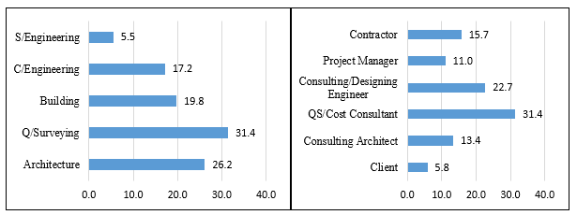
Fig. 2. Respondent’s profesional fields and organisations’ role

From Figure 2, it can be inferred that 31% of the total respondents are Quantity surveyors, 26% Architects, 20% Builders, 17% Civil Engineers, and 6% are Services Engineers. It can also be deduced that 31% of the professionals emanate from the quantity surveying firms, 23% from the consulting/designing engineering firms, 16% from contracting firms, while 13%, 11%, and 6% were from consulting architects, project management, and client organisations.
The reliability test was conducted using the Cronbach’s alpha coefficient to confirm the reliability and validity of the data collected. The attributes or variables (CPA, CPB, CBC) of the CP of VM are described in Table 1. The results of reliability and validity test through the Cronbach’s Alpha in Table 2 show that the current practice attributes are within the range of 0.96 to 0.97.This implies that the result is highly statistical significant because the values obtained are higher than the recommended minimum value of 0.60 [17].

Table 2
Reliability of VM current practice attributes
Variable | Label | Items | Cronbach Alpha
CPA | Information | 7 | 0.96
CPB | Information/Function Analysis | 7 | 0.97
CPC | Creativity/Evaluation/Development/Presentation | 7 | 0.97

4.2 Exploratory Factor Analysis

The level of acceptance of the factor loading is determined by the sample size of the research data which indicates that a factor loading above 0.30 should be significant at 95% confidence level [18, 19].
As recommended by most researchers, factor extraction, principal component extraction, and varimax rotation were carried out for all the measured variables (CPA1 to CPC21). The threshold for Eigen value that is greater than 1 was also upheld. According to Baba et al. [20], variables with cross-loadings on at least two factors of > 0.4 and items with a factor loading of less than 0.4 are usually removed. Nonetheless, the exploratory loadings for all the variables in this research were above the values of either 0.30 or 0.40 as shown in Table 3.

Table 3
Rotated component matrix for current practice of VM attributes
- Variables | - Component
 | 1 | 2 | 3
- Site Visitation |  |  | 894
- Background Information |  |  | 857
- Scope of Project |  |  | 914
- Project Functions and Objectives |  |  | 943
- Involve Clients at IP |  |  | 928
- Assign Responsibilities |  |  | 862
- Define Procurement Approach |  |  | 914
- Commit Client Org | 897
- Clarify Project Information | 862
- Share Project Information | 922
- Make Client Express Scope of Project | 942
- Presentation of Project Constraints | 936
- Identify High Cost Areas | 889
- Generate and Classify Functions | 923
- Brainstorm Ideas to meet Functions |  | 921
- Assess Brainstormed Ideas |  | 903
- Classify Ideas into Realistically Possible Implemented |  | 909
- Classify Ideas into Remotely Possible Implemented |  | 920
- Classify Ideas into Impossible Implemented |  | 913
- Develop an Action Plan |  | 906
- Hold an Action Plan Review Meeting |  | 888
Extraction Method: Principal Component Analysis.
Rotation Method: Varimax with Kaiser Normalization.
- a. Rotation converged in 4 iterations.

4.3 The Measurement and Structural Model
The measurement model demonstrates the strength of relationship among the constructs of this research. It basically measures the relationship of the variables or items to each construct (CPA, CPB, and CPC). While the structural model shows the relationship among the unobserved variables and how they influence the values of other latent variables of the model. The base limits of indices utilized as a part of measuring the goodness of fit of the measurement model are stipulated by Awang et al. [21], Enegbuma et al. [22], and Hair et al. [17] as p < 0.05, Comparative Fit Index (CFI) ≥ 0.90, Goodness of Fit Index (GFI) ≥ 0.90, Chi-square/df (χ²/df) < 5, and Root Mean Square Error of Approximation (RMSEA) ≤ 0.05-0.80.
The statistics shown in Figures 3 & 4 discovered a p-value of 0.001, CFI value of 0.992, GFI, 0.94, χ²/df value of 1.37, and RMSEA value of 0.03. Figure 3 indicated that the fit statistics are adequate and within the acceptable thresholds to establish the convergence validity of the measurement model for the job plan (CPA, CPB, CPC) of the current practice of VM activities and methods in the Nigerian construction industry.
The results from the structural model (Figure 4) are found to have met acceptable thresholds on all of the statistical parameters in literature for a model fit. The tested latent factors of the CP have been verified by the analysis of results.
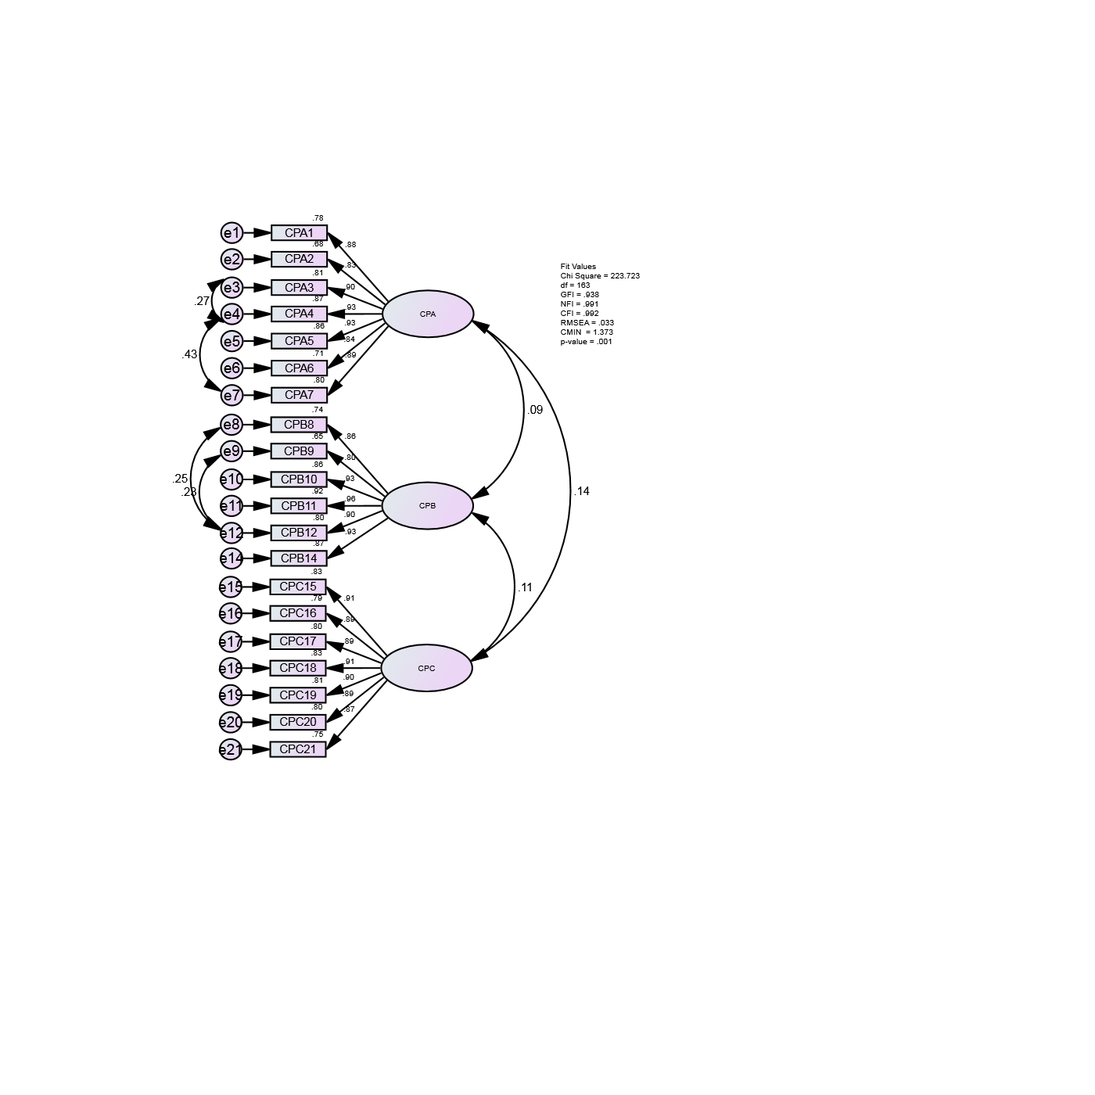
Fig. 3. Measurement model for current practice of value management

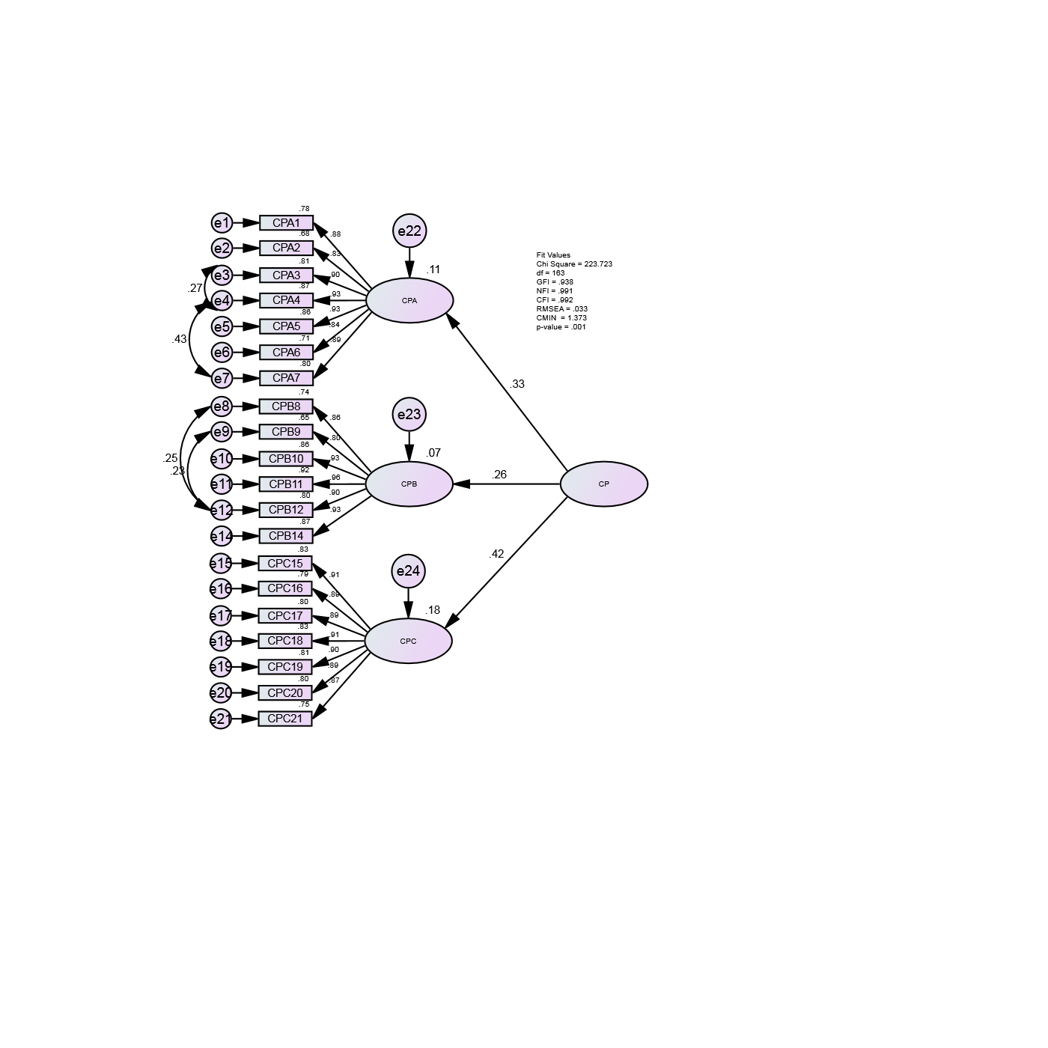
Fig.4. Structural model for current practice of value management
5. Conclusion
This paper carried out an exploration to discover the current practice of VM application in the Nigerian construction industry. The job plan (methodology) responsible for measuring the relationship and extent of predicting the current practice in Nigeria were identified as CPA (Information phase), CPB (Information/Function Analysis phase) and CPC (Creativity/Evaluation/Development/Presentation phase). The activities executed at the CPA are: carrying out site Visitation, obtaining relevant Background Information on proposed projects, defining the timeframe and scope of proposed projects, defining the objectives and functions of the project, involving clients at the initial stage of projects, assigning responsibilities to construction professionals at the initial stage of projects, and defining the procurement approach of proposed projects. At the CPB phase, the following are carried out: committing client organisations in the project cycle, clarifying the background information and constraints of proposed projects, sharing project information among professionals and stakeholders, expressing the scope and expectations of proposed projects by clients, presentation of perceived project constraints by stakeholders, and classifying proposed projects’ functions/elements into basic and secondary elements with their associated costs. And lastly at the CPC phase, brainstorming ideas to meet the desired functions/elements, assessment of the brainstormed ideas, classifying the brainstormed ideas into possible/impossible to be implemented, development of an action plan, and presentation of the action plan constitute the key activities carried out in this phase.
However, one of the critical activities of the Function Analysis phase (CP13) which is identifying high cost areas via relative cost ranking was eliminated as a result of very low loading factor. Nevertheless, most of the activities and methods of the VM practice are evident in the Nigerian construction industry but not in accordance with the usual 6-phases of information, function analysis, creativity, evaluation, development, and presentation. Therefore, the need to carry out the practice according to the formal VM methodology is recommended to ensure value optimization of construction projects.
Acknowledgement
This study is part of an on-going PhD research on the roadmap for implementing value management in the Nigerian construction industry. We gratefully acknowledge the Universiti Teknologi Malaysia (UTM) and Kaduna State Government for funding this research.

References
[1] Phyo, War War May, and Aye Mya Cho. "Awareness and practice of value engineering in Myanmar construction industry." International Journal of Scientific Engineering and Technology Research 3, no. 10 (2014): 2022-2027.
[2] Karim, Saipol Bari Abd, A. Rahmin Rabi’atul‘Adawiyah, Mohd Suhaimi Mohd Danuri, and Othman Mohamed. "Developing the Value Management Maturity Model (VM3©)." Journal of Design and Built Environment 14, no. 1 (2014).
[3] Luvara, Valentine GM, and Benson Mwemezi. "Obstacles against Value Management Practice in Building Projects of Dar es Salaam Tanzania." International Journal of Construction Engineering and Management 6, no. 1 (2017): 13-21.
[4] Ashola, Olanrewaju Abdul Lateef. "Assessing the Practice and Prospects of Value Management in the Nigerian Construction Industry." PhD diss., Kulliyyah of Architecture and Environmental Design, International Islamic University Malaysia, 2008.
[5] Oke, Ayodeji Emmanuel, and Deji Rufus Ogunsemi. "Value management in the Nigerian construction industry: Militating factors and the perceived benefits." In Proceeding of the second international conference on advances in engineering and technology. Faculty of Technology, Makerere University, Uganda, vol. 30, pp. 353-359. 2011.
[6] Kolo, B.A. and Ibrahim, A.D. Value Management: How Adoptable is it in the Nigerian Construction Industry? In: Laryea, S., Leiringer, R. And Hughes, w. (Eds) Conference Proceedings of West Africa Built Environment, (2010): 653-663.
[7] Society of American Value Engineers [SAVE]. Value Management. Retrieved from https://www.wsdot.wa.gov, 2007.
[8] Mohamad Ramly, Zuhaili, and Geoffrey QP Shen. "Value management in Malaysia: past, present and future." (2012).
[9] Chen, Wei‐Tong, and Shen‐Li Liao. "A job‐plan based performance evaluation for construction value engineering study." Journal of the Chinese Institute of Engineers 33, no. 2 (2010): 317-333.
[10] Chougule, Amruta, and A. K. G. S. Patil. "Application of Value Engineering Technique to A Residential Building–Case Study." International Journal of Innovative Research in Advanced Engineering (IJIRAE) 1, no. 12 (2014).
[11] El-Alfy, Alaa El Dean. "Design of sustainable buildings through Value Engineering." Journal of Building Appraisal 6, no. 1 (2010): 69-79.
[12] Jaapar, Aini, Nur Amani Maznan, and Mardhiah Zawawi. "Implementation of value management in public projects." Procedia-Social and Behavioral Sciences 68 (2012): 77-86.
[13] Liu, Guiwen. "A Framework For Implementing Value Management in China's Construction Industry." Department of Building and Real Estate. Hong Kong, The Hong Kong Polytechnic University (2003).
[14] Kelly, John, Steven Male, and Drummond Graham. Value management of construction projects. John Wiley & Sons, 2014.
[15] Shah, Hj Zulkarnain bin Hj Mohd, and Pejabat Harta Bina. "Value Management As an Effective and Efficient Tool for Space Management." (2006).
[16] Hwang, Bon-Gang, Xianbo Zhao, and Shi Ying Ong. "Value management in Singaporean building projects: Implementation status, critical success factors, and risk factors." Journal of Management in Engineering 31, no. 6 (2014): 04014094.
[17] Hair, J.F., Black, W.C., Babin, B.J. and Anderson, R.E. Multivariate data analysis. (7th Edn). Upper Saddle River, NJ: Pearson, 2013.
[18] Pallant, J. SPSS survival manual. A step by step guide to data analysis using SPSS for windows. 2nd edn, Allen & Unwin: Australia. p.286, 2005.
[19] Tabachnick, Barbara G., Linda S. Fidell, and Steven J. Osterlind. "Using multivariate statistics." (2001).
[20] Baba, Adams N., Nooraini Binti Yusoff, Muhammad Gohram Khan, Wallace I. Enegbuma, and Mercy I. Achoba. "EXPLORING LATENT DETERMINANTS OF ENTERPRISE OCCURRENCES IN PLANNED RESIDENTIAL AREAS." Jurnal Kemanusiaan 15, no. 1 (2017).
[21] Awang, Zainudin, Wan Mohamad Asyraf Wan Afthanorhan, and M. A. M. Asri. "Parametric and non parametric approach in structural equation modeling (SEM): The application of bootstrapping." Modern Applied Science9, no. 9 (2015): 58.
[22] Enegbuma, W. I., G. U. Aliagha, and K. N. Ali. "Effects of perceptions on BIM adoption in Malaysian construction industry." Journal of Technology 77, no. 15 (2015): 69-75.

∗ Corresponding author. E-mail address: Bruno Lot Tanko (bruno.tanko@yahoo.com)

